Enhancing the separation performance of glassy poly(2,6-dimethyl-1,4-phenylene oxide) (PPO) with the addition of molecular sieves
Francesco M. Benedetti^{1,2}, M. Grazia De Angelis^{1,2,*}, Micaela Degli Esposti¹, Paola Fabbri¹, Alessandro Orsini³, Alberto Pettinau³
1 Department of Civil, Chemical, Environmental and Materials Engineering (DICAM), University of Bologna, Via Terracini 28, 40131, Italy; 2 National Interuniversity Consortium of Materials Science and Technology (INSTM), Italy; 3 Sotacarbo S.p.A, Grande Miniera di Serbariu, 09013 Carbonia, Italy
*Corresponding author: grazia.deangelis@unibo.it

Highlights
- PPO-based MMMs can be effectively implemented for CO₂ capture applications.
- Inclusion of selective adsorbents such as ZIF-8 and Zeolite 3A remarkably improved gas transport properties of the glassy polymer.
- Increasing temperature enhanced H₂/CO₂ separation, ideal for IGCC application.

1. Introduction
Membrane technologies represent an alternative to address relevant issues such as global warming and energy efficiency, leaving a smaller footprint than traditional technologies. The use of readily available materials to be combined in Mixed Matrix Membranes (MMMs) to improve the performance for gas separation applications, is one of the solutions to achieve large-scale applications.[1] The use of H₂-selective materials in IGCC plants can reduce the energy consumption associated to post-separation CO₂ compression and provide a hydrogen-enriched stream ready to be used as a fuel for power production.[2] To this purpose, we fabricated robust MMMs based on poly(2,6-dimethyl-1,4-phenylene oxide) (PPO) and different molecular sieves such as ZIF-8 and Zeolite 3A. The membrane preparation was optimized to allow the formation of films up to 45 wt.% of filler. Permeation, diffusion and sorption of He (used as a model for H₂), N_{2,} CH₄, CO₂ were investigated at 35, 50, 65 °C. Pure and composite materials were characterized from the morphological and calorimetrical point of view. Simple mathematical models were applied to evaluate the permeability of gases in the MMMs.[3]
2. Methods
Membranes were casted by solution casting technique under quick solvent evaporation conditions. MMMs were thermally annealed at 200 °C to remove residual solvent and activate the filler particles. To verify the complete solvent removal from the casting step and evaluate the thermal stability, TGA and DSC experiments were performed. Gas permeation was determined by means of a manometric technique and diffusion coefficients were evaluated with the time-lag method in the framework of the solution-diffusion model.[4] Diffusion coefficients were also evaluated from the diffusion kinetics while measuring sorption isotherms in a pressure decay apparatus. The quality of the adhesion between the filler and the polymer was determined through FEG-SEM images. Density of membranes was measured by means of the buoyancy method. Maxwell-Wagner-Sillar (MWS) model was used to understand whether the membranes follow an additive rule.
3. Results and discussion
SEM images showed good adhesion between the polymer matrix and filler particles. The dispersion of the filler was homogeneous, especially at low loadings. DSC and TGA analysis revealed that membranes were solvent free after the thermal annealing and thermally stable. Remarkable gas transport results were showed, in particular by PPO/ZIF-8 MMMs, which revealed an increase of He permeability of around 800% with respect to the pure PPO and a He/CO₂ selectivity which was up to 15% higher. Permeability of each gas was successfully described with the Maxwell-Wagner-Sillar model in the range of validity of the model (Figure 1). MMMs sorption isotherms followed the additive rule. The effect of temperature further enables the gas separation properties, indeed both He permeability and He/CO₂ selectivity increase sharply with increasing temperature. The activation energy of the permeation and diffusion were evaluated as function of the filler content.
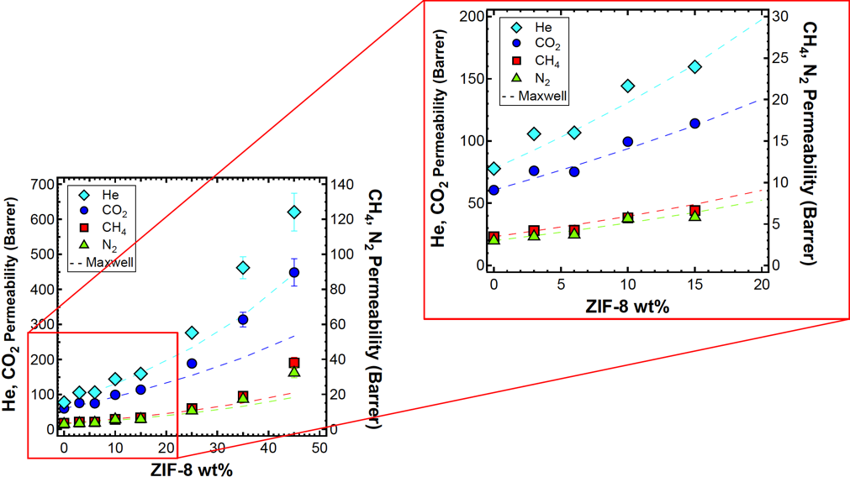
Figure 1. Enhanced gas permeability in PPO/ZIF-8 MMMs. Experimental data (markers) and MWS model (dashed lines).
4. Conclusions
MMMs prepared using PPO and ZIF-8 revealed significantly enhanced transport properties without compromising the processability of the polymer. Density measurements, solubility additive behaviour and Maxell modelling show the ideal behaviour of these MMMs. Higher than ideal permeability at high filler loading may be attributed to percolation phenomenon. Favourable effect on transport properties as the temperature increase make these materials interesting for industrial applications.
References
[1] J. Dechnik, J. Gascon, C.J. Doonan, C. Janiak, C.J. Sumby, Mixed-Matrix Membranes, Angew. Chemie Int. Ed. 56 (2017) 9292–9310.
[2] T.C. Merkel, M. Zhou, R.W. Baker, Carbon dioxide capture with membranes at an IGCC power plant, J. Memb. Sci. 389 (2012) 441–450.
[3] H. Vinh-Thang, S. Kaliaguine, Predictive models for mixed-matrix membrane performance: A review, Chem. Rev. 113 (2013) 4980–5028.
[4] J.G. Wijmans, R.W. Baker, The solution-diffusion model : a review, J. Memb. Sci. 107 (1995) 1–21.

