Stimuli-Responsive DNA-Aptamer Gating Membranes
Thomas Schäfer^{1,2*}, Beñat Olave¹, Iliane Rafaniello¹
1 POLYMAT, University of the Basque Country, Donostia-San Sebastián, Spain; 2 IKERBASQUE, Basque Foundation for Science, Bilbao, Spain
*Corresponding author: thomas.schafer@ehu.es
Highlights
- The conformational change of DNA-aptamers can be used as nanovalves in membrane pores.
- DNA-aptamer gating membranes respond to a molecular rather than a bulk stimulus.
- DNA-aptamers are versatile building blocks for bioinspired nanostructured hybrid membranes.
1. Introduction
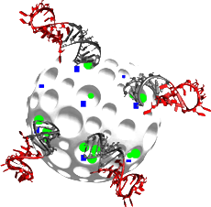
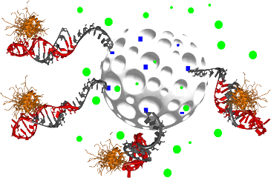
Aptamers are oligonucleic acids that can be selected to specifically interact with in principle any kind of target molecule. An important asset of aptamer conjugates is the fact that upon specific binding, their spatial conformation may change drastically, depending on a fine equilibrium between mainly electrostatic and hydrophobic interactions. Recently, if has been shown that this specific conformational change can be exploited for controlled release applications in particles and membranes, where aptamers serve as a “nanovalve” which selectively triggers the opening or closing of a nanopore depending on the presence of a target molecule [1]. Such systems add an important degree of freedom in the design of stimuli-responsive systems which conventionally respond to bulk stimuli such as pH, temperature, light or electrical and magnetic fields. Figure 1 schematically shows as an example the conformational which an AMP-aptamer undergoes upon target binding.
A
B

Figure 1. Conformational change of a DNA-Aptamer upon molecular target recognition (A, here: AMP) and use for gating the solute permeation in nanoporous matrices (B).

2. Methods
The build-up of the DNA-aptamer gating membrane was monitored in real-time by quartz crystal microbalance with dissipation monitoring (QCM-D) and multi-parameter surface plasmon resonance (MP-SPR). The DNA-aptamer used was specifically recognizing adenosine monophosphate (ATP) but not guanine monophosphate (GTP, negative control). DNA/AAO membranes were manufactured by surface modification of the AAO membrane that allow subsequent self-assembly of the DNA. The permeability of the DNA-aptamer gated AAO membranes was measured spectrofluorometrically using a single-photon counting spectrofluorimeter and fluorescein as a tracer dye. Successful and selective gating was proven by (1) using GTP as negative control and (2) using a scrambled sequence of the DNA-aptamer which has no specificity for the molecular target ATP.
3. Results and discussion
The AAO membranes were modified with a DNA-aptamer that specifically recognizes ATP as a small molecular target. Upon target recognition as a molecular stimulus, the DNA-aptamer gated membranes responded with a nanopore opening whose degree depended on the target (ATP) concentration (Figure 2, left) and was according to the K_{D} of the DNA-aptamer (Figure 2, right).
Figure 2. Left: Permeation of fluorescein across a DNA-aptamer gated AAO membrane as a function of the concentration of the DNA-aptamer molecular target ATP; Right: Dissociation constant K_{D} of the DNA-aptamer for ATP and GTP, respectively.
The scrambled sequence of the DNA-aptamer and the molecular target GTP did not result in any response of the membrane, i.e., the membrane pores remained closed (Figure 2, left), corroborating that the conformational change of the DNA-aptamer upon specific target recognition was the sole trigger for modulating permeation of fluorescein across the membrane.
Owing to the reversibility of the conformational change of the DNA-aptamer, permeate flow of fluorescein could be repeatedly switched on and off depending on the concentration of ATP, simulating in this way to a certain extent the function of transporter proteins in biological membranes.
4. Conclusions
DNA-aptamers are highly versatile building blocks for creating bioinspired stimuli-responsive membranes. The conformational change of the DNA-aptamer is highly specific and reversible, allowing to modulate permeation of solutes across the membrane based on a molecular stimulus.
References
- T.Schäfer and V.C. Özalp. Chem Commun, 2015, 51, 5471.

