Investigating Coarse-Graining Effects on CFD-DEM Simulations of Fluidized and Spouted Bed Reactors
Thomas Eppinger¹, Nico Jurtz², Felix Klippel1, Leonard Becker1, Oleh Baran³, Ravindra Aglave³, Matthias Kraume²
1 Siemens Industry Software GmbH, Nürnberg, Germany; 2 Berlin Institut of Technology, Chair of Chemical & Process Engineering, Berlin, Germany; 3 Siemens PLM, Houston, TX, USA
*Corresponding author: Thomas.eppinger@siemens.com
Highlights
- Effect of different coarse-graining methods and factors are investigated
- Comparison against experimental data shows good agreement with averaged quantities
- Differences in the dynamic behavior are quantified

1. Introduction
Since its introduction [1], the Discrete Element Method (DEM) has proven to be a valuable method for the analyzing and understanding particulate flows. Supported by the continuously increasing computational power, CFD-DEM simulations have found their way into the chemical and process industry for various applications like solid suspension in mixing vessels, fluidized and spouted beds, granular transport and coating applications in rotary drums [2,3].
The major shortcoming of DEM, however, is its computational cost that increases with the amount of particles involved, their material properties (stiffness) and size. This hinders the application of CFD-DEM simulation to large-scale systems of industrial size. To overcome this shortcoming a coarse grain (CG) model has been described [4]. Using straightforward scaling rules, a group of particles gets replaced by a representative coarse parcel. This effectively reduces the number of particles that need to be processed and subsequently shortens the computational time. On the other hand they introduce a modeling error into the simulation. In this study we are investigating different coarse graining models and quantify the effect on different parameters and their fluctuation like pressure drop and expansion height in a fluidized and spouted bed.
In this work two different contact scaling methods are examined for a fluidized and for a spouted bed reactor. The results are compared against experimental results and against a DEM simulation without coarse graining.
2. Methods
In this investigation the software tool Simcenter STAR-CCM+ was used for the coupled CFD-DEM simulation. The built-in DEM solves for each particle Newton’s law of motion in each time step. The particle-particle and particle-wall interaction is taken into account based on Hertz-Mindlin model (spouted bed) or the linear-spring-dashpot model (fluidized bed). Momentum exchange between the background gas phase and the DEM particles is calculated based on Gidaspow drag model and three different coarse graining (CG) approaches were used: Particle-based CG with l3-scaling, Parcel-based CG with l3-scaling and Parcel-based CG with l2-scaling.
3. Results and discussion
Exemplarily the results for the fluidized bed are shown here, but similar results were also found for the spouted bed. Figure 1 shows a snapshot in time of the different CG methods. In general it can be stated that bed expansion and pressure drop are well predicted for all investigated CG methods, but depending on the CG factor the dynamic of the system cannot be captures which can be seen in Figure 2 as deviations in the RMS values for the respective parameter.
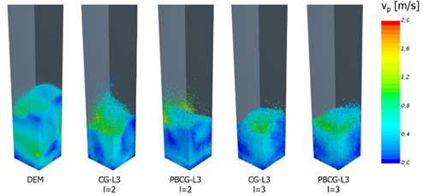 | 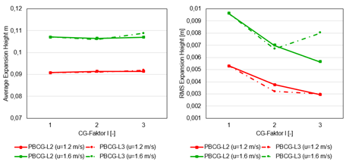
Figure 1. Comparison of the particle dynamics for different CG methods | Figure 2: Average and RMS expansion height for different CG methods
4. Conclusions
Coarse-graining is a promising method to increase the number of particles in CFD-DEM simulations and simultaneously reducing the runtime by orders of magnitude. The predictivity is slightly affected in terms of the particle dynamics while overall properties are still predicted accurately in the investigated CG range.

References
- P.A. Cundall, O.D.L. Strack, Geotechnique, 29 (1979), 47
- T. Eppinger, O. Baran, R. Aglave, S. Lo, Simulating Solid Suspension in Stirred Vessels with a Fully Coupled CFD-DEM Algorithm (161d), AIChE Annual Meeting 2017, Minneapolis
- O. Baran, R. Aglave, M. Tandon, A. Karnik, S. Lo, Numerical Simulation of Dense Gas-Solid Fluidized Beds: Comparison Between Eulerian Multiphase and Discrete Element Methods, AIChE Annual Meeting 2015, Salt Lake City, UT.
- M. Sakai, Y. Yamada, Y. Shigeto, K. Shibata, V.M. Kawasaki, S. Koshizuka, Numerical Methods in Fluids 64 (2010), 1319
- V. Salikov, V., S. Antonyuk, S. Heinrich, V.S. Sutkar, N.G. Deen, J.A.M. Kuipers, Pow. Tech.270 (2015), 622

