Transport processes in disperse multiphase systems in the presence of surfactants: A single drop study
Joschka M. Schulz*, Matthias Kraume
Technische Universität Berlin, Chair of Chemical and Process Engineering, Ackerstraße 76, 13355 Berlin, Germany
*Corresponding author: j.schulz@tu-berlin.de
Highlights
- Prediction of mass transfer rates by consideration of drop movement
- Spatially resolved concentration field measurement by Rainbow Schlieren Deflectometry
- Interfacial phenomena due to the presence of surfactants
- Evaluation of drop production phase

1. Introduction
The presented work focuses on the interaction between mass transfer and fluid dynamics in disperse liquid/liquid systems in the presence of surfactants and is part of the Collaborative Research Center Integrated Chemical Processes in Liquid Multiphase Systems financed by the German Research Foundation. In industrial processes surfactants occur intentionally or as an impurity and change the interfacial behavior. The induced interfacial phenomena such as Marangoni convection or adsorption may lead to a change of important process parameters. Since these phenomena have contrary effects on the mass transfer in multiphase systems, the prediction of their occurrence and the resulting mass transfer rates is a challenging task. To get a deeper insight into the transient mass transfer processes, fluid dynamic measurements of single droplets are used as an indicator for the prediction of interfacial phenomena and mass transfer rates. Furthermore, the mass transfer during droplet production is considered and a refractive index-based optical measuring technique is applied for the non-invasive in situ visualization of the concentration field in the continuous phase.
2. Methods
For experimental purposes a single drop rising test cell with a length of 700 mm is used. Samples are taken at different contact times and the rising speed and path of the droplets are determined optically with a high-speed camera. For detailed analysis, the experimental setup introduced in Merker et al. [1] is used, which extends the concept of the rising test cell by adding a vertical traverse system with real-time control, thus enabling the three-dimensional measurement of shape, velocity and trajectory of the particle during the ascent with high temporal and spatial resolution. Additionally, mass transfer during drop production is measured separately. An experimental setup applying Rainbow Schlieren Deflectometry has been developed for non-invasive real-time measurement of the concentration field in liquid/liquid systems and is used for the visualization of interfacial phenomena.
3. Results and discussion
Figure 1 (left) the shows the transient drop rise velocity of single 1-octanol droplets in water for varying surfactant concentrations of Butyldiglycol, which is chosen as a model surfactant. The terminal drop rise velocity decreases with increasing surfactant concentration showing good agreement with the calculated velocity of a movable interface (Feng and Michaelides [2]) for negligible surfactant concentrations. For high surfactant concentrations the velocity is reduced to the value for rigid spheres (Martin [3]). In case of deformation, the measured velocities can decline even further. Although the observed effect is in good agreement with the literature, the mass transfer rates show contrary behavior due to the occurrence of Marangoni convection, which can be identified by detailed consideration of the drop movement.
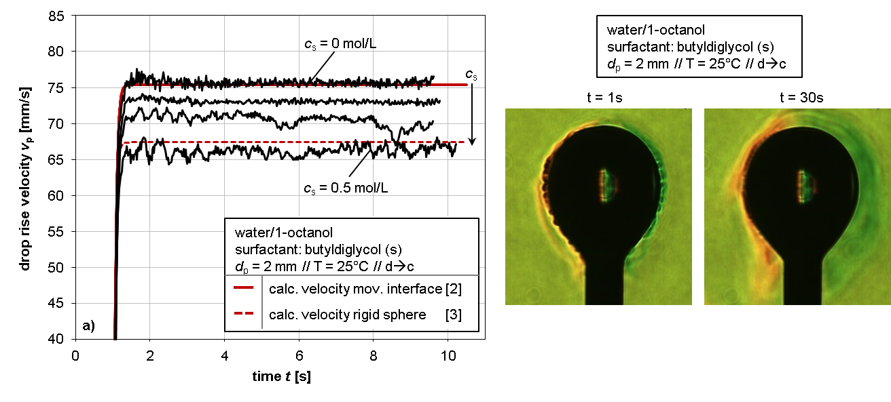
Figure 1. Left: Experimental drop rise velocity of 2 mm 1-Octanol droplets in water for varying surfactant concentration. Right: Concentration gradient field for mass transfer of model surfactant for different contact times visualized with Rainbow Schlieren Deflectometry.
Experimental results for the visualization of the instationary concentration gradient field of the surfactant butyldiglycol around a stagnant 1-octanol droplet in water are shown exemplary in Figure 1 (right) for different contact times. The different color values indicate differing values of concentration and result from the application of Rainbow Schlieren Deflectometry.
4. Conclusions
Fluid dynamic measurements and application of Rainbow Schlieren Deflectometry show great potential for a deeper insight into mass transfer processes and interfacial phenomena induced by surfactants and may lead to a better description of transport processes in multiphase systems.
References
- D. Merker, L. Böhm, M. Oßberger, P. Klüfers, M. Kraume, Chem. Eng. Technol., 2017, 40, 1391-1399.
- Z.-G. Feng, E. E. Michaelides, J. Fluids. Eng., 2001, 123, 841-849.
- H. Martin, Chem. Ing. Techn., 1980, 52, 199-200.

