Performances of a Compact Static Mixer for Turbulent Flows in Pipelines
Alessandro Paglianti¹, Francesco Maluta¹, Giuseppina Montante²
1 DICAM – Università di Bologna, via Terracini 34, 40131 Bologna, Italy; 2 CHIMIND – Università di Bologna, via Terracini 34, 40131 Bologna, Italy
*Corresponding author: giuseppina.montante@unibo.it
Highlights
- Good mixing with limited energy requirements is achieved by a very compact static mixer.
- Enhancement of blending is ensured without modification in existing pipelines.
- Effective mixing with limited space requirement helps continuous process intensification.

1. Introduction
Static mixers for turbulent flows are adopted in several industrial operations, ranging from synthesis of pharmaceuticals [1], to mass transfer in bioreactors [2], emulsification [3] and heat transfer [4], just to mention a few examples. In this work, the mixing performances and the energy requirements of a novel static mixer, whose main characteristics with respect to other traditional designs are the easiness of the installation and a very compact geometry, are investigated by Computational Fluid Dynamics (CFD). The validation of the computational results based on the comparison with experimental pressure drops and tracer homogenization data is presented. The investigation can be easily extended to any industrial application, for the preliminary identification of the most effective geometrical and operating conditions for achieving the desired production target.
2. Methods
The velocity flow field, the pressure drops and the pipe length required to achieve the blending of two miscible liquid streams are obtained by the numerical solution of the Reynolds-Averaged conservation equations of mass, momentum and scalar concentration for incompressible, isothermal and steady-state flow of Newtonian liquids. The Reynolds stress and the Reynolds flux terms are modelled using the eddy viscosity and the eddy diffusivity hypotheses, respectively. The computational domain consists of a pipe of diameter, D, equal to 90 mm and length, L, equal to 10×D placed horizontally and equipped with one compact static mixer element of the TWIN-P series designed by Pittaluga s.r.l. It is a very compact static mixer, being its width, W, equal to D/7, consisting of six 45° pitched blades fixed to the external surface of a Venturi section. Blending is ensured by a double-mechanism, due to the combined action of the blades and of the Venturi section, and is particularly suitable for treating streams of very different flowrates. The domain discretization is performed through an unstructured grid consisting of about 4.3×10⁶ cells. The grid effect on the mean velocity field, on the turbulent variables and on the degree of homogenization is also considered. The simulations replicate a parallel experimental investigation, considering different flow rates of the main liquid water stream, Q, varying from 4 to 35 m³/h and a single flow rate of the secondary stream, Q_{s}, that is an aqueous solution of Rhodamine of 10 L/h. The pressure drops and tracer concentration data adopted as a benchmark for the simulation results are measured by pressure transducers and Planar Laser Induced Fluorescence (PLIF), respectively, placing the static mixer in a test rig consisting of a 7 m long plexiglass pipe, a storage tank and a centrifugal pump.
3. Results and discussion
The energy requirements and the mixing performances of the TWIN-P static mixer are shown in Figure 1, by means of the parameter K at different water flow rates and of the Coefficient of Variation (CoV) of the Rhodamine concentration along the pipe axis. The K value is defined as:
$K=∆P/\left(\frac{1}{2}ρV_{s}^{2}\right)$ (1)
where ΔP is the absolute pressure difference across the mixer, ρ is the fluid density and V_{s} is the fluid superficial velocity. The CoV at selected pipe cross sections is calculated as:
$CoV=\sqrt{\frac{\sum_{i=1}^{N}{{\left(C_{i}-C_{mean}\right)}^{2}}}{N-1}}\frac{1}{C_{mean}}$ (2)
where c_{i} is local Rhodamine concentration at the i-th evaluation point, c_{mean} is the mean concentration on the cross section, N is number of evaluation positions at the cross section.
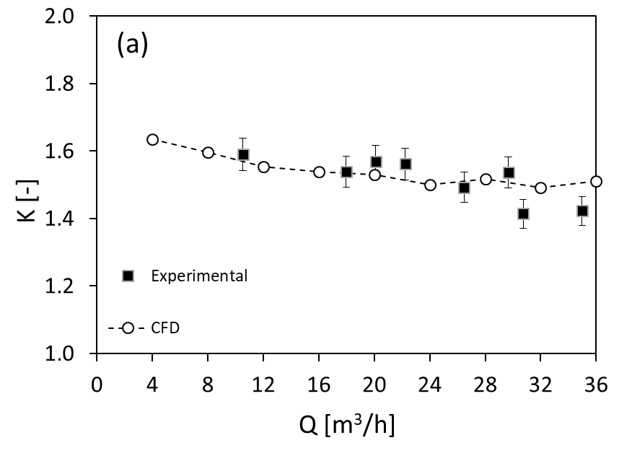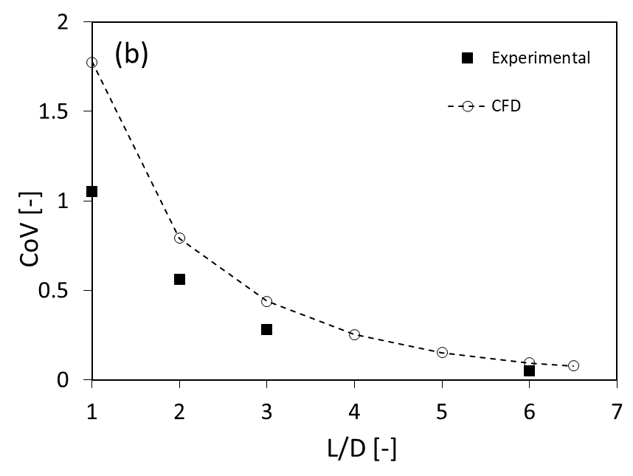
Figure 1. Comparison of CFD and experimental results. (a) K vs Q; (b) CoV at different cross sections downstream the mixer outlet section, Q=20 m³/h.

Based on the experimental data and the comparison with the performances of other static mixers for similar applications⁵, the investigated TWIN-P static mixer is found to ensure low pressure drops and good mixing performances. The CFD results fairly agree with the experiments. As a result, the fully predictive three-dimensional CFD modelling approach considered in this work is confirmed an industrially viable and reliable method for turbulent static mixing design and optimization.
References
- C. Brechtelsbauer, F. Ricard, Organic Process Research and Development 5 (2001) 646-651.
- C.U. Ugwu, J.C. Ogbonna, H.Tanaka, Applied Microbiology and Biotechnology 58 (2002) 600-607.
- F. Theron, N.L, Sauze, Int. J. Multiphase Flow 37 (2011) 488-500.
- R. Rakoczy, S. Masiuk, M. Kordas, P. Gradzik, Chem. Eng. Proc. Proc. Int. 50 (2011) 959-969.
- S.M. Hosseini, K. Razzaghi, F. Shahraki, AIChE J. 65 (2019) 1126-1133.

