Ultrafiltration System Optimisation for Nuclear Decommissioning
Kyriacos Hadjidemetriou^{1,2}, Jay J. Dunsford², Genevieve Boshoff², Claudio P. Fonte¹, Thomas L. Rodgers¹.
1 School of Chemical Engineering and Analytical Science, The University of Manchester, UK.
2 National Nuclear Laboratory, Workington, UK.
Corresponding author: kyriacos.hadjidemetriou@postgrad.manchester.ac.uk
Highlights
- Ultrafiltration optimisation using modelling and experimental work.
- Ferric floc filtration properties in the ultrafiltration process.
- Effluent treatment in nuclear decommissioning.
- Fouling control and cleaning methods for UF tubular membranes.
1. Introduction
The decontamination process of waste radioactive effluent in the Enhanced Actinide Removal Plant (EARP) at the Sellafield Site (UK) has been operating for more than 20 years. The plant has successfully generated and separated ferric flocs with incorporated radioactive components produced from acidic feeds arising from upstream spent nuclear fuel reprocessing plants. The EARP treatment process focuses on the chemical precipitation (CP) of ferric floc and an ultrafiltration (UF) process, in which separation of ferric floc is achieved in a two dewatering stage process ^{[1]}.
UF technology performance and longevity are affected by the fouling deposition on the surface and inside the pores of the membrane. The development of a UF rig will be used for experimental work on the separation of flocs and the validation of the computational models ^{[2]}.
2. Methods
Computational modelling work to build the 1D and CFD models has been utilised to predict the UF rig system performance under various operating conditions. The Darcy’s law and the Poiseuille model for calculating the permeability coefficient were incorporated in the equations to build the 1D model across a tubular metallic membrane, as well as the friction factor for the loss of pressure through the membrane ^{[3]}.
$$J_{M}=\frac{K∆P_{TM}}{μδ}$$ | (1) | $$K=\frac{d_{0}^{2}ε}{32}$$ | (2)
The laminar interface for the laminar flow and the k-epsilon model for the turbulent flow were used on building the 2D CFD model of the membrane. The experimental data from the developed UF system will be used to validate and improve the 1D and CFD model and the fouling resistance effects. The average pore diameter, $d_{0}$, and the porosity of the membrane, $ε$, were measured by using ESEM and porosimetry analysis- Porolux 1000.
3. Results and Discussions
The CFD results show the fluid behaviour inside the membrane and the fluid pulsations happening at the inlet of the membrane due to the pipe - membrane different diameter and the extra shear stresses being caused at the inlet of the membrane and the high fluid velocity, Figure 1.
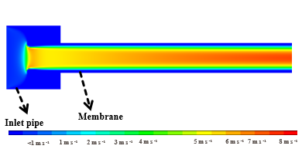 | 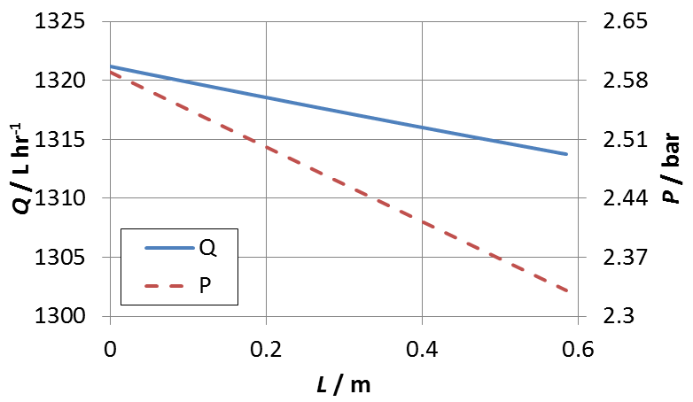
Figure 1: Velocity results of the fluid behaviour in the UF membrane. | Figure 2: Volumetric flowrate and pressure across the membrane.
A 1D model is generated based on equation 1 and 2 using the experimental measurements of pore size and porosity and checked with the CFD model. Figure 2 shows the volumetric flowrate reduction along the membrane as permeate is generated and the pressure drop along the membrane. Table 1 compares the predictions of this 1D model with the obtained experimental data for the pressure drop and the total percentage of the inlet flow as permeate generation across the membrane.
Table 1: Pressure loss through membrane and permeate generation comparison of the 1D model and experimental data.
 | 1D Model | Experiment
Pressure Loss: | 0.26 bar | 0.26 bar
Total % as permeate generation: | 0.56% | 0.50%

4. Conclusions
Initial 1D and CFD models share similar results with the experimental data obtained from the UF system. The two models can predict the flux generation across the membrane, the volumetric flowrate and the pressure differences in the presence of membrane resistances. Further experimental work on the UF rig can potentially prepare fouling control and cleaning methods to reduce the fouling build-up in the system and improve the membrane longevity.
References
1. Weatherill, J., Iron Oxyhydroxide Formation in the Enhanced Actinide Removal Plant. 2018, The University of Manchester p. 245.
2. K. Wang, L., et al., Membrane and Desalination Technologies. 2011.
3. Nagy, E., 7 - Transport of Fluid Phase in a Capillary Membrane, in Basic Equations of the Mass Transport through a Membrane Layer, E. Nagy, Editor. 2012, Elsevier: Oxford. p. 177-192.

