Nanocellulose explosions: influence of the agglomeration and turbulence on the combustion rate-limiting step and flame propagation
Audrey Santandrea¹, Marine Gavard¹, Stéphanie Pacault¹, Alexis Vignes², Laurent Perrin¹, Olivier Dufaud^{1,}*
1 Laboratoire Réactions et Génie des Procédés, Université de Lorraine, CNRS, LRGP, F-54000 Nancy, France
2 INERIS, Parc Technologique ALATA, BP 2, F-60550, Verneuil-en-Halatte, France
*Corresponding author: olivier.dufaud@univ-lorraine.fr
Highlights
- Great influence of agglomeration on the rate-limiting step of the combustion
- Consideration of the whole reactive surface area when evaluating explosivity
- Estimation of an unstretched burning velocity for nanocellulose

1. Introduction
Dust explosion risk assessment is relatively well established for micron-sized particles and requires the determination of key safety parameters representing the ignition sensitivity and explosion severity of the dust. When considering nanoparticles, the particle size distribution (PSD) is more likely to vary during the injection process, due to both the agglomeration phenomenon inherent to strong interactions and the fragmentation phenomenon due to flow shear stresses. As a consequence, safety parameters and their determination methods can differ significantly from micro to nanopowders. A peculiar attention has then to be given to the cloud characteristics (PSD, turbulence), more precisely at the exact moment of ignition. This work focuses on nanocellulose and aims at evaluating the influence of the agglomeration phenomenon and flow turbulence on the dust combustion. Flame propagation tests were performed to evaluate the unstretched burning velocity and explosions tests were carried out to estimate the combustion mechanisms involved.
2. Methods
A nanocellulose powder (NCC - CelluForce), with a specific surface area of 400 m².g⁻¹ and primary fiber dimensions of 3 nm width and an average length of 70 nm, was chosen for this study. The powder was mechanically pressed and then coarsely ground to form agglomerates. In addition to the pure nanocellulose, two ranges of agglomerate diameters were chosen in order to highlight the influence of particle agglomeration on dust explosion: 30-180 µm and 180-450 µm. Explosion tests were performed in a standard 20L sphere according to EN 14034-1 & -2 [1] and the combustion gases were collected and analysed by gas chromatography. The burning velocity was estimated by filming the flame propagation within a semi-opened tube and the flame stretching was analysed. In both the tube and the 20L sphere, the PSD was measured during the dispersion using in situ laser particle size measurement and the turbulence level was obtained using Particle Image Velocimetry.
3. Results and discussion
Dispersion and explosion tests were performed for the three samples to estimate the evolution of the PSD during the injection and its influence on the explosion severity. It appears that the maximum rate of pressure rise significantly decreases when the agglomerate size increases, whereas the maximum explosion pressure is less sensitive to the variation of PSD. Indeed, the particle size has a direct influence on the rate-limiting step, as the combustion can be controlled by surface reaction (small particles) or by the diffusion to the surface (agglomerates). By controlling the agglomerate size, it is then possible to highlight both limitations and their effects. Chromatographic analyzes performed on the gases collected after the combustion of nanocellulose (mainly CO₂, CO, H₂, CH₄, C₂H₄, N₂ and O₂) show that, when increasing the dust concentration, the remaining oxygen content decreases slower for a diffusion-controlled reaction than for a surface-controlled one. It also appears that if the representation of the explosion severity is very commonly done as a function of the mass concentration, considering the whole reactive surface area of the dust cloud leads to agreement when the explosion kinetics is controlled by a surface reaction.
Among their specific properties, nanoparticles exhibit low sedimentation rates. This particularity allows tests at a low turbulence and can lead to an estimation of the unstretched burning velocity, which is an intrinsic parameter of the mixture. By varying the ignition delay time t_{v} during the tests, the turbulence is modified and thus the flame stretching. Figure 1 shows the flame 20 ms after ignition for different ignition delay times. By increasing the latter, the turbulence decreases and the flame becomes smoother and similar to gases explosion (parabolic profile – Fig 1c). The spatial flame velocity was determined considering the flame kernel growth before the interactions with the walls, and an unstretched burning velocity of around 12 cm.s⁻¹ was determined for nanocellulose using the linear relation between the burning velocity and the Karlovitz factor [2].
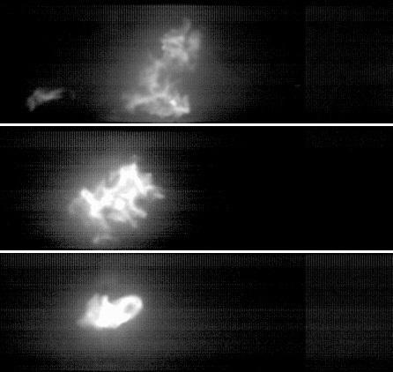
c)
b)
a)
Figure 1. Flame propagation images 20 ms after inflammation for a) tv = 135 ms, b) 220 ms, c) 340 ms
4. Conclusions
Nanopowders tends to be naturally agglomerated. The size of their agglomerate depends on the turbulence of the dust cloud and plays a role on their combustion kinetics and thus on their explosion severity. Controlling these parameters and choosing the right parameter to represent the PSD helps to ensure a reliable explosion risk assessment. Finally, tests are currently performed to highlight the influence of dust agglomeration on the unstretched burning velocity of nanocellulose.
References
- EN 14034-1&2, Determination of explosion characteristics of dust clouds, Eur. Com. for Standard., 2011.
- G.H. Markstein, Non-steady Flame Propagation, Pergamon Press, Oxford, 1964.

