Correlation of Powder Performance on Rotary Tablet Presses and Standardized Methods for Flowability
Maren Zimmermann, Kalaiarasi Sathiyaseelan, Markus Thommes
TU Dortmund, Laboratory of Solids Process Engineering, Emil-Figge-Str. 68, 44227 Dortmund, Germany
*Corresponding author: maren.zimmermann@tu-dortmund.de
Highlights
- A quantitative classification of flowability is possible with a ring shear cell.
- The ff_{c} value correlates with the flow rate through a feed frame.
- Mass flow through a funnel does not predict powder performance on rotary tablet presses.

1. Introduction
In tablet manufacturing powder flow is frequently the rate limiting step as it directly influences several product quality attributes [1]. An insufficient powder flow may cause variations in tablet weight and dose which have to be minimized due to high quality requirements according to legal binding guidelines (e.g. European Pharmacopeia) [2]. Most rotary tablet presses contains feed frames consisting of rotating paddles in order to overcome challenges in powder flow. For the measurement of powder flowability various methods are known which are standardized to ensure comparability. These measurement procedures are used to qualitatively rank powder flowability and rather investigate the performance of powder in tablet manufacturing [3]. The aim of this study is the investigation of the correlation between flow behavior in a rotary tablet press and standardized measurement procedures for the evaluation of powder flowability.
2. Methods
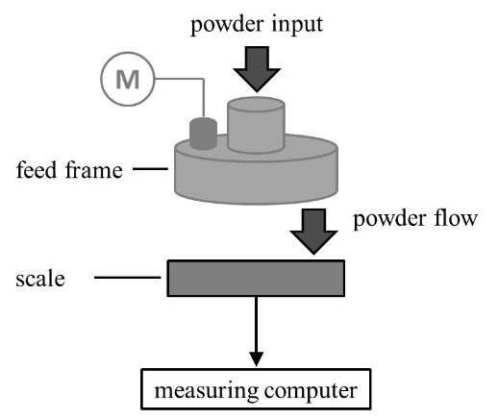
Figure 1. Schematic of the experimental set-up to determine the flow rate through a feed frame
Powder flow experiments were conducted on a feed frame (Fill-O-Matic, Fette Compacting, Schwarzenbek, Germany). The flow rate was measured on an external scale (MSA20201S-000-D0, Sartorius, Göttingen, Germany) (Figure 1). A ring-shear cell (RST-01, Dr.-Ing. D. Schulze Schüttgutmesstechnik, Wolfenbüttel, Germany) with a predefined shear stress (σ = 1000 Pa) was used to determine powder flowability. Flowability was also specified via the tap density (Tap density tester TD1, Sotax, Aesch, Switzerland), the angle of repose and the flow rate through a funnel (Powder flow tester PF1, Sotax, Aesch, Switzerland).
Three powders were chosen as model substances due to their different flowability. Lactose monohydrate (GranuLac 200, Meggle Pharma, Wasserburg, Germany) is the most cohesive powder. Microcrystalline cellulose (Emcocel 90M, JRS Pharma, Rosenberg, Germany) and dicalcium phosphate anhydrate (DI-CAFOS A150, Chemische Fabrik Budenheim, Budenheim, Germany) show a higher powder flow.
3. Results and Discussion
The results of the measurements with the ring shear cell (ff_{c}) are in the expected order: Di-Cafos A150 offers a high flowability due to a high and regular particle size (${\text{d}}_{\text{50}}\text{=181 µm}$). GranuLac 200 is a cohesive powder (${\text{d}}_{\text{50}}\text{=37 µm}$) and it consequently features low flowability. A similar order is found by determining powder flowability via the angle of repose α and the Hausner Ratio (HR). Contrary, the results of the mass flow through a funnel do not meet the expectations. The mass flow of Emcocel 90M is the smallest one, although the powder is less cohesive than GranuLac 200. This method should represent powder flow best, as it considers particle-related as well as dynamic process related factors [2]. By determining the powder flow rate through a feed frame of a rotary tablet press the same expected order can be measured as with the ring shear cell.
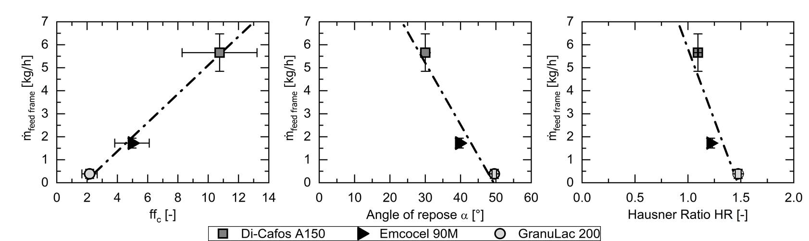
Figure 2. Correlation between powder flow rate through a feed frame (mean ± s, n = 10) and flowability index ff_{c} (mean ± s, n = 3), angle of repose α (mean ± s, n = 6) and Hausner Ratio (mean ± s, n = 6) of three model substances.
Correlation between mass flow rate through a rotary tablet press feed frame and values for flowability determined by standardized methods was proven (Figure 2). The characteristic coefficient of flowability ff_{c} is linearly dependent of the powder flow rate through the feed frame (coefficient of determination R² = 0.9938). Analyzing the angle of repose and the Hausner Ratio this correlation could not clearly be identified.
4. Conclusions
Powder flow rate through the feed frame of a rotary tablet press was investigated in order to determine a correlation with standardized methods. In comparison with the analyzed measurement methods the characteristic coefficient of flowability ff_{c} shows correlation with the mass flow from the feed frame best. Determining powder flowability by measuring the flow rate through an orifice even resulted in a different order.
References
- X. Xie, V.M. Puri, Part. Sci. Technol., 24 (2006) 411–426.
- European Pharmacopoeia Commission, European Pharmacopoeia, EDQM, Strasbourg (2019).
- A. Zettler, et al., J. Pharm. Innov., 11 (2016) 189-199.

