Selftuning adaptive control for convective drying of particulate solids
Robert Dürr^{1,*}, Carsten Seidel², Christoph Neugebauer², Andreas Bück³
1 MPI for Dynamics of Complex Technical Systems, Sandtorstraße 1, D-39106 Magdeburg, Germany;
2 Otto von Guericke University, Universitätsplatz 2, D-39106 Magdeburg, Germany;
3 Friedrich Alexander University, Cauerstraße 4, D-91058 Erlangen, Germany;
*Corresponding author: duerr@mpi-magdeburg.mpg.de
Highlights
- Convective drying of particulate solids
- Model-based controller design
- Automatic adaption of controller parameters
- Guaranteed product quality under varying drying conditions

1. Introduction
Drying, the removal of a liquid from a solid material represents one of the most important operations in the chemical, pharmaceutical and food industries. Besides mechanical liquid removal, thermal drying is extensively applied: Here, a moist solid is heated resulting in subsequent phase change of the liquid into vapor and removal of the vapor from the solid. Thermal dryers are usually categorized by the respective method of heat supply, e.g. contact dryers and convective dryers. Considering the latter, characteristic evaporation rates depend on the moisture content as seen in Fig. 1. Within the second drying phase evaporation rates result from an complex interplay of thermal and moisture fields in the particle [1]. This coupling can be described by the concept of normalized drying curves. Given experimental data, such a curve can be fitted and used for further model-based control design and process intensification. However, such an appropriately designed controller may not be able to keep the desired quality of the product, e.g. moisture content of the dried solid, in presence of external influences like seasonal or local variations in the properties wet solid. Such deviations come along with unforeseen variations of the drying kinetics, i.e. shape variations of the normalized drying curve, and manifest for example in over-/underdrying of the product as well as on-set of unwanted reactions. As an alternative to robust control design techniques which use a fixed controller in order to cope with the described variations [2], adaptive controllers employing online-tuning can be applied to guarantee the desired product specifications [3].
2. Methods
Within this contribution convective conveyor belt drying of baker’s yeast is considered which can be described by a set of nonlinear ordinary differential equations [2]. To cope with variations in the drying conditions a self-tuning adaptive controller is applied. Its basic structure is seen in Fig. 1: An approximate simple model of the process is identified online from process measurements via recursive least-squares estimation. The simplified model is used for adaption of the parameters of

the controller which is applied to the complex process . This procedure is also known as adaptive pole-placement.
3. Results and discussion
The selftuning regulator’s performance is validated in a parametric study for several scenarios, including uncertainty of the shape of the normalized drying curve as well as disturbances of the solids and gas inlet temperature. The adaptive controller is applied to the nonlinear process and compared to the performance of a nominal PI-controller with fixed tuning parameters. The simulation results in Fig. 1 indicate that the latter is outperformed by the adaptive controller.

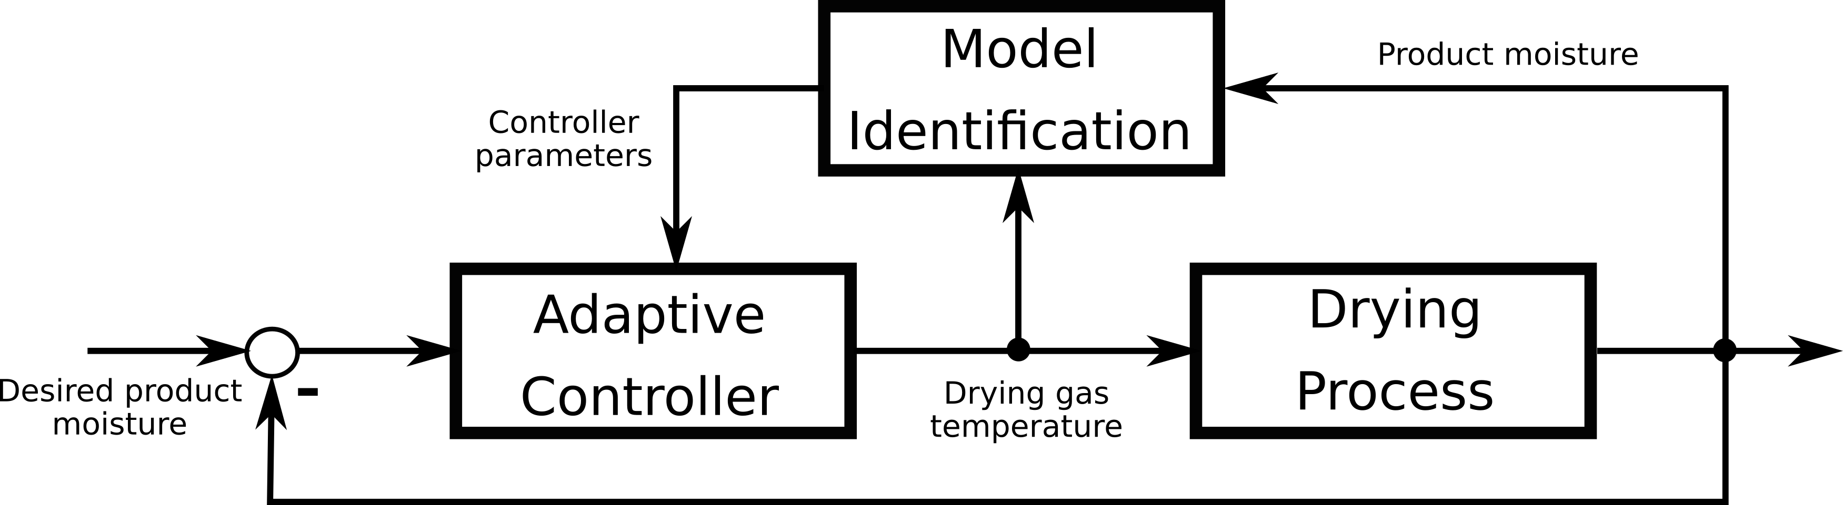
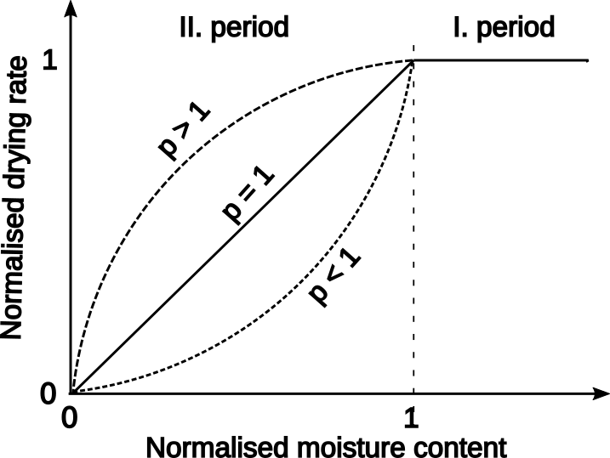

Figure 1. Normalized drying curve (left) and applied adaptive controller structure (right)
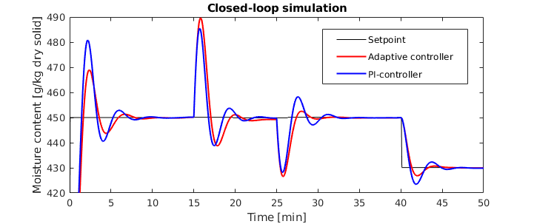
Figure 2. Simulation results adaptive controller and PI-controller for non-nominal process conditions: Disturbance in the gas inlet moisture content (t>15min) and solids inlets moisture content (t>25min)
4. Conclusions
The presented results indicate that the presented self-tuning controller represents a suitable method for control of convective drying processes under unforeseen changes in the material’s drying characteristics.
References
- van Meel, D., Chem. Eng. Sci. 9 (1958) 36-44.
- Bück, A., Seidel, C., Dürr, R., Neugebauer, C., J. Proc. Contr. 69 (2018) 86-96.
- K.J. Åström, B. Wittenmark, Adaptive Control, 2008.

