**Kinetics and mass transfer for biomass reductive catalytic fractionation**

Alexei Kramarenko, John van der Schaaf, *Fernanda Neira d’Angelo*\*

*Eindhoven University of Technology*

*\* M.F.Neira.dAngelo@tue.nl*

**Highlights**

* Biomass reductive catalytic fractionation is studied in a flowthrough reactor
* A kinetic model that successfully fits the experimental data is proposed
* The different reaction steps are studied step-wise by using both native lignocellulose as well as monomer model compounds

1. **Introduction**

Lignin is one of the main components of biomass, together with cellulose and hemicellulose. Despite its rich chemical structure and high aromatic content, it is the most underutilized fraction of biomass. This is due to the severe degradation of lignin during biomass fractionation. Innovative fractionation approaches such as reductive catalytic fractionation (RCF) enable the valorization of lignin by preserving the native structure of lignin. For optimal results during RCF (i.e., maximal yields of lignin-monomers), the RCF reactor should allow for a well-tuned balance between the following reaction steps: 1) lignin extraction from the biomass feedstock and depolymerization using liquid solvents (i.e., a solid-liquid process); and 2) immediate stabilization of lignin monomers using solid catalyst (i.e., a gas-liquid-solid process). Despite the promising results reported so far on RCF, understanding the dynamics of such complex multiphase system is very limited. By following a step-wise approach, we investigate the kinetics of the separate steps using lignocellulosic biomass and lignin-monomer model compounds. Integration of this kinetic information with multiphase transport rates, we propose a reactor model that can successfully predict product yield and product distribution as a function of various reaction parameters. Special emphasis is put on the effect of internal/external mass transfer under different operating conditions.

**2. Methods**

Experiments were carried out in a gas-liquid-solid fixed bed reactor containing a biomass bed and a metallic supported catalyst (Pd/C). The reactor was fed with cocurrent flows of hydrogen and liquid solvent. The studied experimental variables were: reaction temperature, catalyst weight, biomass particle size, residence time and gas/liquid flow ratio. The reaction samples were analyzed using HPLC, GC, GPC and NMR respectively. An heterogeneous 1-D steady state model of the reactor was built in MATLAB accounting for reaction kinetics and mass transfer between the different phases.

**3. Results and discussion**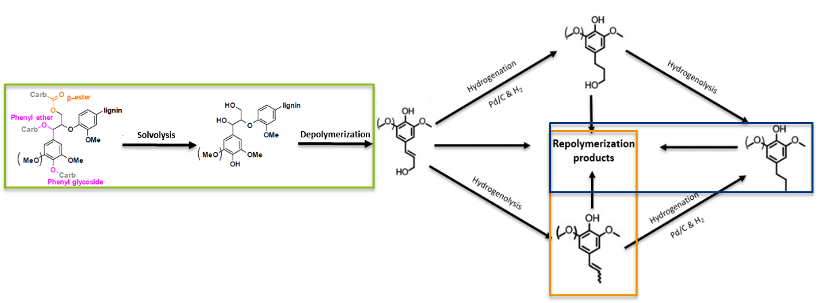

Figure 1: RCF reaction mechanism and experimental results corresponding to reactions (plot series colors match respective color boxes in the mechanism scheme)

**4. Conclusions**

This work provides a crucial understanding of the reaction mechanism. Kinetic parameters have been successfully extracted for the different steps of the complex reaction scheme, as well as relevant insights in the different mass transfer steps involved. The reactor model can successfully predict the experimental data, constituting a powerful tool for further process optimization

**References**

[1] [T. Renders](https://pubs.rsc.org/en/results?searchtext=Author%3AT.%20Renders), a  [E. Cooreman](https://pubs.rsc.org/en/results?searchtext=Author%3AE.%20Cooreman), [B. F. Sels](https://pubs.rsc.org/en/results?searchtext=Author%3AB.%20F.%20Sels), 2018. Catalytic lignocellulose biorefining in n-butanol/water: a one pot approach toward phenolics, polyols, and cellulose. Green Chem. 20, 4607-4619

[2] J. Zakzeski, P. Bruijnincx, A. Jongerius, B. Weckhuysen, 2010. The Catalytic Valorization of Lignin for the Production of Renewable Chemicals. *Chem. Rev.* 110 (6), pp 3552–35