Removal of the imidacloprid pesticide from water samples using supported ionic liquids (SILPs) as adsorbents
Sandra C. Bernardo¹*, Maria João Santos¹, Márcia C. Neves¹, Mara G. Freire¹
1 CICECO-Aveiro Institute of Materials, Department of Chemistry, University of Aveiro, Aveiro, Portugal.
*Corresponding author: sandrabernardo@ua.pt
Highlights
- Removal of pesticides from aqueous solutions.
- Supported ionic liquids (SILPs) for solid-phase extraction (SPE).

1. Introduction
Due to the continuous growth of population and related anthropogenic activities, many toxic compounds are released and are reaching the environment [1]. A common type of these pollutants, are pesticides, which include herbicides, fungicides and insecticides. Pesticides comprise a wide group of chemical compounds, ranging from organo-phosphates, carbamates, to pyrethroids [2]. They are widely used to prevent crops destruction and to increase the agriculture productivity, leading to their accumulation in the food chain and to the contamination of air, water and soil [2]. According to the EU Directive on water quality [3], the maximum allowed concentration for pesticides in water is 0.1 µg/L for individual compounds and 0.5 µg/L for total pesticides. In general, pesticides tend to be environmentally persistent, thereby increasing the probability of exposure by non-target organisms [4]. Thus, a particular area of interest is on effective alternatives for environmental treatment of wastewater and groundwater supplies [1]. In recent years, a variety of methods including biodegradation, photodegradation, chemical precipitation, hydrolysis, oxidative degradation, ion exchange, flocculation, neutralization, membrane separation, ultrafiltration, and adsorption strategies have been applied for the treatment of pesticides from wastewaters [5].
Recently, supported ionic liquids (SILPs) have been described as an alternative adsorbent material for solid-phase extraction [6]. Ionic liquids (ILs) are organic salts, which by definition present a melting point below 100°C. Among other interesting features, one of their most relevant characteristics is their tunability. ILs can be designed to present a set of particular characteristics by changing the cation/anion chemical structure – a property that is transferred to SILPs. Based on these advantages, herein we propose the development of a more efficient and economical alternative technique for the removal of pesticides from water using SILPs.
Several supported ionic liquids (SILPs) silica-based materials were synthesized and characterized. Kinetic and equilibrium experimental data were obtained, and models were fitted for imidacloprid, a systemic neural toxic insecticide [4], used here as a model pesticide.
2. Methods
The synthesis of SILPs was previously described [7]. Briefly, commercial silica gel was used as the starting material for SILPs synthesis. In the first step, activated silica particles react with 3-chloropropyl-methoxysilane, in order to obtain chloropropyl silica (SilprCl). Then, SilprCl material reacts with 1-methylimidazole or other reagents as the source of the cation (see Figure 1). Several techniques were used to characterize these materials. The adsorption kinetics and isotherms of each prepared SILP for imidacloprid were determined at 25°C.
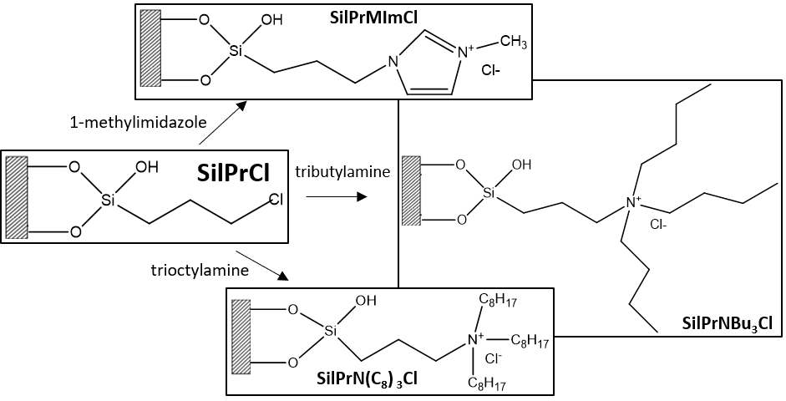
Figure 1. Schematic representation of the prepared SILPs and reagents used as source of the cation.
3. Results and discussion
Adsorption experiments were carried out, including studies of the adsorption kinetics and adsorption isotherms for the prepared materials for imidacloprid. It was found that when using the SilPrNBu₃Cl material the adsorption of imidacloprid is fast (less than 10 min in equilibrium), reaching values of the equilibrium concentration of adsorbate in the solid phase (q_{e}) of 0.027 mmol.g⁻¹.
4. Conclusions
The prepared SILPs show promising results for the removal of imidacloprid from aqueous solutions with high adsorption efficiencies. The best identified SILPs are being tested for the removal of other pesticides from aqueous media, as well as the materials reuse.
Acknowledgments
This work was developed within the scope of the project CICECO-Aveiro Institute of Materials, FCT Ref. UID/CTM/50011/2019, financed by national funds through the FCT/MCTES. This work was developed in the scope of the “Smart Green Homes” Project [POCI‐01‐0247‐FEDER‐007678], a co‐promotion between Bosch Termotecnologia S.A. and the University of Aveiro. It is financed by Portugal 2020 under the Competitiveness an Internationalization Operational Program, and by the European Regional Development Fund.
References
- Hussain, C. M. & Kharisov, B. Advanced Environmental Analysis, Applications of Nanomaterials. 1, (The Royal Society of Chemistry, 2016).
- Kaur, R. et al. Synthesis and surface engineering of magnetic nanoparticles for environmental cleanup and pesticide residue analysis: A review. J. Sep. Sci. 2014, 37, 1805–1825 (2014).
- European Commission. Directive 2013/39/EU of the European Parliament and of the Council amending Directives 2000/60/EC and 2008/105/EC as regards priority substances in the field of water policy. (2013).
- Federoff, N. E., Vaughan, A. & Barrett, M. R. Environmental Fate and Effects Division Problem Formulation for the Registration Review of Imidacloprid. (2008).
- Wang, T. et al. Adsorption of agricultural wastewater contaminated with antibiotics, pesticides and toxic metals by functionalized magnetic nanoparticles. J. Environ. Chem. Eng. 6, 6468–6478 (2018).
- Fontanals, N., Ronka, S., Borrull, F., Trochimczuk, A. W. & Marcé, R. M. Supported imidazolium ionic liquid phases: A new material for solid-phase extraction. Talanta 80, 250–256 (2009).
- Yang, F. et al. Magnetic microsphere confined ionic liquid as a novel sorbent for the determination of chlorophenols in environmental water samples by liquid chromatography. J. Environ. Monit. 13, 440–445 (2011).

