High-throughput droplet-based platform for studying nucleation
Elena C. dos Santos, Giovanni M. Maggioni and Marco Mazzotti
Institute of Process Engineering, ETH Zurich, 8092 Zurich, Switzerland
edossantos@ipe.mavt.ethz.ch
Highlights
- Droplet-based microfluidics
- Stochasticity of primary nucleation
- Effect of shear rate on nucleation
- Nucleation rates estimation and uncertainty propagation.

1. Introduction
Nucleation, the very early stage of crystallization processes, is of fundamental importance on defining crystal properties such as purity, size distribution and polymorphism ^{[1]}. It is well established that nucleation is a stochastic phenomenon ^{[2-3]}, which imposes challenges to obtaining reproducible experimental data. Thus, numerous identical experiments are essential to correctly estimating primary nucleation kinetics. In this context, droplet-based microfluidics offers, not only good control of transport phenomena (enhanced mass and heat transfer), little or no gravity effect, and few impurities, but also, the ability of generating thousands of nanodroplets in a nearly monodisperse fashion. Such a high-throughput technique enables to probe a considerable number of identical discrete crystallizers, necessary to build representative statistics. Nevertheless, the error committed by not sampling the entire population (finite sampling) will invariably exist. The magnitude of this stochastic uncertainty depends solely on the number of samples and on the chosen confidence interval. Such an uncertainty needs to be quantified, firstly, as a criterium for guaranteeing randomness of the process and secondly to be properly propagated to the parameters to be estimated, e.g., nucleation rate. The nucleation rate is the number of nuclei formed per unit time and volume at a given supersaturation. The latter can be regarded as the difference in chemical potential between the supersaturated and equilibrium states of the compound in solution, i.e., the driving force of the nucleation process. However recently, a few studies have discussed that shear promotes the aggregation of meso-scale clusters into stable clusters, so that nucleation proceeds via a two-step mechanism ^{[4-5]}. Despite the number of studies, the exact mechanism controlling nucleation under fluid dynamic conditions is still unclear.

2. Methods
We used PEEK T-junctions followed by translucent FEP tubes to study crystallization in droplets under flow conditions at different droplet velocities. The experimental set-up consists of three main parts. Firstly, in the generation zone (GZ), immiscible fluids were fed with syringe pumps into a PEEK T-junction, where droplets were formed. These components were placed inside a temperature-controlled incubator to maintain solutions at the desired dissolved state. After been formed, droplets flow to the crystallization zone (CZ), which consists of a certain length of FEP tube placed in a cold-water bath. Due to the supersaturation created by reducing the system temperature, a number of droplets crystallizes while travelling along the tube depending on the tube length, which was varied in order to probe different nucleation residence times. Finally, droplets moved to the observation zone (OZ), where the FEP tube was placed under a light microscope, to monitor through image acquisition whether droplets have crystallized, thus enabling building nucleation statistics.
3. Results and discussion
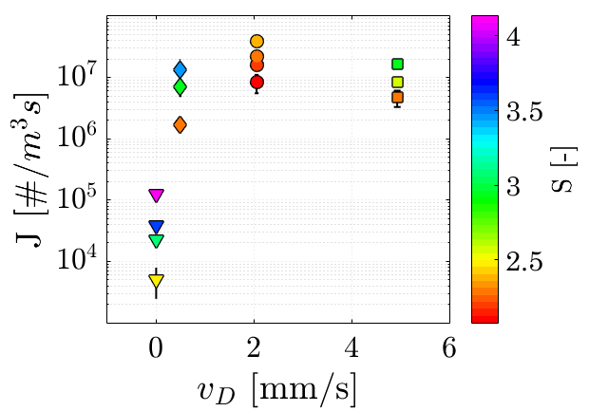
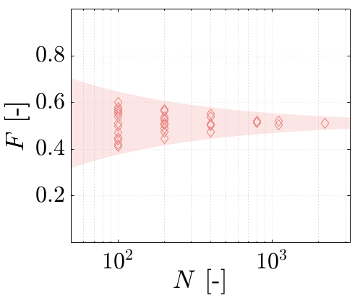
For each single experiment, we have assessed its internal consistency via statistical analysis based on slicing the population of droplets, e.g., comprising of about 3000 droplets, in smaller subgroups. In Fig. 1, we show this procedure and plot both the experimental probability values as a function of the number of droplets, and the uncertainty band. The spread in probability values towards lower number of droplets shows repeatedly strong consistency, and hence, this variability is entirely due to stochasticity. In Fig. 2, values of nucleation rates estimated via the linearized form of the cumulative exponential distribution function are plotted with their corresponding confidence intervals obtained through the propagation of the uncertainties in nucleation probability. In this figure, we observe an increase in nucleation rate of about 3 orders of magnitude in respect to the stagnant situation. Such a high difference can be associated with the recirculation flow patterns, generated inside the droplets at flowing conditions. The latter may favor nucleation via aggregation of pre-clusters by enhancing particle collision, but at the same time may hinder nucleation by reducing contact and bridging time.

Figure 2. Probability points of single experiments sliced in smaller number of droplets.
Figure 1. Probability points of single experiments sliced in smaller number of droplets.

4. Conclusions
We estimated primary nucleation kinetics from large number of nanodroplets in varying fluid dynamic conditions. Making use of statistical tools, we were able to assess the statistical representability of the experimental data and to estimate their inherent uncertainty. Finally, we showed that nucleation rates increase non-monotonically with droplet velocity, possibly because there exists an interplay among the effects of energy dissipation due to mixing on clusters’ agglomeration.
Acknowledgements: This project has received funding from the European Research Council (ERC) under the European Union's Horizon 2020 research and innovation programme under grant agreement No 2-73959-18.
References
- H. H. Tung, Org. Process Res. Dev. 17 (2013) 445-454.
- G. Capellades, et. al, Cryst. Growth Des. 17 (2017) 3287-3294.
- G. M. Maggioni, L. Bosetti, E. C. dos Santos, M. Mazzotti, Cryst. Growth Des. 17 (2017) 2852-2863.
- A. Jawor Baczynska, J. Sefcik, B. D. Moore, Cryst. Growth Des. 13 (2012) 470-478.
- J. Liu, A. C. Rasmuson, Cryst. Growth Des. 13 (2013) 4385-4394.

