Controlled Manipulation of Size and Shape of Needle-like Compounds Using Wet-Milling
Ashwin Kumar Rajagopalan¹, Stefan Bötschi¹, Manfred Morari², Marco Mazzotti^{1*}
1 Institute of Process Engineering, ETH Zurich , 8092 Zurich, Switzerland; 2 Department of Electrical and Systems Engineering, University of Pennsylvania, Philadelphia 19104, United States
*Corresponding author: marco.mazzotti@ipe.mavt.ethz.ch
Highlights
- Manipulation of size and shape of needle-like compounds using wet-mill as actuator.
- Model-based operating policy is unable to guide arbitrary seed populations to targets.
- Incorporation of feedback action is key for robust performance of milling stage.

1. Introduction
In a crystallization process, the particle size and shape influences various downstream operations. The majority of the crystallization literature deals with manipulation of only the size of the crystals. Thanks to the recent advances in particle size and shape monitoring techniques, particles can be better characterized using multiple dimensions [1]. Even though the available literature on feedback control with the aim to manipulate particle size and shape is limited, model-based and model-free feedback controllers have been proposed recently using temperature as a control actuator [2,3].
For needle-like compounds that exhibit small changes in the shape by using only temperature as an actuator, milling can be a suitable alternative. In this work, several operating and control strategies are proposed, all of them using an ex situ wet mill as the control actuator, with the aim to guide various seed populations to different targets in the size and shape plane.
2. Methods
One model-based operating policy and several feedback control strategies were designed and tested in a lab-scale experimental setup. The setup consisted of an ex situ stereoscopic imaging device (for particle size and shape characterization), the µ-DISCO [1], an ex situ rotor-stator wet mill, and a control computer where the image analysis routines for the imaging device and the control strategies were implemented. The model-based operating strategy utilized a two-dimensional population balance model that describes the breakage phenomenon in the mill [4]. The proposed operating policy and control strategies were put to test using two model compounds, namely β L-glutamic acid (BLGA) and γ D-mannitol (GDM).
3. Results and discussion
Two different seed populations of BLGA and one seed population of GDM were milled to reach three different target average lengths in the particle size and shape plane. For the model-based operating policy, it was observed that the multidimensional breakage model was unable to predict the rotor speed that would enable reaching the desired targets for arbitrary batches of seed populations. These experiments highlighted the importance of introducing feedback action to overcome unmodeled phenomena and to counteract process disturbances.
Different feedback control strategies using online observations of the evolution of the average dimensions of the populations subjected to milling were designed and applied. These control strategies applied multiple consecutive milling stages with varying rotor speeds, which enabled reaching the targets robustly and irrespective of the seed population and model compound used (see Figure 1).
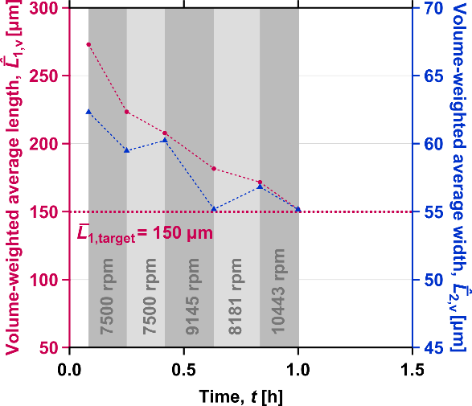
Figure 1. Time-resolved evolution of the measured volume-weighted average dimensions of BLGA seeds with a target average length of 150 µm. The shaded gray region indicates the milling stage with the corresponding rotor speeds.
4. Conclusions
Different operating and control strategies were exploited to manipulate the size and shape of needle-like particles using a wet mill as a control actuator. The control strategies that incorporated feedback action led to robust operation of the milling. Thus, the milling stage is ready to be integrated into complex processes, including crystal growth and fines removal by dissolution, to effectively manipulate the size and shape of needle-like compounds.
References
- Rajagopalan, A. K.; Schneeberger, J.; Salvatori, F.; Bötschi, S.; Ochsenbein, D. R.; Oswald, M. R.; Pollefeys, M.; Mazzotti, M. A Comprehensive Shape Analysis Pipeline for Stereoscopic Measurements of Particulate Populations in Suspension. Powder Technol. 2017, 321, 479–493.
- Eisenschmidt, H.; Bajcinca, N.; Sundmacher, K. Optimal Control of Crystal Shapes in Batch Crystallization Experiments by Growth-Dissolution Cycles. Cryst. Growth Des. 2016, 16, 3297–3306.
- Bötschi, S.; Rajagopalan, A. K.; Morari, M.; Mazzotti, M. Feedback Control for the Size and Shape Evolution of Needle-like Crystals in Suspension. I. Concepts and Simulation Studies. Cryst. Growth Des. 2018, 18, 4470–4483.
- Salvatori, F.; Mazzotti, M. Experimental Characterization and Mathematical Modeling of Breakage of Needle-like Crystals in a Continuous Rotor-Stator Wet Mill. Cryst. Growth Des. 2018, 18, 5957–5972.
Acknowledgements: The authors are thankful to the Swiss National Science Foundation for their financial support (Project Number 155971).

