**Highly active, stable and selective (Ru)Ni catalysts for CO2 methanation**

Joana A. Martins1, Ana C. Faria1, M.A. Soria1, Carlos V. Miguel1, A.E. Rodrigues2, Luís M. Madeira1*

*1LEPABE-Laboratory for Process Engineering, Environment, Biotechnology and Energy, Faculty of Engineering - University of Porto, Porto, Portugal; 2Laboratory of Separation and Reaction Engineering-Laboratory of Catalysis and Materials (LSRE-LCM), Faculty of Engineering - University of Porto, Porto, Portugal*

*\*Corresponding author: mmadeira@fe.up.pt*

**Highlights**

* Activity experiments over CO2 methanation catalysts were performed.
* Ruthenium, nickel and bimetallic catalysts were prepared and tested.
* Nickel-based catalysts presented higher activity, selectivity and stability.

**1. Introduction**

Power-to-Methane is an attractive solution for the storage of the surplus renewable energy from intermittent and fluctuating natural sources (e.g. sun, wind), by the conversion of the electric energy into a chemical. To this end, the surpluses are firstly transformed into H2 (via water electrolysis), and afterwards into methane that can be stored and transported through the existing natural gas grid [1]. Methane is produced through the Sabatier reaction (Eq. 1) using the renewable H2 and captured CO2, the latter being available from emission sources such as power plants, cements kilns or oil refineries [1-2].

CO2 + 4H2 ⇌ CH4 + 2H2O Δ*H*298K= - 165 kJ·mol-1 (1)

Due to the exothermic nature (and negative change in number of moles), the Sabatier reaction is thermodynamically favored at low temperatures (and high pressures). To overcome kinetic limitations and achieve acceptable rates and selectivity, especially at low temperatures, highly active catalysts are required [2]. In this work, metal-based heterogeneous catalysts for the CO2 methanation were screened regarding to their activity, CH4 selectivity and stability.

**2. Methods**

**2.1 Catalyst synthesis**

Catalytic tests were performed on 4 materials: in-house synthesized Ru(2%)/SiO2, Ni(34%)MgAl, Ru(0.5%)/Ni(34%)MgAl and a commercial catalyst supplied by Degussa (Ru(1%)/Al2O3).

Ni(34%)MgAl was prepared by the co-precipitation method, while Ru(0.5%)/Ni(34%)MgAl was prepared by wetness impregnation over the nickel-aluminum derived hydrotalcite. Ru(2%)/SiO2 was obtained by wetness impregnation over a commercial SiO2 support (Sigma Aldrich).

**2.2 Catalyst screening**

The experiments were conducted using *ca*. 100 mg of catalyst particles sized between 200-250 µm and diluted in inert beads that were loaded into a tubular fixed-bed reactor (*L*=12 cm; I.D.= 0.72 cm). The reactor was warmed up at a heating rate of 5 oC·min-1 until 300 oC or 650 oC and held 1 or 2 hours at that temperature, for the Ru or (Ru)Ni catalysts, respectively. Catalyst activation was performed using a stream of 10 vol. % H2­ balanced in N2. Activity tests were conducted sequentially at 250, 300 and 350 oC using a reactant stream made of N2 (30 mLn/min), H2 (16 mLn/min) and CO2 (4 mLn/min) that was fed for 75 minutes. Catalyst stability was assessed at 350 oC during 24 hours before decreasing the temperature and submitting the catalyst to new activity measurements at 300 oC and 250 oC. CO2 conversion () and CH4 selectivity ($S_{CH4}$) were calculated according to Eq. 2 and Eq. 3, respectively, with $F_{CO2}^{in}$ being the CO2 inlet molar flow rate, and $F_{CO2}^{out}$, $F_{CH4}^{out}$ and $F_{CO}^{out}$ the outlet molar flow rates of CO2, CH4 and CO, respectively.

|  |  |
| --- | --- |
| $X_{CO2}=\frac{F_{CO2}^{in}- F_{CO2}^{out}}{F_{CO2}^{in}}$ (2) | $S_{CH4}=\frac{ F_{CH4}^{out}}{F_{CH4}^{out} + F_{CO}^{out}}$ (3) |

**3. Results and discussion**

Nickel-based catalysts Ni(34%)MgAl and Ru(0.5%)/Ni(34%)MgAl were the most promising materials with the highest CO2 conversion (*X*CO2,MAX = *ca*. 81-92 % at 300-350 ºC) and CH4 selectivity (≥ 99 %) (cf. Fig. 1). They also revealed stable performances after 24 hours on stream (cf. Fig. 1a). However, CO2 conversion is lower for the bimetallic Ni-Ru catalyst compared to the Ni(34%)MgAl sample, particularly at 250 oC (62.5 % vs. 36.6 % - cf. Fig. 1a). The undesired formation of CO was limited with both Ni(34%)MgAl and Ru(0.5%)/Ni(34%)MgAl; the maximum CO fraction obtained was 587 ppm, and was null at 300 oC. Regarding to the other ruthenium catalysts tested, it was found that CH4 selectivity drops abruptly after 24 hours on stream (cf. Fig. 1b). These catalysts become more active towards carbon monoxide with CO selectivity reaching 34.1 % and 41.3 % at 300 oC for the Ru(1%)/Al2O3 (Degussa) and Ru(2%)/SiO2, respectively (cf. Fig. 1b).

**Figure 1 -** CO2 conversion (a) and selectivity to CH4 (b) attained at the different temperatures.

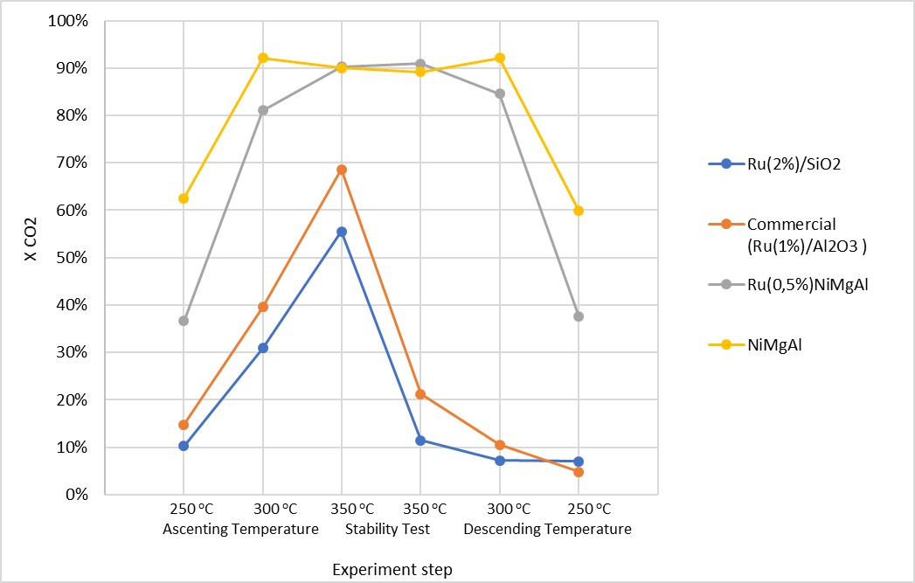

**4. Conclusions**

The nickel-based catalysts, Ni(34%)MgAl and Ru(0.5%)/Ni(34%)MgAl, presented higher activity, selectivity and stability, when compared to the commercial Ru(1%)/Al2O3 and prepared Ru(2%)/SiO2 catalysts. Ongoing detailed physical-chemical characterization will help establishing relationships between catalytic performances.

**Acknowledgments**

This work was financially supported by: i) Project UID/EQU/00511/2019 – LEPABE, funded by national funds through FCT/MCTES (PIDDAC); ii) Project POCI-01-0145-FEDER-030277, funded by the European Regional Development Fund (ERDF) through COMPETE2020 – Programa Operacional Competitividade e Internacionalização (POCI) and by national funds (PIDDAC) through FCT/MCTES and iii) Project “LEPABE-2-ECO-INNOVATION” – NORTE‐01‐0145‐FEDER‐000005, funded by Norte Portugal Regional Operational Programme (NORTE 2020), under PORTUGAL 2020 Partnership Agreement, through ERDF.

**References**

[1] C.V. Miguel, A. Mendes, L.M. Madeira, Energies 11 (2018) 3259-3279.

[2] K. Ghaib, F.Z. Ben-Fares, Renew. Sustain. Energy Rev 81 (2018) 433–446.