Lipase production by Candida tropicalis in a stirred tank reactor using agro-industrial residues as feedstock
Renata Kelly da Silva¹, Brenda Novais Santos¹, Sueli Rodrigues¹, Luciana Rocha Barros Gonçalves^{1*}, André Casimiro de Macedo¹
1 Programa de Pós-Graduação em Engenharia Química, Universidade Federal do Ceará, Campus do Pici, Bloco 709, Fortaleza – CE, Brazil
*Corresponding author: lrg@ufc.br
Highlights
- Lipase was produced by Candida tropicalis URM 7057;
- Enzyme production was conducted using agro-industrial residues: molasses, corn steep liquor and olive mill wastewater (OMW);
- Lipase production was higher when aerated cultivation was conducted.

1. Introduction
Lipases represent around 10% of the global market for enzymes and new processing technologies may boost the interest among researchers to search for new sources of viable lipase stimulating the selection of new strains and the optimization of the production [1].
In this context, this study aimed to evaluate lipase production by Candida tropicalis URM 7057 using agro-industrial residues as feedstock in a bench bioreactor. In order to improve enzyme production, some operational strategies were evaluated, such as: effect of aeration and agitation, as well as the effect of feeding pulses of OMW.
2. Methods
The yeast Candida tropicalis URM 7057 was isolated from cashew bagasse. The culture was activated in a medium containing 40 g/L of glucose, 10 g/L of peptone in potassium phosphate buffer with PH 7.0 and maintained at 30 °C, 170 rpm for 24 h. To prepare the inoculum, a microbial suspension of cells was transferred to flasks of 500 ml, containing 175 ml of cultivation medium and kept in a rotary sacker at 30 °C and 170 rpm until reaching the concentration of 10⁶ UFC/ML.
The cultivation medium contained 5.0 g/L of sugarcane molasses, 6.0 g/L of Corn Steep Liquor (CSL), 0.5% v/v of wastewater from olive plants (OMW), 0.5 g/L of ammonium sulfate and 3.0 g/L of peptone in potassium phosphate buffer, PH 7.0, which was sterilised in autoclave at 110 °c for 15 minutes. The assays were performed in 5L-bench bioreactor (New Brunswick Bioflo Celligen 115, Eppendorf), (HL = 33.00 cm; d = 19.41 cm) with an initial volume of 3.5 L at 30 °C and 300 rpm and pH maintained at 6.5 with NaOH 1, 5m.
The total protein content was determined by the BRADFORD method [2] using bovine serum albumin as the protein standard for the calibration curve. The concentration of reducing sugars was determined by using the DNS reagent [3]. The growth was monitored by counting viable cells in a Neubauer chamber (depth 0.025 mm) performed along the fermentation, using methylene blue staining technique. Lipase activity was determined using p-nitrophenyl laurate (pNFL) as the enzyme substrate [4].
3. Results and discussion
Different agitation speeds and air flows were studied in the production of lipase by C. tropicalis. Enzyme production increased with increase in aeration flow rate, figure 1. The production coefficients Y_{P/S} and Y_{P/x} were higher in 0.25 vvm, although the Y_{P/X} for 0.75 vvm was not much different from the value at 0.25 mvv. Table 1 shows the biomass (Y_{XS}) and Product (Y_{PX}, Y_{PS}) yields, as well as lipolity activity and biomass production (titer and productivity).
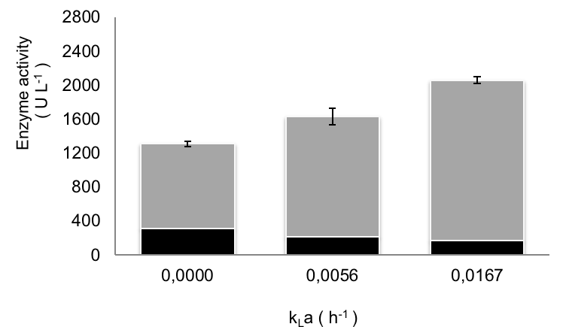
Figure 1. Maximum total enzymatic activity under different aerations: (■) intracellular activity (■) Extracellular activity.
Table 1. Kinetic Parameters of batch and batch cultivation fed
Parameter | X_{max} (UFC/ mL) | S_{total} (g/L) | P_{x, max} (UFC/mL/L) | P_{P,max} (U/L/h) | Y_{XS} (UFC/gS) | Y_{PX} (U/UFC) | Y_{PS} (U/gS).
Batch | 1.9 x 10⁶ | 4.3 | 1.8 x 10⁵ | 24.9 | 7.6 x 10⁷ | 0.8 x 10⁻⁷ | 5.7
Fed-Batch | 2.5 x 10⁶ | 4.7 | 2.9 x 10⁵ | 18.1 | 21.4 x 10⁷ | 2.3 x 10⁻⁷ | 50.0

4. Conclusions
In this work, the production of lipase by C. tropicalis URM 7057 using agro-industrial residues as feedstock could be optimized in an aerated submerged culture. In addition, batch operation proved to be a good strategy to achieve higher enzyme titer.
References [Calibri 10]
- Lai, O.-M., Lee, Y.-Y., Phuah, E.-T., & Akoh, C. C. (2019). Lipase/Esterase: Properties and Industrial Applications. Encyclopedia of Food Chemistry, 158–167. doi:10.1016/B978-0-08-100596-5.21640-5
- Bradford, M. M. (1976). A rapid and sensitive method for the quantitation of microgram quantities of protein utilizing the principle of protein-dye binding. Analytical biochemistry, 72, 248–254. doi:10.1016/0003-2697(76)90527-3
- Miller, G. L. (1959). Use of Dinitrosalicylic Acid Reagent for Determination of Reducing Sugar. Analytical Chemistry, 31(3), 426–428. doi:10.1021/ac60147a030
- Brígida, A. I. S., Amaral, P. F. F., Coelho, M. A. Z., & Gonçalves, L. R. B. (2014). Lipase from Yarrowia lipolytica: Production, characterization and application as an industrial biocatalyst. Journal of Molecular Catalysis B: Enzymatic, 101, 148–158. doi:10.1016/j.molcatb.2013.11.016

