Development of an optimal process for the production of a light-coloured and highly soluble sunflower protein isolate
Sara Albe Slabi^{1, 2}, Christelle Mathé¹, Mélody Basselin¹, Arnaud Aymes¹, Olivier Galet² and Romain Kapel^{1*}
1 CNRS, LRGP, UMR-7274, University of Lorraine, Nancy, France;
2 Avril Group, 75008 Paris, France
*Corresponding author: romain.kapel@univ-lorraine.fr
Highlights
- The optimal extraction conditions were found at pH 7.0 and 0.5 mol∙L⁻¹ NaCl
- Saline ultrafiltration present an original process for sunflower purification that results in highly-purified protein product (around 100 %/dm)
- The established alternative process for sunflower protein production yields in light-coloured and highly soluble isolate (> 75 % at pH 7)

1. Introduction
The growing world population sets a new challenge for food industry because of increased demand for proteins. Sunflower (Helianthus annuus L.) is the fourth most important oilseed with production exceeding 47 million tons in 2016 [1]. The solid residue co-produced after oil extraction process (meal) is a valuable source of proteins (30-50 %/dm). Sunflower proteins (helianthinins and SFAs) are considered very promising for human nutrition thanks to many potential nutrition and functional benefits. However, during solid/liquid extraction phenolic complexation to proteins take place resulting in an unsuitable green colour of protein products [2]. Furthermore, a conventional purification of sunflower proteins is carried out by acidic precipitation. This leads to a poor solubility of protein products and an important loss of sunflower albumins [3]. Therefore, the main objective of this work was to propose an optimal process for sunflower protein extraction and an alternative protein purification by ultrafiltration that yields in light-coloured and highly soluble isolate.
2. Methods
In the first part of the work a 3² design of experiments was used to investigated the influence of NaCl concertation (0-0.5 mol.L⁻¹) in the range of pH (6-9) on extraction yield, protein composition (helianthinin, SFAs) and phenolic contamination. Then, to select the most appropriated conditions for protein extraction a multi-objective optimization strategy with incorporated constraints in algorithms was applied. Finally, the best scenario for protein purification by ultrafiltration was established. For this purpose, retention coefficient of target compounds was determined and modelling a protein purity with overall balance of matter was carried out. The solubility of protein isolate obtained using optimized process was characterized.
3. Results and discussion
The response surface revealed a positive, synergic impact of pH and ionic strength on protein extraction yield and helianthinin extractability. Irreversible phenol-protein interactions revealed dramatically increased with extraction pH. Interestingly, a protective effect of NaCl was also shown. Thus, the objective of the multi-objectives optimization was to maximize extraction yield of protein (≥ 45 %) and the content of helianthinins (≥ 65 %) while minimizing phenolic contamination of helianthinins (≤ 8 %) and SFA (≤ 25 %). Based on these results the solid/liquid extraction at pH 7.0 and 0.5 mol∙L⁻¹ NaCl was found to be the best trade-off between all competing criteria (Fig. 1a). The proteins extracted under optimal conditions were subsequently purified by ultrafiltration using an original protocol with saline diafiltration step (0.5 mol∙L⁻¹ NaCl). The developed process resulted in excellent separation of sunflower proteins and free phenolic compounds (≥ 95 % after 6 DV) and satisfying purification yield (> 70 %). Consequently, a light-coloured proteins with a high-purity (99.9 %/dm) was obtained (Fig. 1b). Additionally, the solubility of protein isolate (≥ 75 % at pH 7, Fig. 1c) was considerably improved comparing to those purified by acidic precipitation (< 10 % at pH 7) [3].
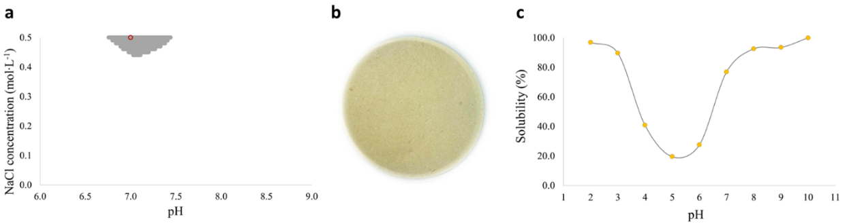
Figure 1. Non-dominated responses (grey points) of multi-objective optimization of protein extraction and the selected optimal condition (red-framed) (a). The coulour (b) and the solubility of purified proteins as a function of pH (c).
4. Conclusions
The obtained response surfaces allowed selecting the optimal extraction conditions found at pH 7.0 and 0.5 mol∙L⁻¹ NaCl. The further protein purification by ultrafiltration yielded in colour-light and highly soluble protein isolate. Thus, the proposed alternative process for preparation of sunflower proteins could be an answer for sustainable valorization of sunflower meal in food industry.
References
- FAOSTAT-Agriculture (2012). FAO Statistics Division. www.fao.org/docrep/016/ap106e/ap106e.pdf
- S. R. Wildermuth et al., Compr Rev Food Sci F. 15 (2016) 829-843;
- C. Pickardt et al., Food Hydrocolloid. 23 (2009).

