Optimal performance membrane processes for nitrogen separation from air
Marjan Bozorg^{1, 2, 3}, Bernardetta Addis², Veronica Piccialli³, Álvaro A. Ramírez-Santos¹, Christophe Castel¹, Eric Favre^{1, *}
1 Université de Lorraine, CNRS, LRGP, F-54000 Nancy, France; 2 Université de Lorraine, CNRS, LORIA, F-54000 Nancy, Franc; 3 Dipartimento di Ingegneria Civile e Ingegneria Informatica, Universitá degli Studi di Roma Tor Vergata, viale
*Corresponding author: Eric.Favre@univ-lorraine.fr
Highlights
- Nitrogen production
- Membrane separation process
- Membrane material
- Process synthesis

1. Introduction
Membrane processes are one of the key technology for gas separation applications. They combine a series of key advantages that can result in energy efficient, small sized and environmental friendly processes. Among those processes, nitrogen production from air by membrane gas separation processes is a mature technology, which is applied in numerous industrial sectors (chemistry, food, aeronautics, space...). Depending on the nitrogen purity requirements (typically between 90 and 99.9%), single stage or multi-stage membrane process configurations are used. The main challenge is then to be able to build and provide tools to optimally design membrane processes that is mainly the answer of the question: what is the best membrane material and the best process architecture to achieve my separation targets?
A very large number of advanced membrane materials have been recently reported, showing increasing permeability and/or selectivity for air separation applications (i.e. trade-off limits of dense polymeric materials for the O₂/N₂ pair gas [1]) compared to the commercially available membranes. The interest of these new materials in terms of nitrogen production cost and their impact in terms of process configuration have never been reported through a process synthesis study. The results of the optimization (process synthesis) are expected to generate useful guidelines for membrane material development: is it better to push selectivity or permeance in order to decrease NEA production cost? Is it interesting to combine different membranes in a multi-staged unit, in order to achieve lower production costs? This is what this study is aimed to answer.
2. Methods
Based on a tailor made global optimization methodology and program [2], optimal process configurations achieving minimal production cost are first identified for standard and commercial O₂/N₂ separation membranes (PSf [3] and PPO[4]) for four different levels of N₂ purity. (90, 95, 99, 99.9%). The same strategy is then performed with membrane materials considered as a variable of the system, with the possibility to combine different materials in multi-staged systems. The choice of the membrane materials can be freely made in the domain delimited by the trade-off limit. The impact in terms of nitrogen production cost for the different purities and the corresponding optimal membrane materials and process configurations are discussed.
3. Results and discussion
The acceptable domain for O₂/N₂ separation membranes considered based on [1] (the green region in the Figure 1). Consequently, the optimal process configuration with associated operating conditions and the lowest N₂ production cost is obtained while converging to the optimal membrane performances for different nitrogen purity levels.
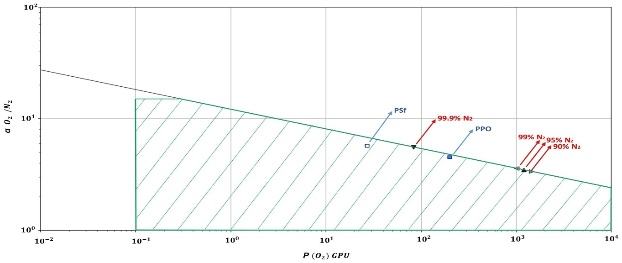
Figure 1. Commercial available membrane materials (blue squares) and the optimal performance membranes for different nitrogen purity levels indicate with triangles.
4. Conclusions
Surprisingly, a medium membrane selectivity combined to a high permeability is shown to systematically offer the best set of performances, for mono or multistage systems. In contrast with current practice, vacuum operation and recycling loops are shown to generate lower N₂ production costs with high performance membranes. For the set of parameters tested in our study, it seems that the use of different membranes in a multistage system does not offers attractive improvement potentialities. It is obvious that this statement does not systematically hold for gas permeation and should be reconsidered from case to case.
References
- L. M. Robeson, The upper bound revisited, Journal of Membrane Science 320 (2008) 390–400.
- Álvaro A. Ramírez-Santos, M. Bozorg, B. Addis, V. Piccialli, C. Castel, E. Favre, Optimization of multistage membrane gas separation processes. Example of application to CO2 capture from blast furnace gas, Journal of Membrane Science 566 (2018) 346–366.
- H. M. Ettouney, H. T. El-Dessouky, W. Abou Waar, Separation characteristics of air by polysulfone hollow fiber membranes in series, Journal of Membrane Science 148 (1998) 105-117.
- S. McConnell, Heavy-duty diesel engine NO_{x} reduction with nitrogen-enriched combustion air (2010).

