Full-field assessment of gaseous flow within open-cell foams: comparison of µCT-based CFD simulations and magnetic resonance velocimetry results
Mehrdad Sadeghi¹, Mojtaba Mirdrikvand², Georg Pesch¹, Wolfgang Dreher², Jorg Thöming¹
¹University of Bremen, Faculty of Production Engineering, Chemical Process Engineering, Bremen, Germany
²University of Bremen, Faculty of Chemistry, in-vivo MR group, Bremen, Germany
*Corresponding author: sadeghi@uni-bremen.de
Highlights
- µCT-based CFD simulations of gaseous flow within open-cell foams were performed.
- CFD simulations are based on real structure of open-cell foams in a foam reactor.
- Magnetic resonance velocimetry (MRV) method was used for flow mapping and verification of CFD results within the open-cell foams.
1. Introduction
Open-cell foams, which are also known as solid sponges, enjoy beneficial morphological properties such as a low pressure drop, a high thermal conductivity and an excellent soli-gas heat and mass transfer which make them a good choice as monolithic catalyst supports. Computational fluid dynamics (CFD) simulations have been employed as a cost-effective and reliable numerical tool for the study of transport phenomena through catalytic sponges; however, their irregular and complex geometries demands high computational effort. Nevertheless, the complexity of the geometry is a major cause for the good performance of the solid sponge. It significantly controls flow pattern and the sponge’s heat and mass transfer characteristics. Apart from detailed experimental studies, this fact requires in-depth numerical studies which spatially resolve transport phenomena in the sponge locally [1]. Magnetic resonance velocimetry (MRV) is a non-invasive method which has been applied for measurement of flow within solid sponges. In this study, the obtained flow fields and velocity profiles form CFD simulations were compared with magnetic resonance velocimetry (MRV) measurements.
2. Methods
In this study, we simulated the entire fully-resolved geometry of sponges which were obtained from micro computer tomography (µCT) imaging of real samples. The Procedure is summarized in Figure 3 in the Appendix. Due to highest investigated Reynolds number (based on reactor diameter, 25 mm) for the flow rate of 1.5 Sl min⁻¹ (Re= 76.49, u_{in}=0.051 ms⁻¹), laminar flow regime and incompressible condition was considered. To ensure the simulations are grid-independent, a grid analysis was carried out for different meshing densities. To guarantee that the simulated flow results are physically correct, they were validated against pressure loss correlations for foams at flow rates from 0.5 to 20 SL min⁻¹. Subsequently, CFD results containing 41.1 millions of computational cells were validated by experimental velocimetry measurements and literature correlations. We investigated numerically and experimentally the incompressible gas flow within three cylindrical (25 × 68 mm) 20 PPI Al₂O₃ open cell foams in a row (See Table 1 in Appendix for morphological properties). A gas flow of methane at different flow rates of 0.5, 1 and 1.5 L min⁻¹ was examined. In this study, CFD simulations are based on the real, large segments of sponges. This allows us to measure the differences between CFD simulations and full-field MRV measurements. The computational cell size and MRV voxels are 0.1 and 0.8 mm, respectively.
3. Results and discussion
In comparison with homogeneous (porousSimpleFoam solver of OpenFOAM) models, µCT-based CFD results (solved using the simpleFoam solver from OpenFOAM) showed the sensitivity of velocity profiles to the local morphology of open cell foams (Figure 4 in Appendix). The obtained flow fields form CFD simulations and MRV measurements are presented in Figure 1. We compared axial velocity profiles of CFD and MRV results for the middle section of porous structure. The results showed remarkable agreement with an accuracy of ±10% (see Figure 2). Furthermore, the obtained average radial velocity profiles from CFD and MRV data are in good agreement together (see one example in Figure 5 in Appendix). This justifies the use of CFD of large sponge segments as an adequate and reliable tool for the study of gaseous flow within porous structures.
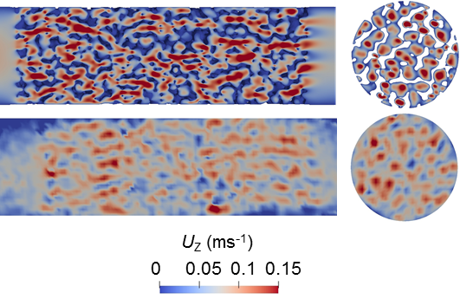
Figure.1. Obtained flow fields form CFD simulations (top) and MRV measurements (bottom)
Figure.2. Obtained average axial velocity profiles within the middle Al₂O₃ sponge from CFD simulations and MRV measurements for different flow rates of 0.5, 1 and 1.5 L min⁻¹.
4. Conclusions
The quantitative agreement between CFD and MRV results amplifies the reliability of CFD simulations and underpins the capability of NMR-based measurements for in-situ temperature and concentration measurements. Obtaining similar results with both methods improves the reliability of either method. Finally, full-field numerical and NMR-based experimental studies of heat transfer and chemical reactions within catalytic sponges are on the way.
Appendix
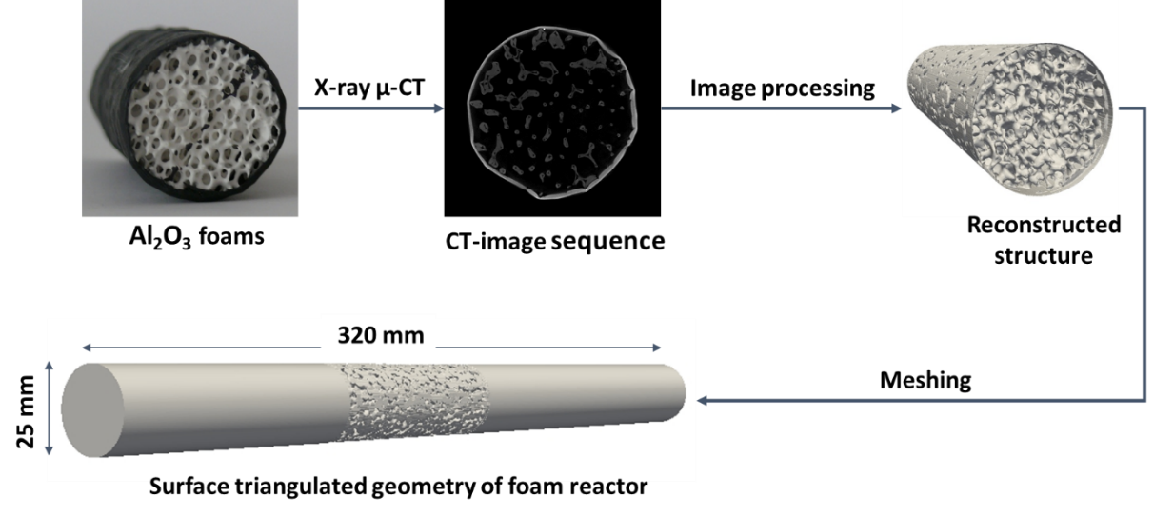
Figure 3. Procedure for preparation of foam reactor geometry
Figure 4. Calculated averaged axial velocity profiles within foam reactor from heterogeneous model (the color markers) and homogeneous model (dotted lines) for different flow rates of 1.5, 5, 10 and 20 SL min⁻¹
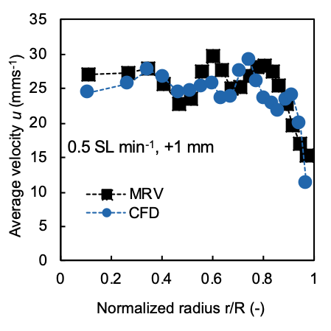
Figure 5. The obtained radial velocity profiles from CFD and MRV for the flow rate of 0.5 SL min⁻¹ and 1 mm after the beginning of second sponge
Table 1. Morphological properties of utilized 20 PPI open cell foams for simulation and experimental velocimetry measurements. Obtained from: 1) processing of CT-images and 2) literature correlation
Quantity | Symbol | Value
Open porosity | ε_{o} | 0.752 (1)
Pore diameter  .10⁻³ m | d_{p} | 3.41±0.6 (1)
Window diameter  .10⁻³ m | d_{w} | 1.904±0.3 (1)
Specific surface area  m² m⁻³ | S_{v} | 852.3 (2)

References
- Jürgen Ulpts, Wolfgang Dreher, Lars Kiewidt, Miriam Schubert, JorgThöming. 2016, Catalysis Today, pp. 91-98.

