Supercritical Water: a Roadmap to Biorefineries Through Innovation.

María José Cocero, Tijana Adamovid, Luís Vaquerizo, Celia Martínez.
Bioecouva Research Institute, High Pressure Processes group. Valladolid University
*Corresponding author: mjcocero@iq.uva.es
Highlights
- Ultrafast supercritical water (SCW) hydrolysis to avoid hydrolysis products degradation.
- Ultrafast preheating to avoid hydrolysis products during the heating step.
- From the conventional hydrothermal ionic reaction media to the non-ionic SCW media.
- Efficient lignocellulosic biomass fractionation in sugars and lignin.

1. Introduction
The selective fractionation of the lignocellulosic biomass in its main components (hemicellulose, cellulose and lignin) is a challenge of the sustainable biorefineries development that has not been solved yet. The complexity of the biomass and its structure limit the process by mass transfer. In addition, the crystallinity of cellulose complicates its dissolution in conventional solvents.
Water at temperature and pressure above the critical point (374ºC and 22MPa) has physical properties that allow dissolving the cellulose. The water ionic product changes from 10-12 at 300ºC to 10-19 to 374ºC, so at subcritical water conditions the ionic reactions mechanisms are favoured and at SCW conditions the radical mechanism predominates. The decrease of the ionic mechanism reaction avoids the loss of selectivity that occurs in the conventional hydrothermal processes. Additionally, SCW has low viscosity and high diffusivity that facilitate the penetration of water into the complex structure of the lignocellulosic matrix, whilst its low dielectric constant, similar to non-polar organic solvents, enhances solubility of organic compounds. Under these conditions, the hydrolysis of biomass fractions is extremely rapid and presents a means to achieve a significantly more process intensive fractionation of biomass.
Reaction speed – while being an advantage to process intensification – is also a significant disadvantage to selectivity at longer reaction times, leading to degradation of hydrolysis products and resulting in complex reaction mixtures. To take advantage of the properties of the SCW and avoid the degradation of hydrolysed products, we have introduced the ultrafast process by operation at residence times below 1 second. This process allows the hydrolysis of the cellulose, but avoids the hydrolysis of the sugars. The control of the residence time is possible by our innovative reactor design: the sudden expansion micro reactor that preheats the biomass in residence times below 10ms, by direct mixture of the SCW and the biomass suspension, and cools the reaction effluent by the Joule Thomson effect that takes place during the depressurization.
This process allows fractionating lignocellulosic biomass in the next stages: i) separation of extractives as polyphenols, antioxidants, starch, proteins or oils; ii) hydrolysis of hemicellulose to produce hemicelluloses oligomers and C5 sugars; iii) hydrolysis of the cellulose fraction to produce a liquid effluent, mainly C6 sugars, and a solid effluent, mainly lignin (1).
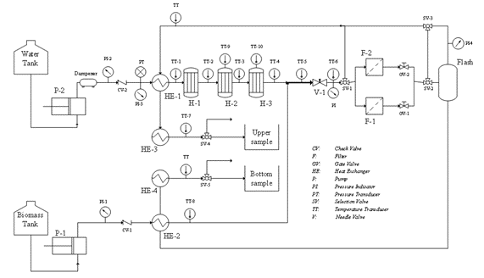
2. Methods
Figure 1 presents a pilot plant flow diagram for lignocellulosic biomass fractionation. The pilot plant operates at temperatures of 400ºC, pressures of 25 MPa and biomass suspension flow of 10 kg/h. The pilot plant has four units: 1) biomass pumping, 2) SCW production, 3) reaction and 4) heat integration and energy recovery (2)

3. Results and discussion
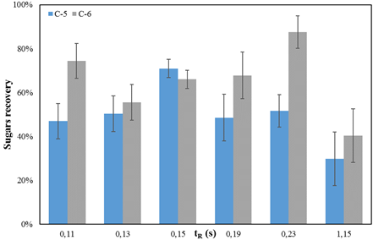
The fractionation of pulp sugar beet is presented as an example of lignocellulosic biomass fractionation. The effect of the residence time on the composition of the liquid effluent sugars is presented in Figure 2. Sugar beet pulp has a concentration of pectin of 27%; although the pretreatment extracts the pectins, the remaining pectins hinder the flow of SCW into the complex biomass matrix, requiring longer residence times. These residence times increase degradation, but even at residence times of 230ms, the C6 yield is higher than 80%, significantly higher than the conventional processes (3).
Figure 2. Beet pulp SCW hydrolysis at 390°C and 25 MPa. C-6 and C-5 liquid concentration at different reaction times.
4. Conclusions
The SCW ultrafast hydrolysis is a selective process for the fractionation of lignocellulosic biomass in a liquid effluent of C5 and C6 sugars than can be used for fermentation, and a solid effluent that is mainly a lignin composite. Any HMF is produced.

Acknowledgements
The authors thank the Spanish Ministry of Economy and Competitiveness for the Project CTQ2016-79777-R. TA thanks Valladolid University for its FPI-UVA grant.

References
- M.J. Cocero, Á. Cabeza, N. Abad, T. Adamovic, L. Vaquerizo, C.M. Martínez, M.V. Pazo-Cepeda, J. (2018) Supercrit. Fluids, 133 pp 550-565.
- Martínez, C.M., Adamovic, T., Cantero, D.A., Cocero, M.J. (2019) Journal of Supercritical Fluids, 143, pp. 242-250.
- Martínez, C.M., Cantero, D.A., Cocero, M.J. (2018) Journal of Cleaner Production, 204, pp. 888-895.

