**Maximising carbon efficiency through steam separation enhancement: carbon recycling into carbon monoxide, methane, methanol, DME**

Jasper van Kampen1, Jurriaan Boon1

*1 ECN part of TNO, Westerduinweg 3, Petten, The Netherlands*

*\*Corresponding author: jurriaan.boon@tno.nl*

**Highlights**

* Development of steam separation enhanced processes for utilisation of CO2.
* Development of sorption-enhanced synthesis of CO, DME, and CH4.
* Development of membrane-assisted methanol and DME.
* Steam separation enhancement key to maximising carbon efficiency CCU process.

**1. Introduction**

The capture and utilisation of CO2 (CCU) presents important opportunities for industry in support of climate change objectives, circularity, the large-scale storage of renewable electricity, and emerging CO2 capture processes [1]. While the relevant products in a CCU scheme can be rather conventional, such as carbon monoxide, methane, methanol, and DME – an optimised CCU value chain requires breakthrough innovation in (among others) the catalytic conversion steps involved in their production. Here, we propose the development and scale-up of steam separation enhanced processes for the utilisation of CO2.

Conversion of CO2 with H2 involves the production of H2O by-product, and reactions are generally equilibrium limited. By the principle of Le Chatelier, the in situ extraction of H2O from the reaction mixture will result in a shift of the equilibrium to the product side and enhance the conversion [2]. Figure 1 shows the increase in product concentration for several reactions under representative conditions. Additionally, the reduction in steam partial pressure may improve catalyst performance.

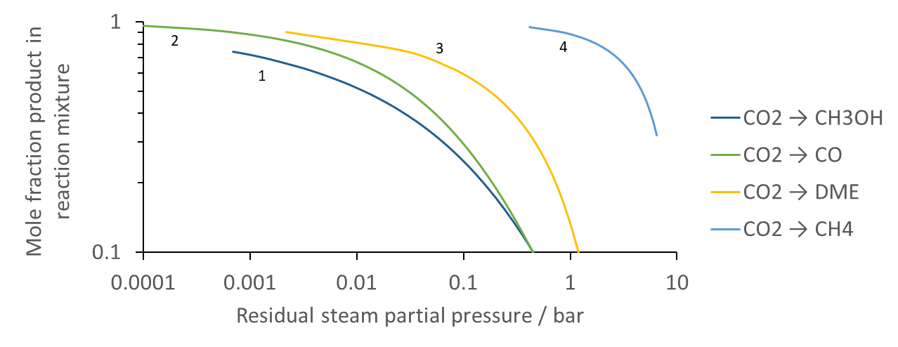

**Figure 1.** Molar fraction of product for stoichiometric H2/CO2 feed for the production of (1) methanol at 250 °C, 30 bar; (2) CO at 300 °C, 10 bar; (3) DME at 275 °C, 30 bar; (4) CH4 at 300 °C, 10 bar.

Use of high-temperature steam adsorbents and steam permselective membranes will be shown to increase the carbon efficiency by intensification of the production of CO, CH4, methanol, and DME.

**2. Methods**

CO, DME, and CH4 have been produced in fixed bed temperature and pressure swing adsorption processes involving commercial catalysts and LTA zeolites. Methanol and DME are being investigated using ceramic-based membranes. In parallel, 1-D reactor models were developed in order to facilitate data interpretation, reactor design, and process scale-up.

**3. Results and discussion**

A combined approach of experimental scale-up and model development has been proven successful in the development and scale-up of steam separation enhanced processes. The processes mentioned above will be highlighted from the perspective of maximising the carbon efficiency of the CCU scheme. Exemplary results include (I) CH4 synthesis by operating conventional methanation and sorption-enhanced methanation in series to allow for a remaining unconverted hydrogen concentration of < 0.1 mol% (Figure 2a), and (II) DME synthesis with an increased single-pass conversion and reduced CO2 content in the product for all syngas compositions and especially for H2/CO2 feed (Figure 2b).

|  |  |
| --- | --- |
| SEM_versus_termo  a) | b) |

**Figure 2.** (a) 3 methanation reactors supplemented by sorption-enhanced methanation reach the unconverted H2 specification of < 0.1 mol% (b) experimentally obtained increase in carbon selectivity to DME in sorption-enhanced DME synthesis relative to thermodynamic equilibrium for three different stoichiometric feed compositions at 275 °C, 40 bar.

It will be shown that crucial aspects in general for reactive steam permeation are the hydrothermal stability of the membranes and their permselectivity, whereas high temperature working capacities and heat management are crucial aspects for reactive steam adsorption. The peculiarities of the highlighted processes will however also demonstrate more specific learnings by, and necessity of, a strong interaction between experimental scale-up and reactor modelling.

**4. Conclusions**

Steam separation enhanced processes production of CO, CH4, methanol, and DME have been demonstrated to improve the conversion and the carbon efficiency in the context of CCU.

**References**

1. Schlögl, R., et al. (2018). Novel carbon capture and utilisation technologies: Research and climate aspects. SAPEA, Berlin. DOI: 10.26356/CARBONCAPTURE
2. Van Kampen, J., et al. (2019). Steam separation enhanced reactions: Review and outlook. *To be submitted*.