Mixing and its influence on the precipitation of organic nanoparticles from the liquid phase: A Lagrangian perspective
Tobias Schikarski¹& Holger Trzenschiok¹, Marc Avila², Wolfgang Peukert^{1*}
1 Institute of Particle Technology, Friedrich-Alexander Universität Erlangen-Nürnberg; 2 Center of Applied Space Technology and Microgravity, Universität Bremen
*Corresponding author: wolfgang.peukert@fau.de
Highlights
- Precipitated nanoparticles of Ibuprofen down to 25nm
- Precise simulations of liquid mixing in a T-mixer
- Prediction of trend of particle size and shape of PSD with Lagrangian mixing

1. Introduction
Mixing is key for the fast precipitation of organic [1] and inorganic [2] compounds because it determines the supersaturation build-up, which in turn governs the primary particle formation steps such as nucleation and diffusion-limited growth [1,2]. Due to the naturally very small diffusivities of liquid mixtures, turbulence is primarily chosen to impose fast and well mixing because of its spatio-temporal randomness and the cascade of various length scales. To accurately model precipitation, turbulent mixing needs to be well captured in simulations.
In our recent study [3], we achieved excellent qualitative agreement in the mixing efficiency of a simple T-mixer between experiments and direct numerical simulations (no turbulence modeling) over a wide range of Reynolds numbers Re=(100,4000). Despite the newly gained insights into the mixing process, analysis of the influence of the mixing on the particle size distribution (PSD) of organic nanoparticles, resulting from precipitation experiments at various flow rates, is still missing. In doing so, we study the mixing behavior along Lagrangian trajectories and relate the findings to the experimentally obtained PSDs. It appears that this approach allows to qualitatively predict the trend of the mean particle size as well as the width of the PSD without any precipitation modeling, which is very challenging itself.
2. Methods
A simple T-mixer is used to mix an alkaline aqueous ibuprofen solution with an acidic aqueous Zirconium chloride solution, which triggers the precipitation of Ibuprofen while Zr-ions stabilize the formed particles. The resulting stable nanoparticle suspensions are analyzed with dynamic light scattering to obtain the PSD. Note that the fluid properties of the water-water mixture are not affected by the chemicals as well as the excellent particle stability prevents ripening or aggregation. The numerical approach consists of direct numerical flow simulations of the mixing process solving for the Navier-Stokes (velocity) and the convection-diffusion equation (composition). An empirical-free approach is here applied which does not require any turbulence modeling. Lagrangian trajectories are computed by solving $\frac{∂x_{i}}{∂t}=u_{i}$, where $x_{i}$ and $u_{i}$ are the position and velocity vector of the i^{th} trajectory, respectively. Details on the mixing and precipitation experiments as well as on the flow simulations can be found in [3,4], respectively.
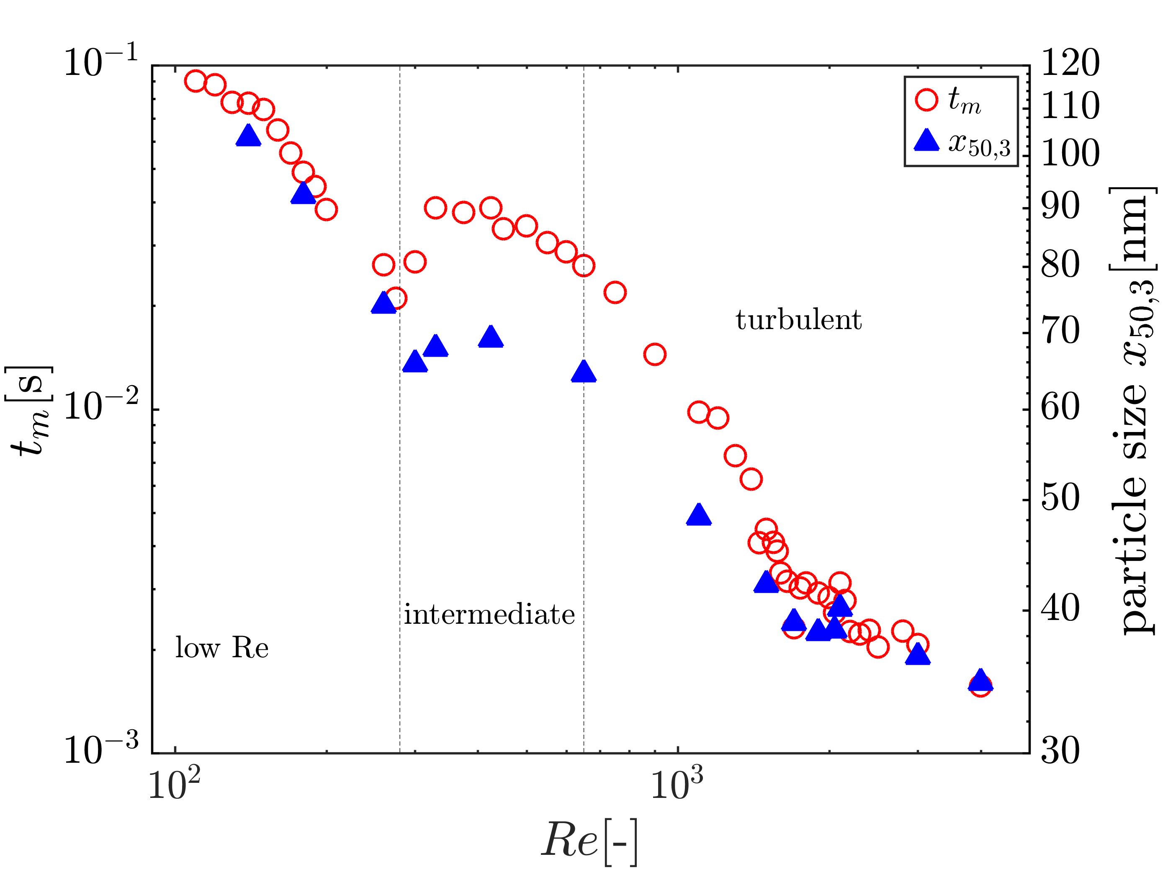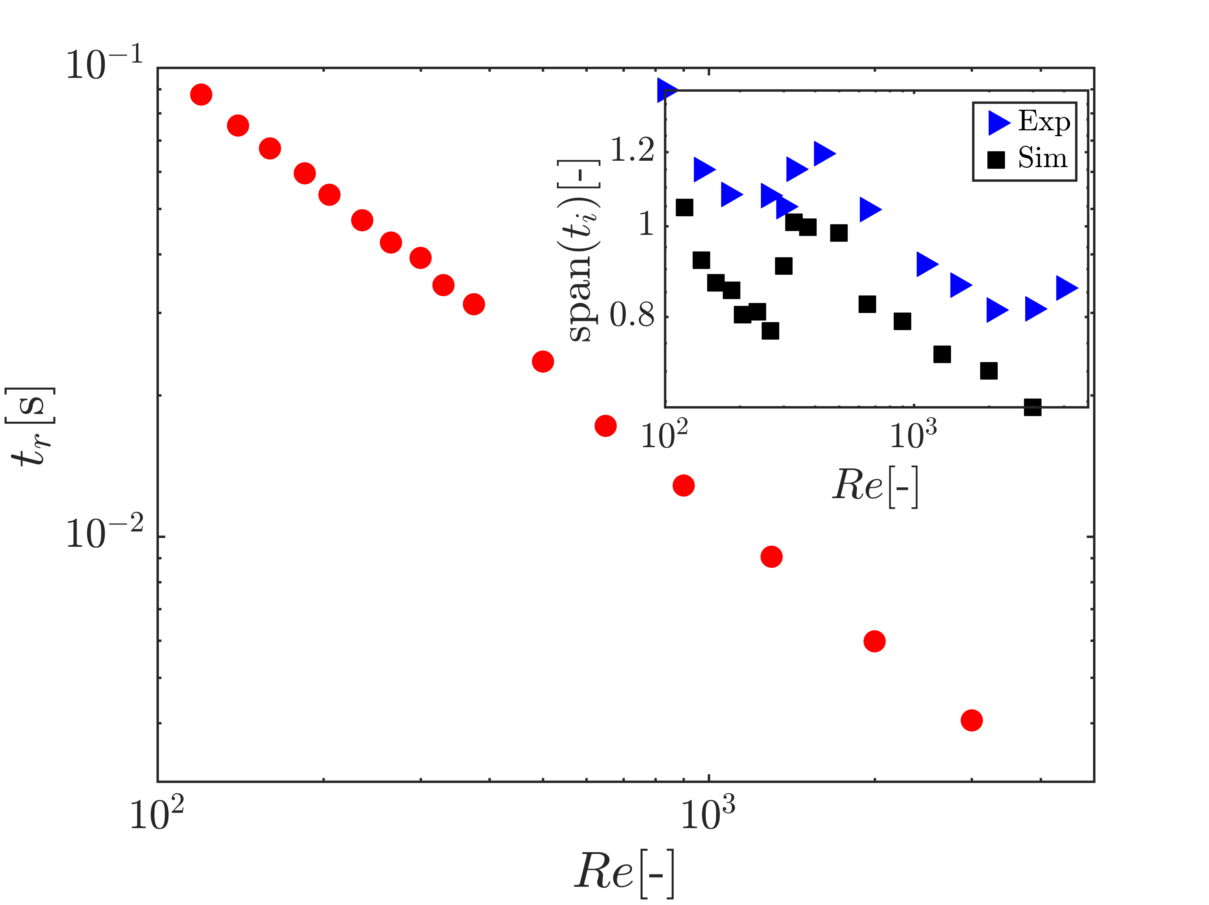
a)
b)
Figure 1. (a) Experimentally measured and computationally estimated mixing time t_{m} (left y-axis) and median particle size x_{50,3} (right y-axis) as a function of Reynolds number Re. (b) Mean residence time t_{r} as a function of Reynolds number Re. The inset compares the width of PSD to that of the RTD.
3. Results and discussion
The supersaturation is the thermodynamic driving force of precipitation, which is determined by the rate the two fluids are brought in contact with each other. Thus, the primary particle formation steps nucleation and growth are mixing controlled under the assumption of fast chemical reactions, and the outcome should reflect the mixing efficiency when a sufficient stabilization is applied. This prevailing view is substantiated in Fig. 1a), which depicts a nearly perfect alignment of the experimentally determined mixing efficiency $t_{m}$ by the Villermaux-Dushman reaction [3] with the median particle size $x_{50,3}$ as Reynolds number increases.
In the chemical engineering community, it is common to relate the reaction outcome with the residence time and its distribution. Having a large number of Lagrangian trajectories, the residence time distribution (RTD) can be precisely calculated by simulations. Fig. 1b) shows the mean residence time $t_{r}$ as a function of the Reynolds number. It turns out that the qualitative trend of the mixing efficiency and likewise of the median particle size induced by alteration of flow structures are not featured by the mean residence time. However, comparing the widths of PSDs with these of RTDs, the qualitative trend is very well captured. This finding suggests that the shape of the PSD is determined by the spatial distribution of large-scale flow structures while the trend of the mean particle size depends primarily on local changes of the fluid composition.
4. Conclusions
In the talk, we will detail the experimental and numerical findings of the comparative study of the precipitation and Lagrangian mixing, respectively. In particular, we will demonstrate how to analyze the fluid composition to predict the qualitative trend of the median particle size. Furthermore, we will address the influence of inflow condition and different mixing fluids.
References
- A. A. Thorat, S.V. Dalvi, Chem. Eng. J. 181 (2012) 1-34.
- S. M. D’Addio, R.K. Prud’homme, Adv. Drug. Deliv. Rev. 63 (2011) 417-426.
- T. Schikarski, H. Trzenschiok, W. Peukert, M. Avila, Reac. Chem. Eng. (2019)
- H. Trzenschiok, M. Distaso, W. Peukert. Chem. Eng. J. 361 (2019) 429-438.

