Discrimination criteria for early decision-making between uncoupled or multifunctional reactor and membrane units
Jean-Marc Commenge¹, Camilo Ruiz¹, Jean-François Portha¹
1 Université de Lorraine, Laboratoire Réactions et Génie des Procédés, UMR 7274, 1 rue Grandville, BP 20451, 54001 Nancy Cedex, France.
*Corresponding author: jean-marc.commenge@univ-lorraine.fr
Highlights
- Superstructures for RSR loop and membrane reactor are optimized for maximal yield
- Dimensionless numbers (Da, Pe) are explored to define optimality domains of structures
- Discrimination criteria are built to delimit the optimality zone of membrane reactors
1. Introduction
The development of a sustainable industry for a successful energetic transition requires rethinking existing processes and/or designing innovative processes by applying Process System Engineering methodologies. Intensified devices and multifunctional units have been extensively studied in the last decades and have demonstrated their interest for cost minimization and plant optimization. Unfortunately, they are not systematically considered in conventional design approaches^{1,2}, whereas the early steps in process design are critical to define the technologies, utilities, control strategy, etc. and to assess the OPEX and CAPEX of a project.
The main objective of this work is to define quantitative criteria to choose the most interesting combination between a reaction step and a membrane separation unit, even at the early phases of the process synthesis. To do so, two cases are studied, optimized and compared: (i) a membrane separator in a Reactor-Separator-Recycle loop (RSR) and (ii) its integrated equivalent, a membrane reactor.
2. Methods
Two superstructures have been designed including either a reactor and a membrane unit, or an integrated membrane reactor (Figure 1). Both superstructures are parameterized by 4 and 2 split factors respectively, and characterized by physical data, such as the reaction stoichiometry and kinetics, reactor volume, membrane area, permeability and pressures. Numerical resolution of the mass balances gives access to all flow rates, compositions and performance criteria such as the overall yield of both processes. For a given chemical system, the split factors of each structure are optimized to maximize the yield. The single-pass conversion and two separation efficiencies are calculated for further comparison and criteria definition. Particular attention is drawn to multiple solutions and, if equivalent, the simplest solution in terms of structure is favored.
To generalize the investigation, the set of parameters is made dimensionless by introducing the permselectivity, the pressure ratio, the Damköhler number and the Péclet number: these numbers enable to easily compare the reaction time, the space time and a characteristic time of the separation^{3,4}.
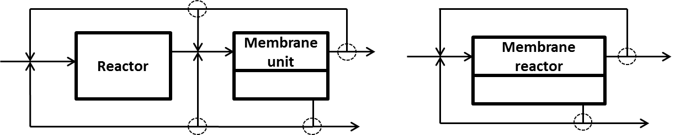
Figure 1. Superstructures studied for the RSR loop (left) and the membrane reactor (right). Dashed circles indicate the positions of split factors.
3. Results and discussion
Concerning the RSR superstructure, for a given chemical system, only a few non-trivial recycle schemes (among 49 possibilities) are optimal with respect to the overall yield: these optimal substructures can be directly related to the local efficiencies and can be discriminated by a simple criterion that describes the frontiers between their optimality domains.
Comparison of both structures confirms the technical superiority of the membrane reactor with respect to the overall yield for all studied cases: the multifunctional unit systematically exhibits a higher criterion than the RSR structure. Nevertheless, the possible gain is not significant over the whole range of dimensionless numbers: both optimized structures may exhibit very similar yields depending on the dimensionless numbers.
For definition of appropriate discrimination criteria, the existence of trivial and multiple optimal solutions requires exploring only a relevant part of the dimensionless space: the Da number should be large enough to enable sufficient single-pass conversion, the permselectivity and pressure ratio should be coherent with typical values, etc. On this basis, the zone of significant superiority of the membrane reactor can be circumscribed.
4. Conclusions
Two superstructures and corresponding balance equations describing the overall efficiency of a RSR loop and a membrane reactor have been studied, enabling to determine the maximum attainable yield and the associated optimal structure to solve a generic reaction separation problem. Exploration of the parameter space enabled to define discrimination criteria and optimality domains, with respect to this technical criterion.
Even if the overall efficiency described in this work is an important parameter in the decision-making procedure for process design, further works should focus on including economic aspects as main criteria for decision-making between uncoupled and multifunctional units.
References
- M. Baldea, Comp. Chem. Eng. 81 (2015) 104–114.
- J.-F. Portha, L. Falk, J.-M. Commenge, Chem. Eng. Process. Process Intensif. 84 (2014) 1–13.
- W. S. Moon, S. B. Park, J. Memb. Science. 170 (2000) 43-51.
- S. Battersby, P. W. Teixeira, J. Beltramini, M. C. Duke, V. Rudolph, J. C. Diniz da Costa, Cat. Today 116 (2006) 12-17.

