not fullbles Leach core liufat.**Properties of liquid marbles stabilized by stearate microparticles for microreactors**

Shoma Tanaka1, Hiroaki Okano2, Nobuyuki Matsuda2, Kazumitsu Naoe1*,

and Masanao Imai3

*1 Dept. of Materials Sci. & Chem. Eng., Faculty of Advanced Eng., National Institute of Technology, Nara College, Yamato-Koriyama, Nara 639-1080, Japan; 2 Research Division, Taihei Chemical Industrial Co. Ltd., Ikaruga, Nara 636-0104, Japan; 3 Graduate School of Bioresource Sci., Nihon University, Fujisawa, Kanagawa 252-0880, Japan*

*\*Corresponding author: naoe@chem.nara-k.ac.jp*

**Highlights**

* The height of liquid marbles increased and reached a constant value as the core liquid volume increased.
* Drying rate of liquid marble was dependent upon the core liquid solution in the liquid marble.
* Surfaces of the liquid marbles were not fully coated with the microparticles.

**1. Introduction**

Liquid marble is a non-stick drop coated with micro- or nano-scale particles demonstrating extremely low friction when rolling on solid substrates. Liquid marbles can be obtained easily by rolling water drops on a solid substrate covered with hydrophobic powder layer or by mixing a hydrophobic powder in water [1]. Liquid marbles have great potential in a wide range of applications such as water quality testing and micro bioreactor etc. [2, 3]. Stearates, salts of stearic acid included in animal fat, have insolubility in water and no toxicity, and are used in thickener as a food additive and an anti-adherent for the manufacture of medical tablets. In this study, preparation of liquid marbles (LMs) using stearate microparticles (SMs) and their properties for microreactors are investigated.

**2. Methods**

For preparation of LMs we used calcium SMs. It has peaks at 5 µm and 100 µm in the size distribution. Aqueous solutions were dropped by syringe onto a substrate surface covered with a layer of calcium SMs. Slight tilting of the covered substrate surface caused the drop to roll and become coated with calcium SMs. The height and drying rate of prepared LMs were measured. The weight of LMs was recorded with time by electronic balance in a low temperature & humidity test chamber at 35˚C and 40 % (RH) of humidity. The drying rate of the LMs was calculated from the weight data. The initial surface of LMs was observed by optical microscopy.

**3. Results and discussion**

At small core liquid volumes of the LMs they were spherical, but as the volume increased it changed to a puddle shape. The heights of LMs at various core liquid volumes are shown in Fig. 1. As the liquid volume increased, the height of LM increased and reached a constant value (Hmax).

The drying rates of LMs containing each core solution calculated from the weight data are shown in Fig. 2. The drying rate of LMs was dependent upon the core liquid solution of LMs. The obtained drying curves of LMs were similar with general drying curves of wetted powders. Drying rate of liquid marble was dependent upon the core liquid solution in the liquid marble. The drying naoelab11:Users:naoelab11:Desktop:田中:研究:Graph:PDF:2019 Firenze:40%(RH) 再現実験含み.pdfrate of the LMs prepared with 0.1 M MgCl2 aqueous solution is the lowest.

naoelab11:Users:naoelab11:Desktop:田中:研究:Graph:PDF:2019 Firenze:40%(RH) 再現実験含み.pdfnaoelab11:Users:naoelab11:Desktop:田中:研究:Graph:PDF:2019 Firenze:Milli-Q height.pdf

**Fig. 2** Relationship between drying rate of LM and weight of core liquid per LM. Salt conc. = 0.1 M.

**Fig. 1** Relationship between core liquid volume and height observed from side in the preparation of liquid marble.

Fig. 3 shows a microscopic image of the surface of LMs prepared with MgCl2 aqueous solution before drying. The initial surfaces of the LMs were not fully coated with SMs, indicating that gas or vapor can be transported through the surface of LMs.

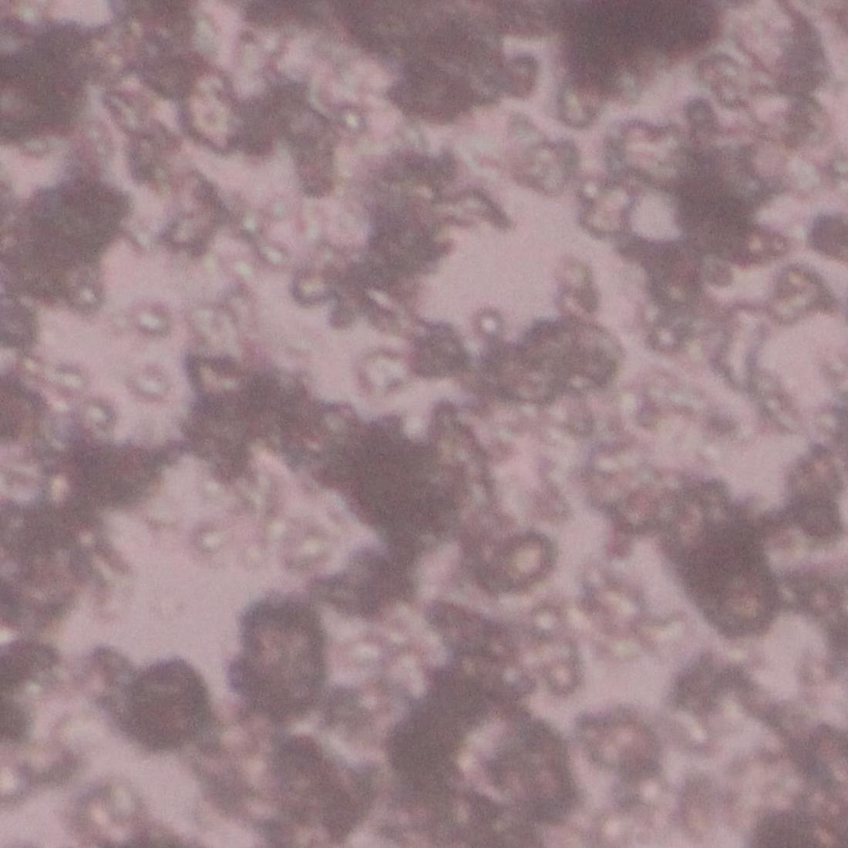

**Fig. 3** Microscopic image of surface of SMs LMs prepared with 0.1 M MgCl2 aqueous solution.

**4. Conclusions**

Preparation of LMs using SMs and their properties for microreactors were investigated. At small core liquid volumes of the LMs they were spherical, but as the volume increased it changed to a puddle shape. The heights of LMs at various core liquid as the liquid volume increased, the height of LM increased and reached a constant value (Hmax). The drying rate of LMs was dependent upon the core liquid solution of LMs. The initial surfaces of the LMs were not fully coated with calcium SMs, indicating that gas or vapor can be transported from surface of LMs.

**References**

[1] Aussillous, P. and Quere, D. Nature, 411, 924-927 (2001)

[2] Junfei, T. et al., Chem. Eng. J., 165, 348-353 (2010)

[3] Vadivelu, R. K. et al., Sci. Rep., 7, 12388 (2017)