Integration of power-to-gas concepts with biomass gasification in the Swedish electricity grid
Johan M Ahlström^{1*}, Viktor Johansson¹, Lisa Göransson¹, Stavros Papadokonstantakis¹
¹ Chalmers University of Technology, 412 96 Gothenburg, Sweden
*Corresponding author: johanah@chalmers.se
Highlights
- A gasifier combined with an electrolyser implemented in an energy systems model
- The value of process flexibility is compared to hydrogen storage
- Results highlight the benefits of a flexible biomass gasification process

1. Introduction
The variability of wind and solar electricity generation will demand a flexible electricity system in the future. Simultaneously, increased demand for fuels and chemicals produced from biomass is expected in the future in response to climate change mitigation goals [1]. A power-to-gas concept, which produces H₂ and O₂ can contribute to balancing the electricity grid while increasing the output of biofuel production processes [2]. In the present study we suggest a concept where generated H₂ is utilized to increase the output of methane from a biomass gasification plant by converting CO₂ effluent from the gasification cold gas, using the Sabatier process. The purpose is to evaluate the value of having a direct, oxygen blown, gasification process that can use H₂ to increase production when it is economical, in relation to a process with constant H₂ demand.
2. Methods
In a previous study, four process configurations were assessed for the upgrading of the produced gas to biomethane [3]. The considered configurations differ in terms of how CO₂ separation and H₂ separation are placed in relation to the Sabatier reactor in the flowsheet. Here, two gasification processes are considered, a flexible gasification process which can utilize H₂ to increase production if it is beneficial from an economical perspective, and a non-flexible process that requires a constant feed of H₂. Data generated from a sensitivity analysis over model parameters is used to create a linear surrogate model for CAPEX, OPEX and biomethane production as a function of CO₂ recirculation and H₂ addition (applying the partial least squares method). The equations are implemented in a cost-minimizing regional electricity system model [4]. Actual wind, solar and load data from Sweden is applied. The model optimizes the cost of the total electricity system and can produce biomethane with or without H₂ addition; the biomass supply is limited to 100 TWh/year.
3. Results and discussion
Figure 1 shows the total H₂ production and the electricity price over one year for the two types of gasifiers, the flexible one that can use H₂ to enhance production of biomethane, and the one which requires a constant feed of H₂ to generate biomethane of sufficient quality. For both cases, the model produced biomethane using all available biomass. In the flexible case, H₂ is injected at 44% of the hours of the year, for the second case it is constantly required. The gasifier configuration with an adjustable hydrogen demand (Fig. 1 a)) uses electricity for hydrogen production at an average price of 4.5 €/MWh. The electrolysers in the adjustable gasification process are dimensioned to meet the maximal hydrogen demand from the process. To avoid electricity generation in gas turbines, the electrolysers are used with a storage to produce fuel for fuel cells if the biomethane price is above 70€/MWh. Implying, that it becomes cheaper to generate electricity at peak-load with fuel cells rather than using biomethane as fuel in gas turbines.
For the configuration with a constant demand for process hydrogen (Fig. 1 b)), the average electricity price for hydrogen production is 47 €/MWh. When high priced electricity is used for H₂ production the value increases and there is an incentive to store hydrogen. Therefore, the optimized electrolyser is dimensioned with approximately 10% higher capacity than the maximum H₂ input. Both the adjustable process and the process with constant demand increase the value of wind power contra the value of thermal generation techniques.
a)
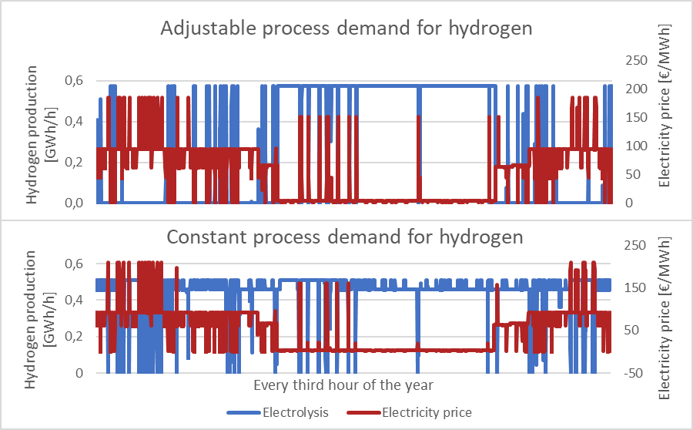
b)
Figure 1. Hydrogen production and electricity price with a three-hour time resolution over 1 year. a) is a process configuration that can use H₂ flexibly, b) is a process configuration that need constant feed of H₂ to operate.
4. Conclusions
The adjustable gasification process uses low-priced electricity to increase methane production and the process with a constant H₂ demand avoids H₂ generation at the hours with highest electricity price by using storage. Both a static and flexible H₂ demand increases the economic benefits of constructing variable electricity generation. Thus, there is economic incentive to combine electrolysers with biomass gasification from a process perspective while it constitutes a driving force to increase wind power capacity. Future work will include analysis of the possibilities to include CCS in the gasification process and sensitivity analysis on important economic parameters, e.g. biomass price.
References
[1] D. Connolly, B.V. Mathiesen, and I. Ridjan, Energy, 2014. 73: p. 110-125.
[2] V. Johansson, L. Göransson, Impacts of variation management on cost-optimal investments in wind power and solar photovoltaics. Renewable Energy Focus, Under review.
[3] J.M Ahlström, S. Harvey, and S. Papadokonstantakis, Computer Aided Chemical Engineering, 2018. 44: p. 109-114.
[4] L. Göransson, et al.,. Applied Energy, 2017. 197: p. 230-240.

