Degradation and valorization of post-consumer textile fiber composite materials
Michael Menden¹, Volker Steidel², Volker C. Hass^{1,*}
1) Hochschule Furtwangen University, Faculty of Medical and Life Sciences, Villingen-Schwenningen, D-78054, Germany; 2) Lauffenmühle GmbH & Co. KG, Lauchringen, D-79787, Germany
*Corresponding author: hass@hs-furtwangen.de
Highlights
- Accelerated biological degradation of PET-like textile fibres.
- Anaerobic and aerobic degradation of PET-like fibres.
- Mathematical process models for anaerobic and aerobic degradation.

1. Introduction
Textile polyester wastes are difficult to recycle due to their composition and a large number of different dyes and additives. In 2012 about 1,5 Mio. tons of textile wastes were recycled worldwide, while 4,3 Mio. tons were burned or stored in landfills [1]. Biodegradable synthetic fiber materials can potentially be recycled to generate biogas or be disposed via a composting process. Unfortunately, due to their slow degradation rates, processing them with common biogas- or composting methods would be unprofitable [2].
In this study, the influence of different process parameters on the degradation rate of a PET-like polyester were investigated. Furthermore, enzymatic and hydrothermal pretreatment methods were employed to improve the biodegradability of this polyester. Kinetic process models were developed to systematically plan and evaluate the experiments.
2. Methods
Alkaline and neutral thermal hydrolysis was performed in water or potassium hydroxide solution at different temperatures ranging from 100 to 150 °C in an airtight container. The degree of hydrolysis was determined by measuring the loss of solid material and by measuring the amount of released monomers via HPLC. For the evaluation of anaerobic and aerobic degradation carbon balances were applied to compare different process strategies. For composting, the evolved carbon dioxide was measured gravimetrically in accordance with ISO 14855-2 by absorbing it with soda lime. For anaerobic digestion, methane and carbon dioxide emissions from a miniature biogas plant were measured volumetrically. For future scale up, experiments were performed with composting and fermentation vessels of different volume.
Kinetic models were developed for aerobic and anaerobic degradation as well as neutral hydrolysis. Model parameters and initial states were adapted based on experiments earlier in this study. Based on model behavior process strategies for further experimentation were chosen.
3. Results and discussion
Experiments on aerobic and anaerobic degradation of biodegradable PET-like polyester with different process strategies were performed. The kinetic models have been expanded to reflect the influence of pH and temperature on the degradation process. It has been shown for both the aerobic and anaerobic model, that they can be adapted to reflect the experimental results. For the anaerobic process model-based predictions have been made for different process strategies. The strategy which promised the highest degree of degradation within 31 days was chosen for an additional experiment. As seen in figure 1 the kinetic model could successfully predict an increase of the degree of degradation within 31 days.
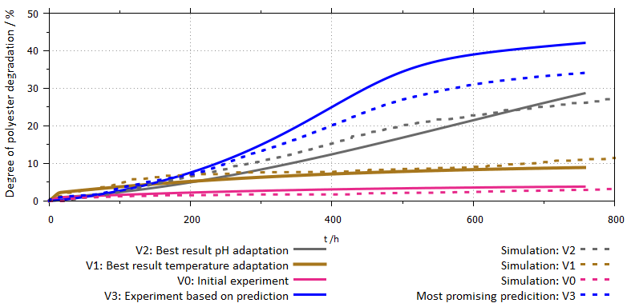
Figure 1. Model based improvement for the anaerobic digestion process of an biodegradable PET-like Polyester. Parameters for the anaerobic digestion model were chosen based on experiments V0, V1 and V2. Different predictions for new process strategies were made via the parametrized model. A new experiment V3 was performed based on the most promising prediction.
For enzymatic and thermal hydrolytic pre-treatment experiments for different pretreatment strategies were performed. The kinetic model for polyester hydrolysis was successfully adapted to reflect the influence of temperature and time on the degree of the resulting hydrolysis.
4. Conclusions
It has been shown, that aerobic and anaerobic degradation of a biodegradable polyester could be accelerated by improved process strategies and enzymatic or thermal hydrolytic pretreatment of the polyester. A kinetic model has been successfully applied to determine an improved strategy for the anaerobic degradation process.
References
- Lacasse, K.; Baumann, W. (2012): Textile Chemicals: Environmental Data and Facts. 1 Band. Heidelberg: Springer Science & Business Media.
- Soroudi, A.; Jakubowicz, I (2013): Recycling of bioplastics, their blends and biocomposites: A review. In: Eur Polym J 49 (10), S. 2839-2858
- G.R. Pangar, L. Liu, in: N.C. Jones, A. Bianchi (Eds.), The Electronic Technology, E-Publishing Inc., New York, 2009, pp. 181–304.

