Photocatalytic Oxidation in a Rotor-Stator Spinning Disk Reactor: Improving Process Sustainability
Arnab Chaudhuri¹, Parimala Shivaprasad^{1, 2}, Koen Kuijpers¹, Emma Anna Carolina Emanuelsson², Timothy Noël¹, John van der Schaaf¹*
¹ Deparment of Chemical Engineering, TU Eindhoven, 5612 AZ, Eindhoven, Netherlands
² Department of Chemical Engineering, University of Bath, BA2 7AY, Bath, United Kingdom
*Corresponding author: J.Vanderschaaf@tue.nl
Highlights
- Photocatalytic Oxidation of L-methionine was investigated with a RS-SDR
- High conversions were obtained with short residence times indicating possibilities for improvements in process sustainability
- Results were compared to conventional reactor systems

1. Introduction
In recent years, process intensification (PI) has been a promising pathway to achieve sustainable chemical production [1]. The rotor-stator spinning disc reactor (rs-SDR) is one such PI reactor were high shear force on the feed due to velocity gradients between the rotor and the stator result in high rates of mass and heat transfer [2]. This leads to rs-SDR being a particularly interesting reactor for photochemical applications where photon transfer and mass transfer of the activated species are often limited (e.g. for high concentration). In this study, we demonstrate the potential of a photo-rs-SDR for applications towards photochemical reactions. A challenging reaction where additional gas-liquid mass transfer limitations are observed has been selected for this study [3].
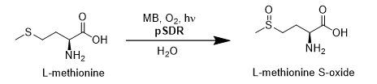
Figure 1: Reaction scheme
2. Methods
The oxidation of L-methionine with methylene blue as the catalyst (Fig.1) was chosen as the model reaction for this proof of concept study. The rs-SDR was illuminated using a solar light simulator (AM1.5G), to ensure no light limitations. The reaction was carried out by co-feeding the reaction solution and oxygen at the bottom of the reactor; samples were collected after a single pass and the reaction conversion was measured using HPLC. The schematic is illustrated in Fig 2.
3. Results and discussion
A few of the results obtained are presented in this abstract. As illustrated in Fig 3, the reaction conversion (residence times between 24—28 seconds) increased with increasing rotation speed

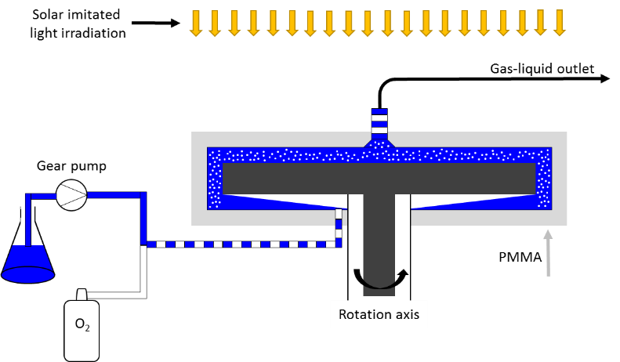

Figure 2: Schematic representation of the reactor set-up

Figure 3: Effect of spinning speed and gas-liquid flowrate on reaction conversion

up to 900 RPM. A maximum conversion of 55% was observed at 900 RPM for an optimum gas-liquid flowrate. Such high conversions within 24 seconds of residence time indicate that productivity of photochemical reactions can be significantly improved. Larger phase separations were observed at higher RPMs which caused inefficient mixing, leading to lower conversions.
The effect of rotation speed, gas-liquid flowrate and catalyst concentration on the reaction conversion have also been investigated under both the solar limit simulator and more limiting conditions. Additionally, the results were compared to two conventional reactors which are currently used in photochemistry: batch and microflow.
4. Conclusions
To the best of the authors’ knowledge, this is the first study of a successful synergistic reaction system using photochemistry and the rs-SDR. We are currently investigating the potential of the photo rs-SDR for targeted applications in pharmaceuticals and the fine chemical industries to further illustrate how process intensification can lead to improvements in sustainability.
References
[1] Vlachos, D.G. and S. Caratzoulas, Chemical Engineering Science 2010, 18-29.
[2] Meeuwse, M., J. van der Schaaf, and J.C. Schouten, AIChE Journal 2012, p. 247-255.
[3]Emmanuel, N., Mendoza, et. al., Organic Process Research & Development, 2017, p. 1435-1438.

