Impact of bead collisions on hWJ-MSC culture performances
C.Sion^{1,2}, C.Loubière^{1,2}, M. Wlodarczyk-Biegun³, N.Davoudi⁴, C.Müller⁴, I.Chevalot^{1,2}, E. Guedon^{1,2}, E.Olmos^{1,2}
1 CNRS, Laboratoire Réactions et Génie des Procédés, UMR 7274, 2 avenue de la forêt de Haye, TSA 40602, Vandœuvre-lès-Nancy, 54518, France ; 2 Université de Lorraine, LRGP, 2 avenue de la forêt de Haye, TSA 40602, Vandœuvre-lès-Nancy, 54518, France ; 3 INM - Leibniz-Institut für Neue Materialien gGmbH,Campus D2 2, 66123 Saarbrücken ; 4 FB Physik und Forschungszentrum OPTIMAS,AG Grenzflächen, Nanomaterialien und Biophysik, Kaiserslautern
*Corresponding author: eric.olmos@univ-lorraine.fr
Highlights
- Agitation mode and microcarrier distribution within the bioreactor have an important impact on MSC culture.
- Collisions between microcarriers are detrimental to MSC viability
1. Introduction
Mesenchymal stem cells extracted from the Wharton’s jelly of human umbilical cords (hWJ-MSC) are of increasing interest for cell therapies due to their reduced immunogenicity, high expansion capabilities, fast growth kinetics and various growth factors synthesis capabilities. To address the problem of cell confluence on microcarriers during their culture in stirred bioreactors, it was previously shown that the addition of fresh microcarriers could maintain the cell growth and could allow reaching higher cell densities than without microcarriers feeding [1]. However, the resulting increase in the bead shocks frequency could also negatively impact cell quantity and quality. Until now, no quantitative study describing the impact of bead interactions on MSC death was reported in the literature. It is crucial to determine the respective influence of microcarrier feed strategy and microcarrier mixing characteristics on cell viability and to propose robust culture conditions of mixing and microcarrier concentrations. The objective of this study was to demonstrate the importance of the agitation mode on the expansion and the ability of cells to migrate to new fresh carriers. It appears that agitation has an important impact on the cell death and more precisely on the cell lysis in microcarrier cell cultures due to the lack of protective cell wall, high cell size and the lack of individual cell mobility [3].
2. Methods
hWJ-MSC were cultivated on Cytodex-1 microcarrier in HPL-supplemented medium, with an initial concentration of 7000 cells/cm². Previous studies (Loubière et al. 2018) showed that the best choice of microcarrier for hWJ-MSC adherence and expansion, in dynamic conditions, was Cytodex-1 [2]. Two types of culture systems were evaluated, shaken flaks (orbital agitation) and spinner vessels (mechanical agitation), agitated below or above particle just-suspended agitation rate (N_{js}). Glucose, glutamine, ammonium, lactate and lactate dehydrogenase concentrations were monitored every day. Moreover, cells were counted from the post-processing of DAPI-stained cells pictures [2]. Using this method, a strategy of microcarrier feeding at an appropriate time during the culture was established to maintain a constant target value of cells per microcarrier [4].
3. Results and discussion
First, it was shown that hWJ-MSC bead-to-bead transfer appeared to be a potential way to avoid or delay cell and microcarrier aggregation, allowing an increase of the maximal total cell number in comparison with a culture with only medium feed addition. This assessment was applied to all culture systems: shaken flasks or spinner vessels. In the meantime, better performance of bead-to-bead transfer could be obtained by controlling N_{js} and the mode of agitation. The results also showed that the addition of fresh microcarriers could have a significant negative impact on cell viability, as revealed by the dead cell staining and the strong increase in LDH concentration in the liquid phase (Figure 1). However, as indicated by LDH concentration measurements, this was particularly the case in orbitally shaken flasks and below N_{js}. For these conditions, a concentration of microcarriers was observed in the lower part of the bioreactor, promoting more frequent collisions.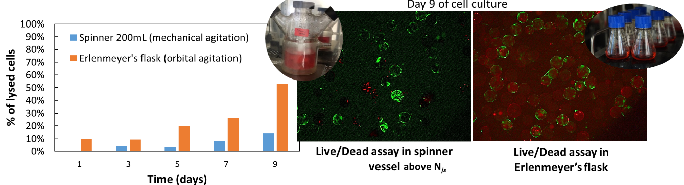
Figure 1. Impact of the cell culture system on viability and cell lysis.
Consequently, these results suggest that the collisional energy dissipation was more detrimental to cell viability than the hydromechanical stress arising from mechanical agitation. Hence, a compromise must be found between a limited concentration in microcarriers and the ability of cells to migrate towards other microcarriers, promoted by contact between them.
4. Conclusions
To conclude, this study underlined the importance of the just-suspended state determination and particle distribution in the bioreactor on the hWJ-MSC performances, notably during the bead-to-bead transfer phenomena.
References
- Ferrari, C., et al., (2012). Limiting cell aggregation during mesenchymal stem cell expansion on microcarriers. Biotechnology progress, 28(3), 780-787
- Loubière, C., et al., (2018). Impact of the type of microcarrier and agitation modes on the expansion performances of mesenchymal stem cells derived from umbilical cord. Submitted to Biochemical Engineering Journal.
- M. S. Croughan, J.-F. Hamel, D. I. Wang, Hydrodynamic effects on animal cells grown in microcarrier cultures, Biotechnology and bioengineering 67 (2000) 841–852.
- Sion C., Loubière C., Grandfils C, Sevrin C., Vandeberg R., Guedon E., Chevalot I., Olmos E.
Control of microcarrier feed time by quantitative determination of bead-to-bead transfer
during hMSC cultures. Conference at the European Society of Biochemical Engineering Science
(ESBES), Lisbon, in September 2018

