Adaptive, Model-Based Control of Saccharomyces cerevisiae
Fed-Batch Cultivations
Christian Appl¹, Christian Fittkau¹, André Moser¹, Volker C. Hass^{1,*}
¹Furtwangen University, Faculty of Medical and Life Sciences, Villingen-Schwenningen, D-78054, Germany
*Corresponding author: hass@hs-furtwangen.de
Highlights
- Adaptive, nonlinear model predictive controller
- Optimization of aerobic Saccharomyces cerevisiae cultivations
- Implementation of a NMPC with a commercial process control system

1. Introduction
The Open Loop Feedback Optimal (OLFO) controller belongs to the class of adaptive nonlinear model predictive controllers [1]. The controller consists of a model parameter identification part and an optimization part. Model parameters are estimated frequently on the basis of available online and offline data. The updated model parameters are passed on to the optimization part, where process trajectories like substrate feeding profiles are calculated. Based on the process of yeast cultivation, the controller was tested in virtual and real experiments.
2. Methods
For the implementation of the OLFO controller two communicating WinErs-projects (IB Schoop GmbH) were created and executed simultaneously. Project 1 is a conventional process control project for controlling the bioreactors Biostat B (2 L) and Biostat C (20 L) (B. Braun). Project 2 contains the OLFO controller. The required parameter estimators and process optimizers were realized in WinErs via available packages. In our work the Saccharomyces cerevisiae cultivation model was integrated in form of a C-eStIM – WinErs – Interface – *.dll [2]. The basis for model development were several batch and fed-batch cultivations of S. cerevisiae. The OLFO project received the required state variables from the current process. These data were used to adapt the parameters and initial states of the deposited yeast culture model. Based on this, the glucose feed rates were calculated to achieve a maximum biomass density in the further course of the process. The calculated feed rates were transferred to the process control system (project 1).
3. Results and discussion
Figure 1 shows the result of a virtual yeast cultivation using the OLFO controller. The controller can adapt the parameterization of the used process model to fit the data of the cultivation process and map the trend.
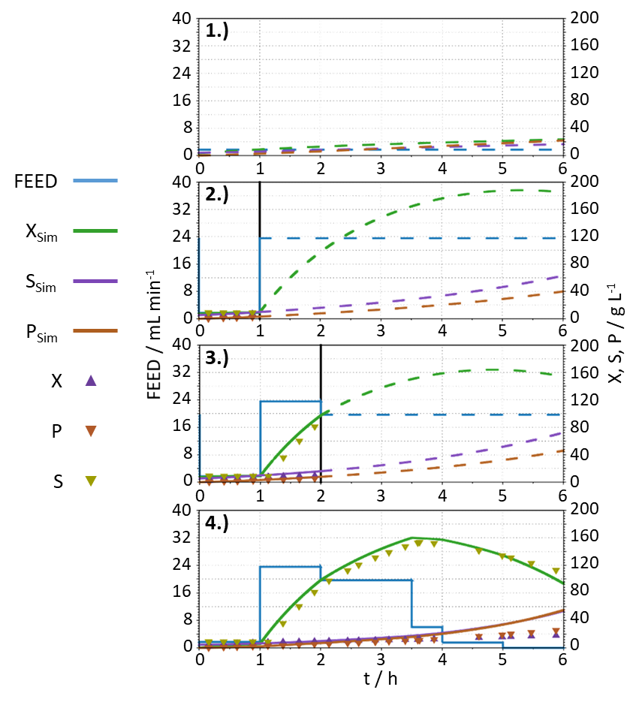
Figure 1. Demonstration of the OLFO controller working principle using a virtual bioreactor [3]. Dashed lines show the predicted trend for feed and concentration of the model utilized by the OLFO Controller.
Furthermore, fed-batch cultivation experiments were carried out in stirred tank reactors (STR). The transfer of the OLFO controller to real experiments was successful. The potential of the OLFO strategy is clearly visible. In subsequent works the OLFO controller will be used to optimize the cultivation process.
4. Conclusions
Our yeast cultivation experiments show, that even fairly simple mathematical models may successfully be used within the OLFO controller and lead to an increase in biomass production. The tool is now available for the systematic optimization of aerobic microbial cultivations.
References
- R. Luttmann, et. al., In: Agricultural Feedstock and Waste Treatment and Engineering. Advances in Biochemical Engineering / Biotechnology, Vol. 32, p. 95-205.
- F. Kuhnen, Modellierungssystem C-eStIM. Kurzeinführung. Hochschule Bremen, internal communication (2008).
- V.C. Hass, R. Pörtner, Praxis der Bioprozesstechnik mit virtuellem Praktikum, 2. Auflage (2011)

