Enhanced natural attenuation by stimulation of anaerobic microflora in a previously aerobic groundwater
Giovanna Carpani¹, Ilaria Pietrini¹, Luca Serbolisca¹, Camilla Lanari², Lucia Poppa², Luciano Zaninetta²
1 Eni S.p.A., Environmental Technologies (TEAMB); 2 Syndial S.p.A., Research & Technology Innovation
*Corresponding author: giovanna.carpani@eni.com
Highlights
- Treatment of groundwater contaminated by a mix of chlorinated hydrocarbons
- Isolation of biodegrading aerobic strains
- Trial of treatment of the remaining pollutants under anaerobic conditions
- Monitoring of the treatment

1. Introduction
Halogenated solvent-contaminated sites are a worldwide problem in industrialized countries. Chlorinated ethenes are among the most diffused pollutants in groundwaters; they are prevalently degraded by reductive dechlorination reactions, which take place under anaerobic conditions. In some cases, groundwater conditions does not support anaerobic respiration processes, because of redox conditions and due to the presence of not negligible oxygen concentrations. The present work illustrates a pilot trial of anaerobic treatment in a chlorinated compounds polluted aerobic groundwater, by the use of slow release amendments for the stimulation and growth of the anaerobic microflora after the total consumption of the oxygen present in the water.
2. Methods
Microcosms set up (aerobic conditions). 1L of groundwater was filtered (0,22 μm) and the particulate was used to inoculate a number of aerobic cultures (30 ml each) set up with the same sterilized groundwater additioned of ammonium chloride, potassium phosphate, sodium chloride, oligoelements and vitamins (pH 6,7).
Chemical analysis. 1,2-dichloroethane concentration was followed by Headspace GC analysis on a DB-5 Megabore column. Chemical analysis during monitoring of the pilot test were conducted by a certified laboratory.
qPCR experiments. The DNA extracted from groundwaters was amplified in qPCR experiments using the primers for Dehalococcoides sp. (Cocc728f aaggcggttttctaggttgtcac - Cocc944r cttcatgcatgtcaaat) or coding for dehalogenases bvcA, vcrA and tceA (bvc925F aaaagcacttggctatcaaggac – bvc1017R ccaaaagcaccaccaggtc, vcr1022F cgggcggatgcactatttt - vcr1093R cgggcggatgcactatttt, tceA1270F atccagattatgaccctggtgaa – tceA1336R gcggcatatattagggcatctt).

3. Results and discussion
The initial aerobic conditions of the groundwater showed the presence of bacteria able to degrade 1,2-dichloroethane, present in concentrations of 1 - 10 ppm. The degrading species was isolated and identified as Ancylobacter sp.; some species, such as A. dichloromethanicus, are known to metabolize 1,2-dichloromethane, in addition to other carbon sources (chlorinates alcohols, methanol, formate, succinate and formaldehyde). The species showed a good activity and resistance to 1,2-DCA, up to 800 ppm (Fig. 2). After a few years, the analysis of groundwater showed the almost total consumption of this pollutant, while chlorinated ethenes remained non-degraded. The injection of the selected amendment resulted in the change of redox conditions and in the consumption of the oxygen present in almost all the analyzed wells. Monitoring of the chlorinated ethenes showed the initial reduction of concentrations of perchloro- and trichloroethene (PCE – TCE) and the slight start in the increase of 1,2-cis dichloroethene (1,2-cisDCE) as the first product of the metabolic chain a few months after injection (Fig. 2). qPCR experiments were set up to identify the presence of species belonging to Dehalococcoides group and also for the confirmation of the presence of enzymes involved in PCE – TCE degradation.

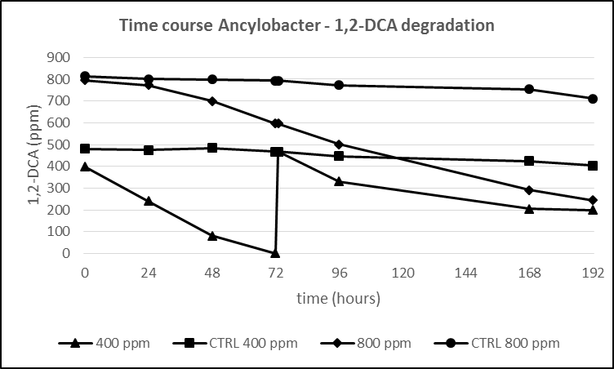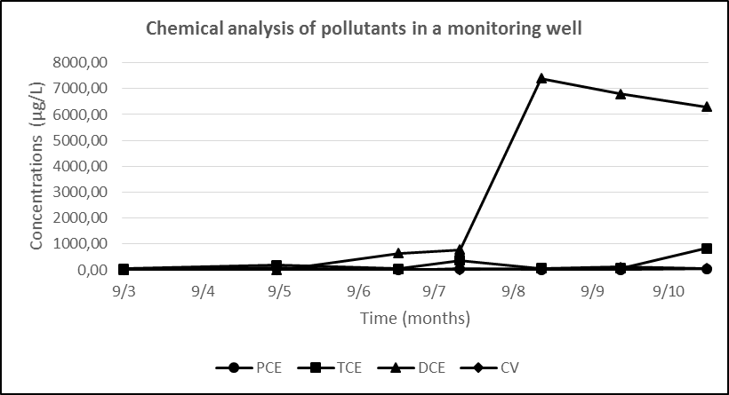

Figure 1. Time course of Ancylobacter sp. 1,2-DCA Figure 2. Chemical analysis of the chlorinated hydrocarbons
degradation; T=72: 400 ppm spike 1,2-DCA after the injection of the slow-release amendment

4. Conclusions
The preliminary results of this work show the potential, for chlorinated hydrocarbons remediation, to follow natural attenuation in the groundwater conditions if the suitable microbes are present. In a second phase, it is possible to change redox/oxygen conditions shifting to anaerobic conditions and stimulating anaerobic degrading bacteria with appropriate amendments. This protocol is particularly useful in the case of mixed contamination of different chlorinated compounds.

References
- A. Tiehm and K.R. Schmidt , Curr. Op. Biotechnol. 22 (2011) 1–7.

