Dynamic Laser Speckle Technique to Monitor Biological Tissues Under Magnetic Field.
Roberto Azevedo¹, Roberto Braga², Renato Guimaraes², Caio Salgado³, Leandro Reis²
1 IFSULDEMINAS, Campus Machado, Rod. Machado-Paraguaçu km 3, Machado MG, Brazil; 2 UFLA, CP 3037 Lavras MG, Brazil, 3 Klabin, Av. Brasil, 26 Telêmaco Borba PR, Brazil
*Corresponding author: robertobraga@deg.ufla.br, robbraga@gmail.com
Highlights
- Dynamic laser speckle is sensitive to biological changes in tissues.
- Magnetic field enhance activity in seeds.
- Magnetic field can enhance germination.
- Dynamic laser speckle can identify the increase of activity in seeds after magnetization.

1. Introduction
We live in a permanent magnetic field of low intensity (30 to 60μT), however the increase of the field intensity can influence biological activities. In seeds, the application of a magnetic field around mT can improve their germination [1], while it is also possible to enhance plant growth [2] and some other characteristics in plants [3-7]. Despite the successful results reported, still remains issues about the best level of the magnetic field and its time of application in each biological material. Thus, to test the optimum procedure one needs to validate it using time consuming tests. In order to overcome the time limitations presented by the traditional tests, this work aimed to evaluate a well known optical method dedicated to monitor biological activity named dynamic laser speckle [ ]. This technique could provide faster analysis than the traditional ones as well as provide additional information such as a map of activity.
2. Methods
Seeds of coffee (Coffea arabica L.) were submitted to a magnetic field of 28mT during 6 days in a germinator. The field was from a permanent magnet and the seeds were placed inside the magnets associated to create the desired level. The seeds were placed in a germination paper imbibed in water and within the magnets. After 6 days in the germinator, the seeds, divided in control and magnetized, were illuminated by the laser and analyzed using a dynamic laser speckle index, the Absolute Value of the Differences AVD [9], to create a map of activity of the seed.
3. Results and discussion
Figure 2 presents the activity maps of a seed submitted to a magnetic field and another used as a control. In the maps (AVD index) it is possible to observe the higher activity in the embryo region when the 28mT field was applied. In the graphical outcome of the speckle images the pseudo-colors present the level of activity from low activity in blue to high activity in red. The same result was observed with replications. The usage of dynamic laser speckle to access the activity of the coffee’s embryo after 6 days was proved to be reliable if compared to the traditional test that usually demands 30 days in the germinator [8]. With this achievement the dynamic laser speckle can forecast the germination process and reduce significantly the time to test the result of magnetization in seeds with different combinations of time and level of magnetic field.
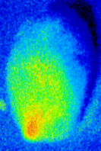 | 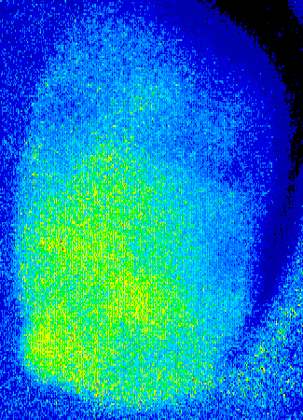
(a) | (b)
Figure 1. Maps of activity of a coffee seed using the dynamic laser speckle index, AVD, where in (a) the embryo presented high activity in red and in (b) the embryo in the bottom left did not presented the same activity in the early protusion

4. Conclusions
The dynamic laser speckle was able to identify the change caused by the magnetization in a coffee seed after 6 days of magnetization and before 24 days of the germination test.
References
[1] P.S. Phirke P.S., M.N. Patil, S.P. Umbarkar, Y.H. Dudhe Seed Sci Technol 24 (1996) 365–373.
[2] K. Namba , A. Sasao , S. Shibusama Acta Hort 399 (1995) 143–145.
[3] A. Aladjadjıyan J. Cent. Eur. Agri. 3 (2002) 89–94.
[4] A. Esitken J. Hort. Sci. Biotechnol. 78(2) (2003) 145–147.
[5] M. Rochalska, A. Orzeszko-Rywka Seed Sci. Technol. 33 (2005) 669–674.
[6] A. Souza, D. Garcia, L. Sueiro, F. Gilart, E. Porras, L. Licea Bioelectromagnetics 27 (2006) 247–257.
[7] E. I. Alemán, A. Mbogholi, Y.F. Yilan Fung Boix, J. González-Olmedo, A. Chalfun-Junior Pol. J. Environ. Stud. 23(1) (2014) 95-101.
[8] P. Vivas, L. Resende, R.A. Braga, R. Guimarães, R. Azevedo, E. Silva, P. Toorop Ann. Appl. Biol. 170 2016) 141-149.
[9] Braga, R. A., Rivera, F. P., Moreira, J. A Practical Guide to Biospeckle Laser Analysis: Theory and Software. (1st ed.). Editora UFLA, Lavras, 2016.

