Microalgal Triglycerides recovery during Day/Night Cycles:
Physiological influence over Downstream
Vladimir Heredia*¹, Marchal Luc¹, Cueff Marie¹, Hervé Laura¹, Gonçalves Olivier¹, Pruvost Jeremy¹
1 GEPEA-CNRS / 37 Bd de l’Université, 44600, Saint-Nazaire, France;
2 ALGOSOLIS / Chemin des Infirmieres, 44602, Saint-Nazaire, France
*Corresponding author: arturo-vladimir.heredia-marquez@univ-nantes.fr
Highlights
- Cell destruction is affected by day/night cycles and so TAG availability for downstream
- TAG recovery by wet-extraction was optimized with a Box-Behnken experimental design
- Optimal large scale TAG production relies on a key harvesting time during Day/Night cycles

1. Introduction
Coupling microalgae cultures at photobioreactor with cell destruction and wet-extraction has shown to be energy-efficient for recovering lipids¹. Also, Nannochloropsis gaditana is capable to produce up to 38% triacylglycerol (TAG) during nitrogen depletion². However, most of these cultures have been done only under continuous light, which means the cells have a constant energy supply for lipid synthesis. Large scale production brings to scene the challenges of maintaining high TAG yields in real day/night cycles (D/N). Notably, not all the produced lipids can be extracted mainly because of losses in downstream.
2. Methods
This approach involves four stages of analysis: I) Tracing the physiological changes and cell destruction during the culture at Subitec Flat panel 200L photobiorectors (One reactor -S2- was filled with ASW+CONWAY(3N3P) medium as a control; the second one –S1- was depleted in nitrogen source to trigger lipid accumulation), II) Bead-milling pre-optimization, III) A Box-Behnken DoE for wet-extraction optimization using a Rousselet centrifugal extractor and IV) Direct Impact of physiological changes on the final TAG recovery. The downstream process optimization has considered bead-milling duration, biomass concentration and solvent consumption.
3. Results and discussion
For a D/N of 15h/9h, it was shown that cell destruction at the end of the night is the most efficient (Figure 1). On the other hand it seems that TAG accumulation reaches its maximal level at the end of the day. Such a result may suggest an optimal harvesting time affecting the entire process which will be discussed. For cells coming from S2 (full media) it was only needed 2 or three destruction cycles for achieving ~80% destruction while for cells coming from depleted media, it was required 4 cycles. This reveals the influence of "stress by nutrients" over lipid availability.
The Box-Behnken experimental design, also reveals the optimal conditions to get the maximal efficiency for TAG recovery.
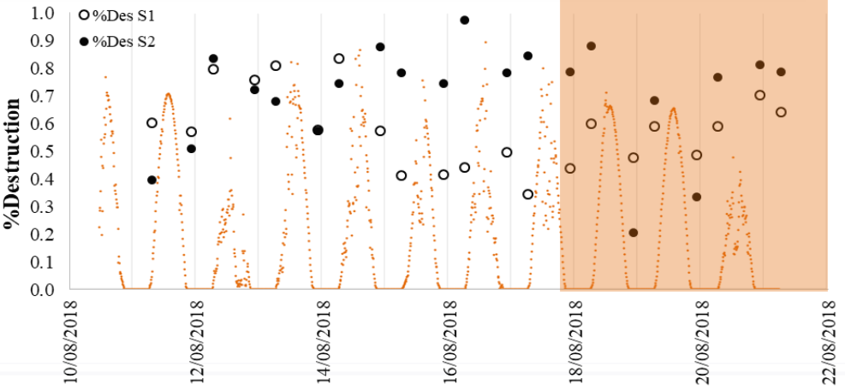
Figure 1. Destruction rate comparison for Nannochloropsis gaditana
during day/night cycles at two different growth conditions.

4. Conclusions
At the present day, no work had considered the direct effect of the D/N over the final TAG recovery. In the present work, a global approach is proposed to elucidate how D/N affects the cell destruction during nitrogen starvation coupled with the subsequent wet-extraction. Further studies will aim at proposing an optimal coupling between the production and downstream processing stage. This will take into account the dynamic of lipid production/consumption during D/N and changes in cell destruction during nitrogen starvation.
References
- Ghasemi Naghdi F, González González LM, Chan W, Schenk PM. Progress on lipid extraction from wet algal biomass for biodiesel production. Microb Biotechnol. 2016;9(6):718-726. doi:10.1111/1751-7915.12360.
- Simionato D, Block MA, La Rocca N, et al. The response of Nannochloropsis gaditana to nitrogen starvation includes de novo biosynthesis of triacylglycerols, a decrease of chloroplast galactolipids, and reorganization of the photosynthetic apparatus. Eukaryot Cell. 2013;12(5):665-676. doi:10.1128/EC.00363-12

