Ciprofloxacin photocatalytic degradation present in water using MOCVD deposition of TiO₂ and UVA LEDs
Thibaut Triquet¹, Claire Tendero², Romain Richard¹, Marie-Hélène Manero¹, Caroline Andriantsiferana^{1*}
1 Laboratoire de Génie Chimique, Université de Toulouse, CNRS, INPT, UPS, Toulouse, France; 2 Centre Inter-universitaire de Recherche et d’Ingénierie des Matériaux, Université de Toulouse, CNRS, Toulouse, France *Corresponding author: caroline.andriantsiferana@iut-tlse3.fr
Highlights
- CIP is degraded by photolysis with 365 nm UV but not its intermediates
- Photocatalysis with TiO₂ deposits is efficient to mineralized CIP
- Very low quantities of TiO₂ are sufficient to degrade CIP and its intermediates.
1. Introduction
Nowadays, many toxic molecules particularly micropollutants (pharmaceuticals products such as antibiotics, anti-inflammatory, analgesic) are present in waterways and underground water, causing serious consequences for the environment. Advanced Oxidation Processes (AOP) and particularly the photocatalysis are promising processes to eliminate such molecules by generating powerful and non-selective radical oxidants through UV irradiation of the catalyst (commonly powder of titanium dioxide TiO₂) [1]. When implemented in water treatment process, an expensive filtration step is then necessary in order to remove the catalyst. In this context, a deposit of TiO₂ on a support could propose a competitive industrial implementation. In this study, two different morphologies of TiO₂ coating were studied to eliminate a target antibiotic: the ciprofloxacin (CIP). Both compact and columnar coatings were synthetized using Metal Organic Chemical Vapor Deposition (MOCVD) [2]. The aim of this study is to compare the efficiency of TiO₂ powder and both coatings on the degradation of CIP using LEDs (365 nm).
2. Methods
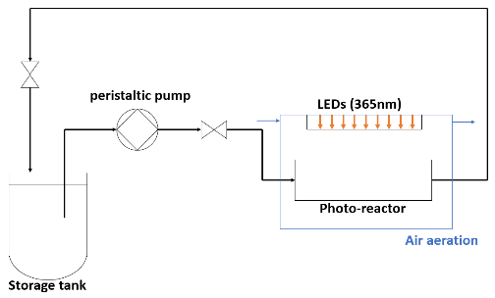
Analytical grade ciprofloxacin, C₁₇H₁₈FN₃O₃ (CIP, 98% purity) and TiO₂ powder (DEGUSSA-P25) were purchased from Sigma Aldrich. The deposition of TiO₂ on glasses surface were obtained by MOCVD [2]. Figure 1 represents the experimental set-up used for all photolysis and photocatalysis experiments. The top of the photo-reactor (130x10x12mm) is a window made of glass which is irradiated by LEDs (365 nm). The loop reactor is composed of the photo-reactor (V=15.6 mL) and a storage tank (V=100mL). The liquid flows via a peristaltic pump at a constant rate (200 mL/min). For each experiment, a 20mg/L CIP solution (100mL) was used and the temperature was maintained at 25°C (±1°C). For photolysis (without TiO₂), two irradiations were studied: 3mW/cm² and 10mW/cm². For photocatalysis (I=10mW/cm²), P25 was added (11.5mg and 5.6mg). In all experiments, an adsorption step of 1.5h was carried out before switching on the UV LEDs during 8h. The liquid samples were collected in the storage tank and filtered through a 0.45 µm membrane before being analyzed. The CIP concentration was determined by HPLC-UV (detector at 280 nm) and a C18 column. A measurement of Total Organic Carbon (TOC) was implemented before and after treatment.
Figure 1 : Experimental set-up
3. Results and discussion
Figure 2a shows the evolution of CIP concentration for both photolysis and photocatalysis experiments with TiO₂ powder and using glass TiO₂ deposits. Without photocatalyst, after 10h, 75% of CIP is degraded. In presence of a small quantity of TiO₂ powder, 100% of CIP degradation was obtained after 2h (11.5mg) and 4h (5.6mg). After 8h of irradiation, the COT removal is higher than photolysis: 55-61% with P25 powder vs 8% without TiO₂. Even if the target molecule is easily degraded by photolysis, the problematic intermediates have not been eliminated [3]. In presence of low amount of catalyst, a total mineralization is not reached for both cases, in agreement with literature [4]. In addition, refractory aliphatic acids with small carbon chain remain generally in solution [4]. Indeed, as shown in Figure 1B, the areas, of the chromatogram pics associated to the intermediates, decrease and after 6h, these intermediates have almost disappeared. The efficiency of TiO₂ deposits is comparable to the one of P25: the amount of carbon removal is 55% for columnar coating and 64 % for the compact one. However, the degradation kinetic is slower than experiments with P25, probably due to a lower surface available for photocatalysis reaction. This could be explained by (i) the inaccessibility of the part of TiO₂ fixed on the glass and/or (ii) a possible recombination of the electron-hole pair due to the low quantity of O₂ near the glass.
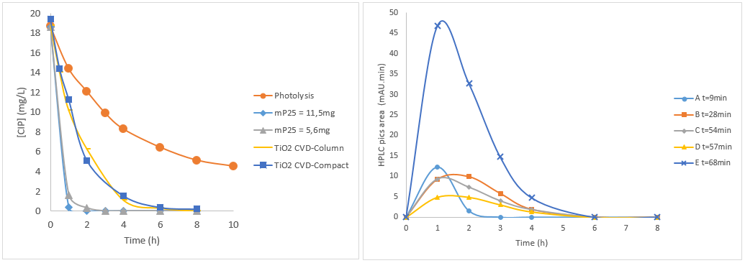
m_{P25} = 5.6mg
(a)
(b)
Figure 2 : Photolysis ant photocatalysis kinetics (a) and HPLC peaks area of principal intermediates A, B, C, D and E (b)
4. Conclusions
It has been shown that ciprofloxacin can directly react with 365 nm UV but a total mineralization of CIP cannot be achieved (8h/8%). In presence of a low TiO₂ powder quantity (11.5mg), photocatalysis is efficient: a total CIP degradation (2h) and a high TOC removal (8 h/61%). Both TiO₂ coatings on glass present the same photocatalytic activities and a total elimination takes 3 times longer than with powder. To go further, another support will be tested: activated carbon (AC). Indeed, previous studies have demonstrated the synergistic effect of AC and TiO₂ [5, 6].
References
- González-Labrada, Katia and al., Latin American Applied Research, 46(2016), 115-120
- F. Maury and F.D. Duminica F.D., Surf Coat Tech, 205 (2010) 1287
- Si Li. Jiangyong Hu and al., Water Research, 132 (2018), 320-330
- Muna Sh. Yahya and al., Chemosphere, 117 (2014) 447–454
- C. Andriantsiferana, E.F. Mohamed, H. Delmas, Env tech 35 (2014) 355
- C. Andriantsiferana, E.F. Mohamed, H. Delmas, Environ. Eng. Res. 20 (2015) 181

