Dewatering of Cellulose Nanofibrils (CNF) Suspensions using Centrifugation
Jennifer Astorsdotter¹, Eva Ålander¹, Maria Sedin¹
1 RISE Bioeconomy, Stockholm, Sweden; 2 Affiliation and address
*Corresponding author: maria-sedin@ri.se
Highlights
- It is possible to dewater CNF using centrifugation with industrial relevant g-forces.
- Addition of NaCl or decreased pH improves the dewatering of carboxymethylated CNF.
- Final concentrations achieved was 5.3 w% for enzymatic CNF.
- Final concentrations achieved was 4.4 w% for carboxymethylated CNF using NaCl.

1. Introduction
Dewatering and thickening of cellulose nanofibrils (CNF) suspensions are challenging. Traditional filtration-based dewatering processes are very time-consuming. Once the solids of the suspension start forming a network, the permeability is very low due to small size-scale of the particles and the compressibility of the fibre network. In centrifugation the dewatering flow counteracts the compression of the network, thus maintaining a higher permeability during the thickening process. Therefore, centrifugation may be a viable alternative separation method.
2. Methods
Two qualities of CNF were produced by passing either enzymatic pre-treated (CNF1) or carboxymethylation pre-treated (CNF2) pulps through a high-pressure homogeniser yielding CNFs at 2 w% with different size distributions and charge densities ^{1, 2}. An analytical centrifuge ³ was used to study the dewatering behaviour. The height of the supernatant was determined during centrifugation from in-situ light transmittance measurements at 25°C and the average sediment concentration was calculated. The influence of g-force, initial concentration, pH and ionic strength were investigated.
3. Results and discussion
The average concentration of the sediment at 2320g is shown Fig. 1 for CNF1 and CNF2. In the figure it can be seen that for CNF1 a final concentration greater than 5 w% could be achieved whereas the final concentration for CNF2 could not be increased if the initial concentration was greater than approximately 0.5 w%. This is due to the highly charged particles, 600 μeq./g, attained with carboxymethylation. For comparison CNF1 has a total charge of approximately 60 μeq./g. The time required to reach the final concentration is given in Fig. 1. For CNF1 the time was about 30–60 s but CNF2 required at least 2 min or more if the separation was possible.
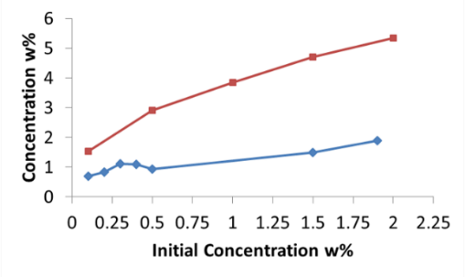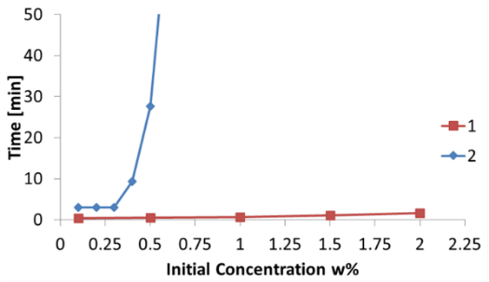
Figure 1. Effect of initial concentration on final concentration and separation time at 2320g for CNF1 and CNF2.
To improve the separation of CNF2, the pH and ionic strength of the suspension were changed. In Fig. 2 the effect of decreasing the pH is shown for 1.5 w% CNF1 and CNF2 suspensions. pH has a negligible effect for CNF1 on final concentration and separation time. On the other hand, the pH affects CNF2 significantly if the pH is less than 5; the final concentration is almost 4 w% and the separation time is comparable to CNF1 or even less. This is due to the protonation of the carboxyl group introduced in CNF2; pK_{a} approximately 4. Decreasing the pH will therefore reduce the electrostatic repulsion between CNF2 particles and improve the separation. The effect of adding NaCl to the suspension showed the effect of shielding the charges on the particles. At 0.1 and 0.5 M NaCl the final concentration at 2320g was 3.7 and 4.4 w%, respectively, for CNF2 whereas NaCl had a negative effect on CNF1. The effect of pH and NaCl on CNF2 was also visible in the light transmittance measurement: a zone with a concentration gradient was observed for CNF2 but not for CNF2 with NaCl added or pH adjusted.
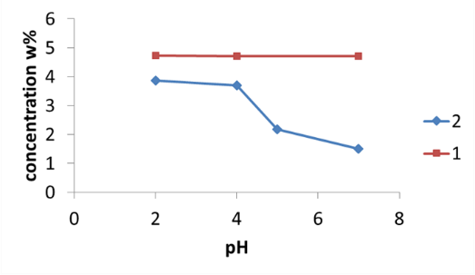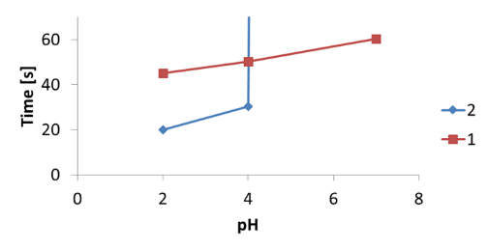
Figure 2. Effect of pH on final concentration and separation time at 2320g for CNF1 and CNF2 with initial concentration of 1.5 w%.
4. Conclusions
With centrifugation it is possible to increase the concentration of CNF1 (enzymatic) to more than 5 w% with a separation time of less than 60 s at 2302g. At an initial concentration above 0.5 w%, it is not possible to dewater the carboxymethylated CNF2, but with addition of electrolyte (shielding of charges) or decreasing the pH (protonation) 4 w% and a comparable separation time as CNF1 is reached.
References
- Pääkko, M., M. Ankerfors, H. Kosonen, A. Nykänen, et al., Biomacromolecules 8(6) (2007) 1934–1941.
- Siró, I., D. Plackett, M. Hedenqvist, M. Ankerfors, et al., J. Appl. Polym. Sci. 119(5) (2011) 2652–2660.
- Sobisch, T. & D. Lerche, Colloids Surf. A 331(1–2) (2008) 114–118.

