Pilot-scale application of electro-coagulation for treatment of industrial effluents
Pavel Krystynik¹, Petr Kluson¹, Michal Syc¹, Pavel Masin², Josef Jadrny³

1 Institute of Chemical Process Fundamentals of the CAS, v.v.i., Rozvojova 135/1 Prague 16502 Czech Republic; 2 Dekonta a.s., Dretovice 109, 273 42 Stehlceves, Czech Republic; TERMIZO, a.s., Dr. M. Horákové 571/56, 460 06 Liberec, Czech Republic
*Corresponding author: krystynik@icpf.cas.cz
Highlights
- The large scale electrocoagulation unit was operated on site - plant for energetic use of wastes.
- The technology showed solution for industrial effluent (removal of Zn, Pb, Cd).
- Removal of contaminants was successful reaching removal efficiencies above 90 %.

1. Introduction
Electrocoagulation is a water treatment method which can be used for removal of a wide range of contaminants, especially dissolved metallic ions via (co)precipitation processes. The method is an alternative method to standard chemical coagulation, which is one of the most common water and wastewater treatment processes. Whilst chemical coagulation is one of the commonly used procedure in industry, where soluble salts of Al or Fe are used (e.g. Al₂(SO₄)₃ and FeCl₃), in electrocoagulation (EC) precipitating agent (e.g. Al³⁺, Fe³⁺) is generated by corrosion of metallic electrodes made of aluminum or steel. The use of electrodes as a source of Fe or Al ions to solution, effectively replaces chemical dosing stations with more compact electrochemical reactors.
2. Methods
The process was tested in pilot-scale unit placed in movable container and operated in continuous regime on site - plant for energetic use of wastes. Two types of process effluent streams were tested:
- Process water at pH 8.4
- Water focused on Zn reduction
3. Results and discussion
Process water at pH 8.4 was tested with different regimes of pretreatment:
- No pH adjustment
- pH adjustment with addition of Ca(OH)₂
- pH adjustment with Na₂S
The EC cell was operated with flow rate 350-400 l/h with current input 60 A, providing 150-180 mg/l Fe according to Faraday’s law, established voltage oscillated between 1.2 and 3.5 V depending on electrode surface passivation.

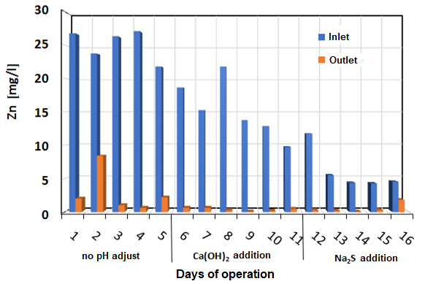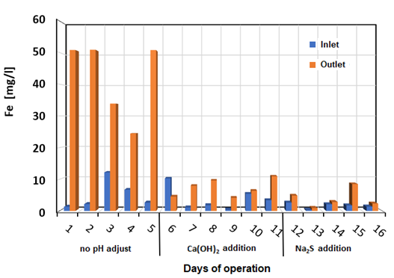
Figure 1. Concentration of Zn (left) and residual Fe (right) during operation with various ways of pretreatment

Figure 1 describes results of Zn concentration before and after treatment by EC with corresponding pretreatment. It is obvious that removal efficiency of Zn in most of the case exceeded 90 % and thus it can be claimed that pH adjustment for Zn removal is not of a significant benefit. Also, other contaminants like Pb or Zn were followed (not plotted). In case of Pb, removal efficiencies were not significantly influenced by pH adjustment while in case of Cd, addition of Na₂S significantly enhanced its removal. That’s due to formation of water insoluble CdS. In case of residual Fe, the situation is different. Here, pH adjustment significantly reduces residual concentration of Fe in treated water. The energy consumption during operation was also monitored.
4. Conclusions
The results have shown that the removal efficacies of Zn are satisfactory high and in most of the cases exceeded 90 %. In case of Zn, pH adjustment was not of significant benefit. It is also very reliant on contaminant content in treated effluent. It was verified that electrocoagulation has a great potential in contaminant removal from industrial effluent. The energy consumption was determined to be 0.75-1.1 kWh/m³ of treated water.

Acknowledgement
Financial support of Technology Agency of the Czech Republic (project No.: TH03030388) is gratefully acknowledged.

