Extraction of Glycyrrhetinic acid from Dried Licorice Root by using Supercritical Carbon Dioxide.
Kohei Wada and Masanao Imai*
Course of Bioresource Utilization Sciences, Graduate School of Bioresource Sciences, Nihon University,
1866 Kameino, Fujisawa, Kanagawa-pref. 252-0880, Japan
*corresponding author: XLT05104@nifty.com
Highlights
- Glycyrrhetinic acid was extracted by supercritical carbon dioxide from dried Licorice.
- Extracted amount was increased with increasing pressure and decreasing with temperature.
- Extracted amount was correlated with estimated density of supercritical carbon dioxide.
- Lower energy required for extraction led higher extracted amount of glycyrrhetinic acid.

1. Introduction
Licorice is one of major medicinal herbs expecting anti-inflammatory and anti-cancer^{1-3］}. Pharmaceutical effects have been brought by glycyrrhetinic acid. In the licorice root, glycyrrhetinic acid is contained as an aglycone and glycyrrhizin is also included glycoside. In this work, glycyrrhetinic acid was focused as a target component. Supercritical carbon dioxide (SCCO₂) has been anticipated as lowest risk solvent and non-residual character in products. The aim of this study is to measure of effect of temperature and pressure on extracted amount of glycyrrhetinic acid. Extracted amount was correlated with the estimated density of supercritical carbon dioxide. Energy required for extraction was preliminary evaluated and then correlated with the extracted amount of glycyrrhetinic acid.
2. Methods
Licorice root was purchased from Uchida Wakanyaku Ltd. (Tokyo, Japan). Pure glycyrrhetinic acid (98%) was purchased from FUJIFILM Wako Pure Chemical Industries, Ltd (Osaka, Japan). It was used to determine the calibration curves to measure the concentration of glycyrrhetinic acid by high performance liquid chromatography. The mean size of the powdered licorice root was varied from 200 to 990 μm. The SCCO₂ extraction apparatus was presented in Fig.1^{4]}. The extraction was operated as batch mode. Extraction period was 30 min. throughout this study.
3. Results and Discussion
Extracted amount in this study was expressed as [mol-target・(g-dried‐sample)⁻¹・(mol-SCCO₂)⁻¹]. Liquid-solid extraction by ethanol was employed as a primary experiment. Extracted amount was 6.0 [mol-target・(g-dried‐sample)⁻¹・(mol-SCCO₂)⁻¹] at 303K.
The extracted amount was decreased with increasing temperature (Fig.2). It was remarkably decayed in the range of 313-318 K. The extracted amount was gradually increased with increasing pressure (Fig.3). Density of supercritical carbon dioxide was estimated by Bender’s empirical equation^{5］}. The extracted amount was strongly depended on the density within 0.71-0.93 [g・cm⁻³]. Energy required for extraction was evaluated from the square of difference of solubility parameters between SCCO₂ and glycyrrhetinic acid. Lower required energy led higher extracted amount of glycyrrhetinic acid.
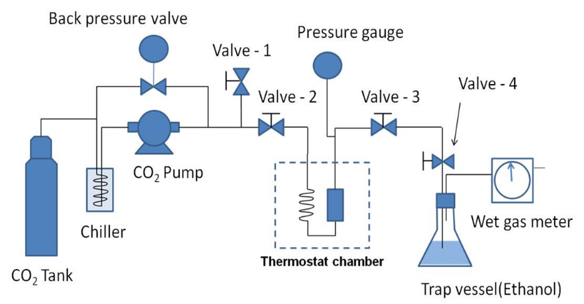
Fig. 1. Schematic illustration of SCCO₂ extraction process

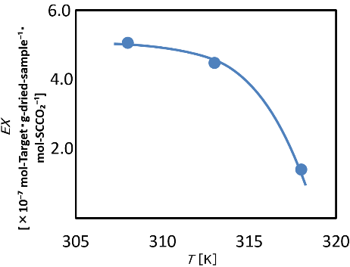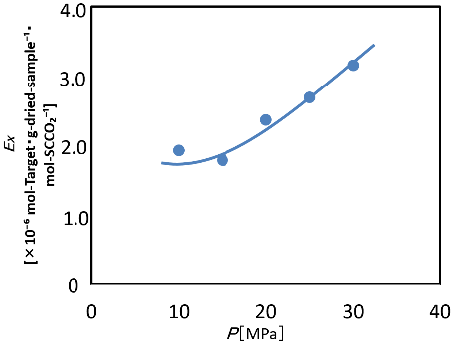
Fig. 2. Effect of temperature on the extracted amount Fig. 3. Effect of pressure on the extracted amount

4. Conclusions
Glycyrrhetinic acid was successfully extracted by supercritical carbon dioxide from dried Licorice root ranging 308-318K and 10-30MPa. Extracted amount was increased with increasing pressure and decreasing with temperature. Extracted amount was closely correlated with the estimated density of supercritical carbon dioxide. Energy required for extraction was estimated from solubility parameter of supercritical carbon dioxide and glycyrrhetinic acid. Lower energy required led higher extracted amount of glycyrrhetinic acid.
References
- Nomura T, Fukai T, Akiyama T., Pure. Appl. Chem. 74(2002) 1199-1206.
- Cao L, Ding W, Jia R, Du J, Wang T, Zhang C, et al., 64 (2017) 234-242.
- Wang L, Yang R, Yuan B, Liu Y, Liu C., Acta Pharm Sin B 5 (2015) 310-315.
- Saotome,Y.and Imai,M., Food Sci. and Technol. Res. 24 (2018) 63-73 .
- Bender,E., 5th Symposium on Thermophysical Properties,New York (1970) 227-235.

