Fixed-bed reactors from metal-foam pellets: experiments and CFD models
Gregor D. Wehinger¹, Ginu George¹, Stan T. Kolaczkowski²,
Didier Beton³, Leonhard Schmalhorst³, and Lars Torkuhl³
1 Chemical and Electrochemical Process Engineering, Clausthal University of Technology; 2 Chemical Engineering, University of Bath, 3 Alantum Europe GmbH
*Corresponding author: wehinger@icvt.tu-clausthal.de
Highlights
- Comprehensive and validated modeling approach for porous pellet fixed-beds.
- Synthetic bed generation gives realistic bed structure also for porous pellets.
- Porous resistance approach shows good results for pressure drop in full fixed beds.
- Explorative heat transfer study reveals promising characteristics of porous pellet beds.

1. Introduction
During the last two decades, a certain interest has arisen to apply open-cell solid foams as structured catalyst support. Kolaczkowski et al. compared pellets made from metal foams, see Figure 1, with monolith-foam structures in terms of pressure drop and heat transfer performance [1]. In the manufacturing process, different pellet shapes can be realized. The foam pellets showed advantages, especially due to their mixing behavior. However, a systematic investigation of the potentials and weaknesses of open-cell foam pellets applied in fixed-bed reactors is missing up to date.

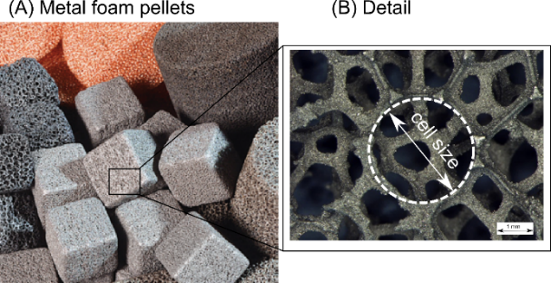 | (C) Manufacturing process  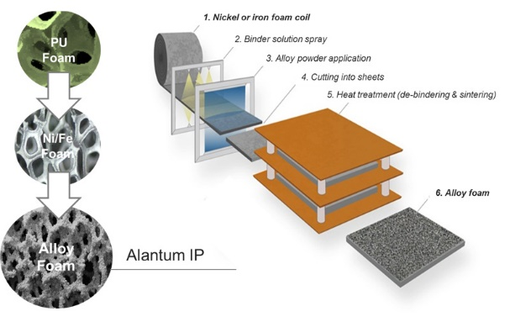
Figure 1: (A) Metal foam pellets with (B) details. (C) Manufacturing process of alloy metal foams.

2. Methods
In this contribution, the established particle-resolved CFD model [2] is transferred to fixed-bed reactors made of open-cell metal foams. The randomly oriented pellets forming the packed bed are captured geometrically. However, instead of resolving the inner structure of the foam, a pseudo-homogeneous porous CFD-model is applied in order to describe the transport phenomena inside the porous foam pellets. Therefore, a pressure-drop [3] and an effective thermal conductivity correlation [4] are implemented into the model. The interstitial void is described with CFD and coupled with the porous pellet phase. Surface-to-surface radiation is included in the heat transfer simulations. The synthetic generation of fixed beds of foam pellets is validated against experimental x-ray computed tomography (µCT) data. This step is important, since the CFD results are highly sensitive to the underlying bed structure.

3. Results and discussion
In Figure 2, a comparison between µCT scanned structure and a synthetically generated bed is shown. There is an excellent agreement between simulation and experiments. In Figure 2 (D), the specific pressure drop over superficial velocity is illustrated for fixed-bed reactor made of porous cubes and porous cylinders. The agreement is reasonable between experimental data and the CFD simulations, which shows the accuracy of the model. The cubes show a larger pressure drop than the cylinders. Consequently, different pellet shapes are currently explored in terms of radial porosity distribution, pressure drop, and radial heat transfer characteristics.

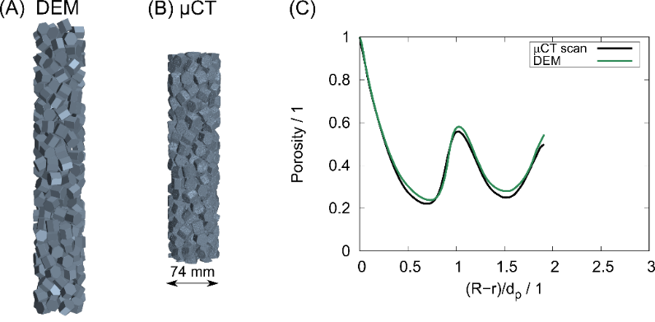 | (D)  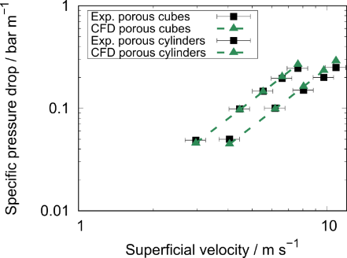
Figure 2. Bed structure in a 74 mm diameter tube with 16x15 mm hexagons. (A) DEM bed, (B) µCT scan, (C) radial porosity over normalized distance from wall. (D) Pressure drop: experiments vs. CFD for porous cubes (10 mm) and porous cylinders (15 mm).
4. Conclusions
We have shown that the synthetic bed-generation method developed in previous works can be applied also for porous pellets. This detailed CFD model was validated against µCT data of the bed structure and pressure drop over a packed bed. This numerical workflow allows the exploration of various novel pellet shapes, since it is independent of geometrical data. In the future, chemical reactions will be included to extend the model to catalytic fixed-bed reactors.
References
- Kolaczkowski, S. T., Awdry, S., Smith, T., Thomas, D., Torkuhl, L., & Kolvenbach, R. (2016). Catal. Today, 273, 221-233.
- Wehinger, G. D., Eppinger, T., & Kraume, M. (2015). Chem. Ing. Tech., 87(6), 734-745.
- Lacroix, M., Nguyen, P., Schweich, D., Huu, C. P., Savin-Poncet, S., & Edouard, D. (2007). Chem. Eng. Sci., 62(12), 3259-3267.
- Zhao, C. Y., Lu, T. J., Hodson, H. P., & Jackson, J. D. (2004). Mater. Sci. Eng., A, 367(1-2), 123-131.

