**Kinetics and modeling of Ibuprofen removal in the absence and presence of heterogeneous catalysts**

Soudabeh Saeid1, Vincenzo Russo2, Pasi Tolvanen1, Narendra Kumar1,

Jyri-Pekka Mikkola3, Tapio Salmi1

1. *Laboratory of Industrial Chemistry and Reaction Engineering, Johan Gadolin Process Chemistry*

*Centre, Åbo Akademi University, FI-20500 Åbo/Turku, Finland*

1. *University of Naples “Federico II”, Chemical Sciences Department, IT-80126 Naples, Italy*

*3 Technical Chemistry, Department of Chemistry, Chemical-Biological Centre,*

*Umeå University, SE-90187 Umeå, Sweden*

*\*Corresponding author:* [*ssaeid@abo.fi*](mailto:ssaeid@abo.fi)

**Highlights**

* The degradation of ibuprofen by catalytic ozonation was studied.
* A kinetic model was developed.
* The model gave a valid description of data.

1. **Introduction**
2. Pharmaceuticals are continuously entering surface waters due to the growing worldwide consumption which is a health risk to humans as well as the environment [1]. Hundreds of different compounds – painkillers, inflammatory mediators, hormones and antibiotics are eluted to the seas, because conventional water treatment plants cannot eliminate these compounds from wastewaters. Ozonation is a good treatment upon removal of micropollutants; however, low mineralization, peril by-products, limited ozone solubility and low stability in water are the main shortcomings of ozonation. The limitations of using ozone alone can be avoided by combining solid catalysts with ozonation which promotes the of ozone reactivity and the formation of hydroxyl radicals, and eventually a complete mineralization becomes possible [2]. In order to progress towards process design, a detailed mathematical model for the three-phase system is required.

**2. Methods**

Semibatch ozonation experiments were conducted in a double jacketed glass reactor (1100 ml) connected to an ozone generator (Fig. 1). The experiments were managed in a gas-liquid reactor system which consisted of the aqueous phase containing IBU, ethanol and deionized water in batch, while the gas mixture containing ozone was continuously bubbled from the bottom into the solution through a disperser. In case a catalyst was used, it was immobilized inside the stirrer, which is a special mixing device (SpinchemTM Rotating Bed Reactor) that maximizes the mass transfer between all phases. The operating conditions were: concentration of ibuprofen (IBU): 10 mg/L, ethanol 10ml/L, gas flow range: 250-1100 ml/min, mixing rate: 900-1070 rpm, temperature: 5-30˚C and the reaction time was typically 2-4 h. For the catalytic experiments, a preset amount of 0.25-0.5 g catalyst (zeolites) were used in a rotating mixer.

**3. Results and discussion**

The kinetic model for catalytic ozonation of IBU was implemented in gPROMS, which helped to describe and evaluate the reaction kinetics. The dissolved ozone concentration and the kinetic parameters were modeled based on the experimental data, and the data were utilized to model the ibuprofen decomposition using a number of experiments performed under various conditions. An improved understanding on the complex behavior of the reaction system was successfully achieved thanks to the model.

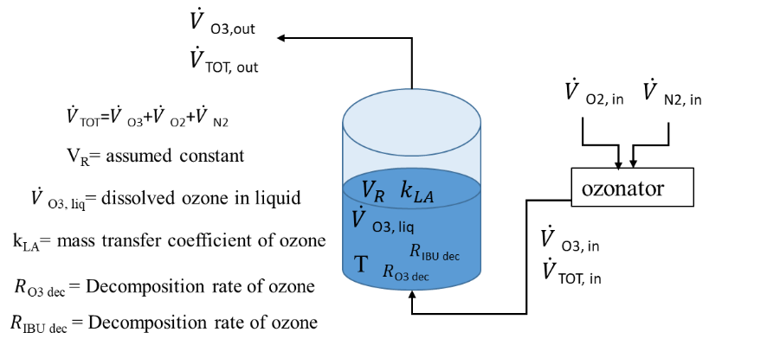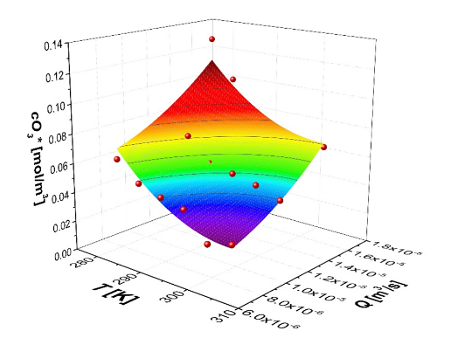

**Figure 1.** Left: The reactor setup and considered parameters for modeling. Right: fitting of the dissolved ozone concentration vs T(ºC) and gas flow rate.



**Figure 2.** IBU ozonation experiments conducted at different temperatures without heterogeneous catalyst. Symbols represent the experimental data, lines the calculated profiles.

A preliminary interpretation was achieved to describe the experiments conducted in the absence of heterogeneous catalysts. The calculations were performed by fixing a power-law rate expression, finding apparent reaction orders of 1.5 for ibuprofen and 3 for ozone, suggesting a complex reaction mechanism. The activation energy was determined to 100kJ/mol. The results are portrayed in Figure 2. As revealed, a good fit was obtained. The model was further developed to describe the ozonation system in the presence of heterogeneous catalysts, where the catalyst amount, the mixing intensity and the active metal species were shown to have an important role.

**Conclusions**

An extensive study of ibuprofen removal was carried out. The ozonation system and the ibuprofen decomposition with and without heterogeneous catalyst was successfully modeled.

**References**

[1] Rosal, R.; Rodríguez., A.; Gonzalo, M. S.; García-Calvo, E. Appl. Catal. B Environ. 2008, 84 (1–2), 48–57.

[2] Saeid, S.; Tolvanen, Salmi, T.et al., Appl. Catal. B Environ. 2018, 230 (January), 77–90.