Bulk Density Control in the Cooling Crystallization of L-Methionine with pH Control
Wang-Soo Kim, Kee-Kahb Koo
Department of Chemical and Biomolecular Engineering, Sogang University, Seoul 04107, Korea
*Corresponding author: koo@sogang.ac.kr
Highlights
- Explosive primary nucleation of L-methionine (L-Met) was induced by pH control.
- Agglomeration was observed with particle counts measured by FBRM.
- Larger and thicker L-Met agglomerates with high bulk density could be obtained by cooling L-methionine slurry made by pH increase.

1. Introduction
L-Methionine (L-Met), which is one of hydrophobic amino acids, has been used for a dietary source due to the role as a donor of an active methyl group [1]. Generally, it is difficult to obtain single crystals of L-Met due to strong tendency for agglomeration and final L-Met agglomerates obtained by cooling from aqueous solution has very low bulk density due to their hollow structures [2]. In the present work, to improve the bulk density, L-Met was crystallized by pH increase with one-pot injection of an electrolyte aqueous solution into saturated acidic solution of L-Met and then large-sized agglomerates with high bulk density could be obtained by slow cooling the suspension made by the one-pot injection.
2. Methods
L-Met was crystallized with pH increase of acidic L-Met solution (saturated state of 60 °C from 300 g water with addition of 2 wt % sulfuric acid) by the injection of sodium acetate aqueous solution (1 mole dissolved in 20 g water). After the injection was completed, the slurry was stirred for about 2 h to agglomerate L-Met crystals and then cooled to 30 °C with a slow cooling rate of -6 °C/h. During crystallization by pH increase, particle counts were in-situ monitored by focused beam reflectance measurement (FBRM) and hydrogen ion concentration was observed with real time by measuring pH values using the relation, pH = -log[H⁺]. Size and morphology of L-Met agglomerates were confirmed by images of scanning electron microscopy (SEM).
3. Results and discussion
Figure 1 shows the history of particle counts and pH values when sodium acetate aqueous solution was injected with one-pot using a syringe. As soon as the injection was carried out, the pH increased instantaneously from 2.6 to 4.0 and particle counts were observed to drastically rise. Thereafter, the pH remained constant, but the particle counts began to decrease monotonically. This result indicates that the great number of tiny L-Met crystals generated by explosive primary nucleation tend to agglomerate continuously. The total number of particle counts measured by FBRM (Figure 1a) is the sum of the number of chord length (Figure 1b; the range of 1 – 1000 μm) that is the distance of laser light from FBRM probe traveling over each particle surface [3]. When the suspension in which agglomeration occurs is monitored by FBRM, particle counts are generally decreased due to high possibility of measuring the largest chords of agglomerates. Therefore, it can be expected that the decreases in both particle counts and chord length distribution area are caused by agglomeration.
Figures 2a and 2b show that L-Met agglomerates obtained by pH increase were found to be denser and thicker than those by just cooling. As shown in Figure 2c, much larger and denser L-Met agglomerates was found to be obtained with crystallization by pH increase followed by the cooling process. It can be concluded that supersaturation generated by cooling was predominantly consumed to enlarge L-Met agglomerates.
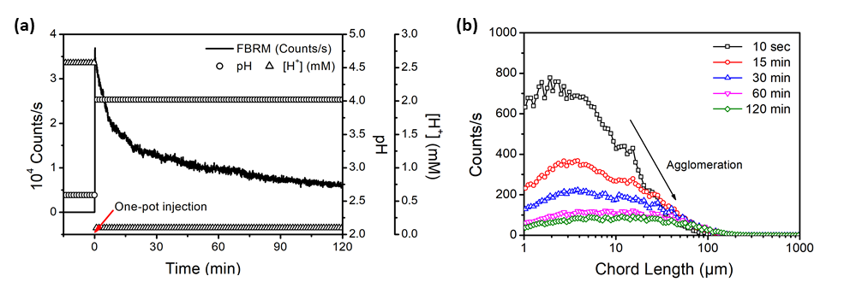
Figure 1. (a) Total counts and pH values in case of one-pot injection, (b) chord length distribution varying with time.
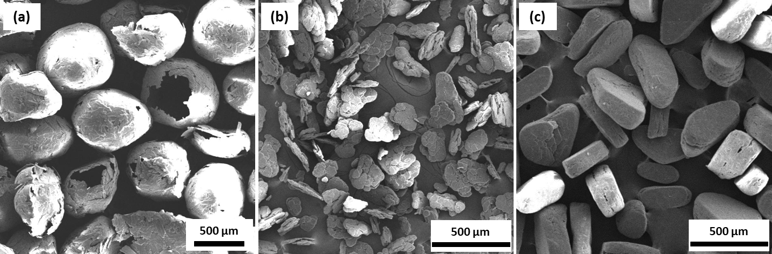
Figure 2. SEM images of L-Met agglomerates obtained by (a) cooling from 60 to 30 °C, (b) pH increase from 2.6 to 4.0, (c) pH increase followed by cooling.
4. Conclusions
Explosive nucleation was generated by instantaneous pH increase, resulting in production of L-Met agglomerates with the bulk density of 500 g/L. Furthermore, as a result of additional cooling, large and dense agglomerates with 760 g/L could be successfully obtained. On the other hand, the bulk density of L-Met agglomerates with the hollow structure obtained from just cooling was 200 g/L.
References
- S. Roje, Phytochemistry, 67 (2006) 1686-1698.
- H. Steckel, H.G. Brandes, Int. J. Pharm., 278 (2004) 187-195.
- M.R. Abu Bakar, Z.K. Nagy, A.N. Saleemi, C.D. Rielly, Cryst. Growth Des., 9 (2009) 1378-1384.

