Effect of the solvation force and the van der Waals forces on the Pull-off between Two Slightly Rough Surfaces from a Molecular View.
Gerson E. Valenzuela^{1*}
1 Chemical Engineering Department, Universidad de La Frontera, Av. Francisco Salazar, Temuco 01145, Chile; Centro de Excelencia de Modelación y Computación Científica CEMCC, Universidad de La Frontera, Temuco 01145, Casilla 54-D, Chile.
*Corresponding author: gerson.valenzuela@ufrontera.cl
Highlights
- Water bridge effect on the pull-off.
- Solvation versus van der Waals forces.
- Molecular dynamics simulation of nanometric systems.

1. Introduction
The correct understanding of the interaction forces between particles and surfaces is determinant in technological development [1] and processes with nanoparticles. [2] Such interaction in the air is composed of the van der Waals and electrostatic forces, and the capillary and solvation forces because of water bridges. [3] The effect of humidity on the interaction force is expressed in the pull-off measurement obtained in force spectroscopy during retraction of the tip in atomic force microscopy. [4] Computer simulations have been shown the solvation force produces pull-off between smooth hydrophilic surfaces. [5]. In this work it is shown that, during a pull-off, the van der Waals forces between two slightly roughness surfaces can be hidden by the solvation force, depending on the size of the bridge. The systems and the results are of nanometric resolution.
2. Methods
Figure 1-A1 shows a general diagram of the system. Each substrate (S1 and S2) have a circular roughness of radius 3 nm and depth 0.25 nm (Fig. 1-A2). When S2 is moving down the water droplet (500 molecules) becomes in a water bridge. S1 and S2 are hydrophilic. Interaction parameters of the system can be reviewed in refs. [5] and [6], the droplet forms a contact angle of 57°. The simulations are performed with a program that has been used in previous works. [5, 6, 7] The water temperature is controlled at 298 K. The force laws are obtained according to the method developed in refs. [6] and [7]. The pull-off simulations are performed according to ref. [5]. Cross interaction S1-S2 is defined by the Lennard-Jones potential with parameters $σ_{S1-S2}=0.3$ nm and $ϵ_{S1-S2}=5k_{B}$, providing a Hamaker constant of $0.98{x10}^{-20}$ J (similar for glass [8]).
3. Results and discussion
The force laws in Fig. 1-B shows that the water bridge controls the adhesion between the smooth surfaces. The interaction of the two-layer bridge (B2) and the monolayer (B1) appears with repulsive walls at a higher distance of separation than the interaction of S1 and S2. When the substrates are roughness (Fig. 1-C) the force law of the water bridge displaces to the left (in D axis) due to the depth of the roughness, and the interaction of B2 develops in a similar range than the interaction S1-S2. In an approach and retraction of S2, the pull-off simulation (Fig. 1-D) shows a small peak (P1) when interaction S1-S2 are on. From P1, S2 is pull-off out of the interaction domain S1-S2, but the attraction increases with the retraction because the pull-off is controlled by the bridge. The effect of the bridge is clear considering a smaller one (256 water molecules) which is fully trapped into the roughness (inset Fig. 1-E). Figure 1-E show the pull-off, the water bridge does not affect the maximum attraction between S1 and S2 showing in Fig. 1-C (red line).
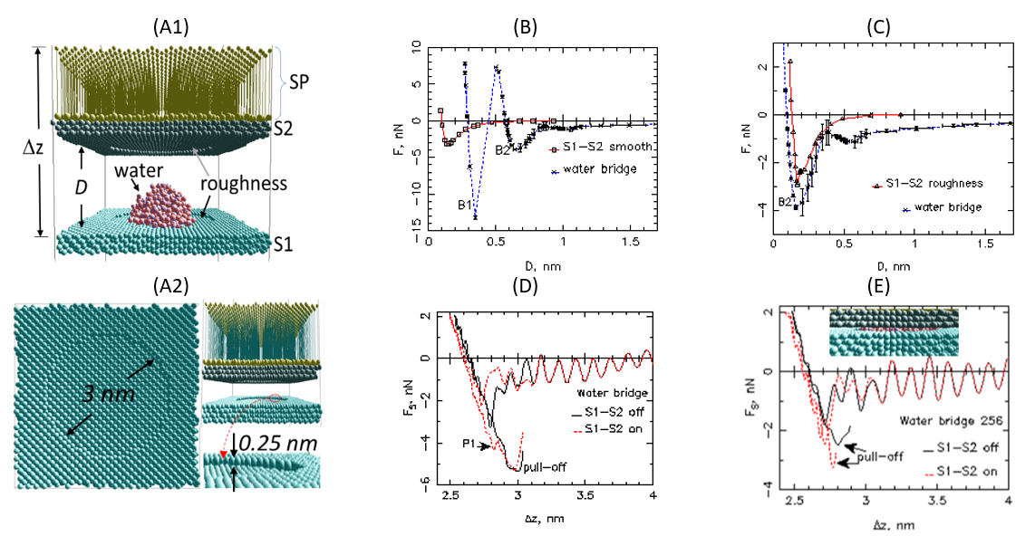Figure 1. (A1) System. The force exerted by the bridge and the interaction S1-S2 is measured by the deflection of the SP. The “tip” (S2) is moved by displacing the top sites of the “cantilever” (SP) with constant speed, analogous to an AFM experiment; (A2) Detail of the roughness. (B) Force law for the interaction S1-S2 smooth alone (without a water bridge) and the force law for the bridge alone (interaction S1-S2 off) (C) Force laws between S1 and S2 roughness and for the bridge between them. (D) Pull-off for 500 water molecules (E) Pull-off for 256 water molecules.
4. Conclusions
The pull-off force between two smooth hydrophilic surfaces may be entirely dominated by a water bridge due to repulsive walls in the force law. For slightly roughness surfaces, the bridge affects the pull-off depending on its size. For a small bridge (250 water molecules) the van der Waals force between the surfaces is not affected by the solvation force, but for a bigger bridge (500 water molecules), the pull-off correspond to the solvation force.
References
- H.R. Moutinho, C.-S. Jiang, B. To, C. Perkins, M. Muller, M.M. Al-Jassim, L. Simpson, Sol. Energy Mater. Sol. Cells 172 (2017) 145-153.
- J. Laube, M. Dörmann, H.-J. Schmid, L. Mädler, L. Colombi Ciacchi, J. Phys. Chem C 121 (2017) 15294-15303.
- J.N. Israelachvili, Intermolecular and Surface Forces, Academic Press: San Diego, 2011.
- M. He, A. Szuchmacher, D.E. Astos, C. Buenviaje, R.M. Overney, R. Luginbühl, J. Chem. Phys 114 (2001) 1355-1360.
- G.E. Valenzuela, J. Phys. Chem C (2018) DOI: 10.1021/acs.jpcc.8b09907.
- G.E. Valenzuela, J.H. Saavedra, R.E. Rozas, P.G.Toledo, Phys. Chem. Chem. Phys. 18 (2016) 11176-11183.
- G.E. Valenzuela, R.E. Rozas, P.G. Toledo, J. Phys. Chem. C 121 (2017) 25986-25993.
- S. Acuña, P. Toledo, Langmuir 24 (2008), 4881-4887.

