Investigation of the Mechanical Characteristics of Particle Separation with Dynamic Filtration - Analyzed by Surrogate Particles.
Henrik S. Marke^{1*}, Martin Peter Breil², Manuel Pinelo¹, Ernst Broberg², Ulrich Krühne¹
1) Technical University of Denmark; 2) Novo Nordisk A/S
*Corresponding author: hensmar@kt.dtu.dk
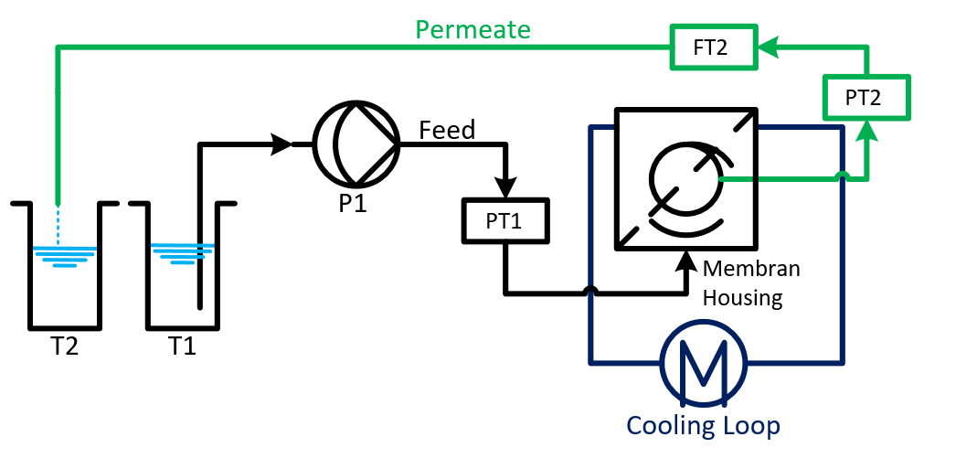 | 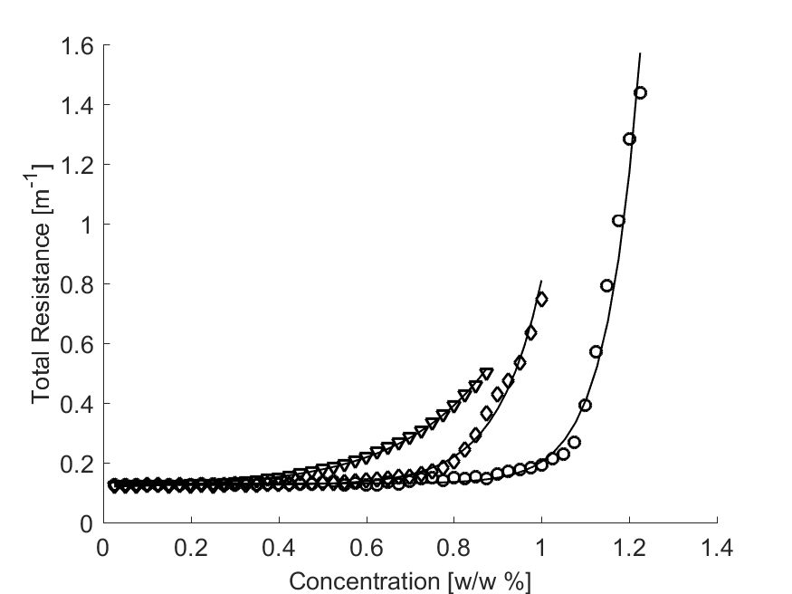
Figure 1: Schematic of the experimental setup.  Particles dilute from T1 are pumped into the membrane house, where they are concentrated. The permeate was collected in T2. The permeate Flow (FT2) and operational pressure (PT1, PT2) was measured | Figure 2: Total Resistance$\left(R_{tot}\right)$ plotted as a function of particle concentration for three different experiments.  ◊: High rotation, High Flow. $∇:$ Low rotation, High Flow.  ○: High rotation, low Flow. The solid lines represent the modelled resistance for each experiment.
Highlights
- The mechanics of dynamic filtration has been studied by surrogate particles
- The particle specific pressure was isolated from known pressure components
- A model for the particle resistance was derived from the isolate particle pressure

1. Introduction
Solid separation by membrane filtration promises better separation, with a cleaner permeate fraction compared to centrifugation. Despite those advantages, most cell separations in the bio-chemical industry are still done by centrifugation. The filtration properties of the fermentation broth are too unfavorable for mass embracement of membrane separation for cell recovery [1]. To make membrane filtration of cells from fermentation broth economically variable, novel filtration technologies are needed. One such novel technology is dynamic filtration where filtration is enabled by movement of objects, not movement of liquid. Different methods to inducing such moment have been devised. For instance, by having an impeller rotating above the membrane, or by moving the membrane itself, ether by rotation or by vibration [2]. In this project a system with rotating membranes have been investigated.
The ultimate goal for this project is to describe how different process conditions affect the filtration performance of microorganisms in a rotating filtration system. Due to the complexity of biological feeds, the system was simplified to a more manageable complexity level. The simplified filtration system was made with uniform particles of chalk (CaCO₃). The use of a well-defined system ensures experimental reproducibility, which would have been difficult with a biological system.
2. Methods
For the experiments, a dedicated filtration setup was assembled, according to the schematic shown in Figure 1. Operation parameters, such as pump speed and disc rotation were controlled with help of LabVIEW. Pressure and flow measurements were collected likewise. Each experiment consisted of two stages. First, the solvent system was measured, i.e. the membrane resistance was determined without particles. Secondly, the system was investigated with particles in the feed. For each experiment, a dilute solution of chalk particles was prepared. The particles used had a mean size of 2.5 µm, and the solution had a concentration between 1.2 % w/w and 2.7 % w/w. The filtration was performed as a dead-end filtration, meaning particles would accumulate in the house. The particle accumulation leads to an increased operational pressure with time.
3. Results and discussion
For a set of operational conditions, a filtration performance curve was recorded, based on the operational pressure$\left(ΔP\right)$. The pressure curve was analyzed by decomposing it into known and unknown pressure components. The known components are related to the solvent system and to the rotation of the membrane. The known parts can be described as:
$$P_{sys}=\underset{Solvent}{\underbrace{μ_{s}⋅J⋅R_{m}}}+\underset{Rotation}{\underbrace{{\left(k_{1}ω\right)}^{2}⋅\frac{ρ}{4}⋅\left(r_{1}^{2}+r_{2}^{2}\right)}}$$
The unknown components are related to the particles and buildup of cake on the membrane surface. The pressure difference between$ΔP$ and$P_{sys}$ is the pressure resulting from the presents of particles. The difference can be used to find the particle resistance and the total resistance in the system, as presented in Figure 2:
$$R_{C}=\frac{ΔP-P_{sys}}{J⋅μ_{s}}\begin{matrix} & \end{matrix}R_{tot}=R_{C}+R_{m}$$
Conducting the experiments at different operational conditions, such as different filtration rates, particle concentrations, and membrane rotational speeds, a model for$R_{C}$ can be derived. With this model, a general performance description of a filtration unit will be derived, facilitating process design.
4. Conclusions
By isolating the particle pressure from the operational pressure, a resistance model can be derived. This model is a starting point for filtration process design.
5. References
[1] S.P. Beier, G. Jonsson, Separation of enzymes and yeast cells with a vibrating hollow fiber membrane module, Sep. Purif. Technol. 53 (2007) 111–118. doi:10.1016/j.seppur.2006.06.019.
[2] M.Y. Jaffrin, Dynamic shear-enhanced membrane filtration: A review of rotating disks, rotating membranes and vibrating systems, J. Memb. Sci. 324 (2008) 7–25. doi:10.1016/j.memsci.2008.06.050.

