Determination of the Factors Responsible for Stabilization in Hydrotreating.
Ngoc Yen Phuong Cao¹, Benoit Celse^{1*}, Denis Guillaume¹, Isabelle Guibard¹, Joris W. Thybaut²
1 IFP Energies nouvelles, Rond-point de l’échangeur de Solaize, BP 3, 69360 Solaize, France; 2 Ghent University, Laboratory for Chemical Technology, Technologiepark 914, Ghent, B-9052, Belgium
*Corresponding author: benoit.celse@ifp.fr
Highlights
- Stabilization is due to chemical phenomena and depends on feed and operating conditions
- Stabilization follows a first-order transfer function
- A characteristic time parameter is defined for stabilization

1. Introduction
Hydrotreating is a catalytic conversion process in petroleum refineries, among others for removing organic nitrogen, sulfur and oxygen from hydrocarbon streams. A kinetic model is mandatory for the design and simulation of this process. It is usually developed based on data acquired at steady state conditions. A significant challenge in this respect is that establishing the steady state requires several days, leading to long duration to acquire sufficient experimental data for kinetic model construction. However, during the transient state, effluent analyses are carried out at regular time intervals to determine whether the steady state has been reached. The aim of this work is to have a better understanding of the stabilization behavior by estimating the influential factors, such that the data acquired in this period can also be employed for kinetic modelling.
2. Methods
The experimental data are obtained using the hydrodenitrogenation pilot plant operating in a continuous manner in IFP Energies Nouvelles. The total catalyst volume in the reactor is 50 cm³. Operating conditions are switched after having reached the steady state corresponding with the previous operating conditions. Data cover 11 Vacuum Gas Oil (VGO) feeds over two catalysts. Liquid Hourly Space Velocities (LHSV) vary between 0.5 and 4 h⁻¹, the total pressure between 50 and 140 bar and the temperature between 350 and 410 °C. The data are measured as the ‘liquid product nitrogen content’ with time on stream, including 920 measurements, see Figure 1. One ‘episode’ is defined as a series of points corresponding to one experimental run.
A hydrodynamics study on the pilot plant has been done using a tracer technique. Stabilization evolution is assessed via exploratory data analysis [1]. It resulted in a first-order transfer function as shown in Equation (1). The characteristic time τ of each episode presented in the equation is estimated via nonlinear least-squares problem (solid line in Figure 1). A multiple linear regression with interaction technique is then used for τ prediction to evaluate the phenomena underlying the transient data. The most influential input variables are estimated via variable selection technique ‘leaps’ [2].
 | $$N=N_{init}+\left(N_{final}-N_{init}\right)\left(1-e^{\left(\frac{-(TOS-{TOS}_{init})}{}\right)}\right)$$ | (1)
Where:
- N : product nitrogen at a specific TOS (ppm) | - TOS : time on stream (h)
- N_{init} : first point of episode (ppm) | - TOS_{init} : TOS corresponding to N_{init} (h)
- N_{final} : last point of episode (ppm)  Second episode  First episode | - τ : characteristic time (h)
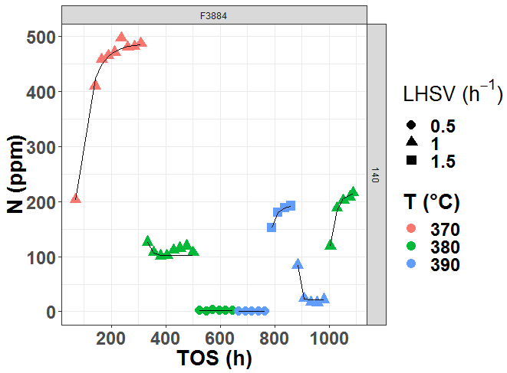
Figure 1. Data representation (Feed F3884, P = 140 bar, point : experimental data, solid line : model fitting Equation (1))
3. Results and discussion
The stabilization evolution of the tracer component is significantly faster than the stabilization of hydrodenitrogenation. Chemical phenomena are therefore involved in the stabilization. τ reflects the time required to reach the steady state. First episodes take more time to stabilize than other episodes. Two linear models for τ were built: one for first episodes (model M1) and another for other episodes (model M2). Model M1 was achieved with a R² of 0.83, see Figure 2. It contains three variables (LHSV, feed resin, pressure) and one interaction term LHSV*resin. An inverse relationship between LHSV and τ was found. The interaction term shows that the impact of LHSV on τ depends on the value of feed resin which is the polar components with high molecular weight. A direct relationship between pressure and τ was observed. Temperature is not an influential parameter for stabilization. However, stabilization of other episodes seems more complex. Model M2 relies by not only on the operating conditions and feed properties but also on the operating conditions of the previous episode.
Model M1
Model M2
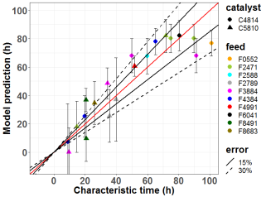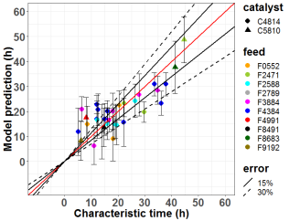
Figure 2. Parity plot with 95% confidence interval for model M1 (left, R² = 0.83) and model M2 (right, R² = 0.66)
4. Conclusions
Stabilization behavior is a critical point for hydroprocessing experiments. Two models (one for the first episode, another for the others) were built to predict the stabilization time and assess the most influential parameters (LHSV, resin, pressure). The models will be tested against new data.

References
[1] J. W. Tukey. Exploratory Data Analysis, Addison-Wesley, Reading, MA, 1977.
[2] G. M. Furnival, R. W. Wilson, Jr. Regressions by Leaps and Bounds, Technometrics, 1974, 499-511.

