Methanol synthesis in a stirred batch reactor – application of the total pressure method and reaction-diffusion modelling

Pasi Tolvanen¹, Vincenzo Russo^{1,2}, Kari Eränen¹, Tapio Salmi^{1*},

1 Laboratory of Industrial Chemistry & Reaction Engineering, Department of Chemical Engineering, Johan Gadolin Process Chemistry Centre, Åbo Akademi University, FI-20500 Åbo-Turku, Finland
²Università di Napoli ‘’Federico II’’, Chemical Science Department, IT-80126 Napoli, Italy

*Corresponding author: tapio.salmi@abo.fi
Highlights
- The theory for the total pressure method applied on the study of heterogeneously catalyzed kinetics was presented
- Experiments on methanol synthesis was carried out in a intensively stirred batch reactor
- The reaction-diffusion model for porous particles were used to interpret the data and to determine the kinetic parameters
- The applicability of the total pressure method was demonstrated for methanol synthesis and generic examples
- Introduction
The total pressure method is well-known for the measurement of the kinetics of homogeneous gas-phase reactions. If the number of molecules change in a gas-phase process, the total pressure in a closed reactor vessel changes indicating the progress of the reaction. The total pressure method can be applied to heterogeneously catalyzed gas-phase reactions, too. In this work, the general theory for the interpretation of kinetic data in stirred batch reactors is presented. The concept was applied to the synthesis of methanol from carbon monoxide and hydrogen on a commercial copper-based catalyst.
2. Methods
The catalyst particles were placed in a spinning impeller which rotated at high speed, typically 300-600 rpm. The volumes of the autoclave reactor and the gas phase were constant. Catalyst particles of equal sizes were used in all the experiments and isothermal conditions prevailed. The reaction temperatures and pressures were 150-250ºC and 10-30 bar, respectively. The classical modelling approach, based on simultaneous chemical reactions and diffusion in porous media was applied. This implies that that separate mass balances are valid for the gas-phase components in the gas bulk and in the catalyst pores. The catalyst particles were presumed to be chemically (activity, number of active sites) and physically (particle size, porosity, tortuosity, surface area) equal. Thus the aspects of particle size distribution and chemical inhomogeneity of the catalyst surface were ignored.

The model for the catalyst particles in the rotating device is
where x = the dimensionless particle coordinate, R = particle radius, s = shape factor, r_{i}= the generation rate of component i, ρ_{P} = particle density, ϵ_{P} = particle porosity, D_{ei} = effective diffusion coefficient. For the gas bulk surrounding the spinning impeller, the balance equation is given by
where n_{P} and A_{P} denote the number of particles and their outer surface area, respectively. V_{G} is the gas volume. The model was solved numerically and the parameters were estimated from collected total pressure data.
3. Results and discussion
The results of the sensitivity analysis of the model revealed that the increase of the kinetic constant leads to a faster decrease of the overall pressure. The initial pressure plays an activating role on the reaction kinetics as well. By working at higher H₂/CO ratio, a lower rate is observed. Examples of the intraparticle profiles of carbon monoxide and hydrogen are displayed in Figure 1, which confirms the role of the internal diffusion effect in the catalyst pores as concentration gradients appear inside the particles.
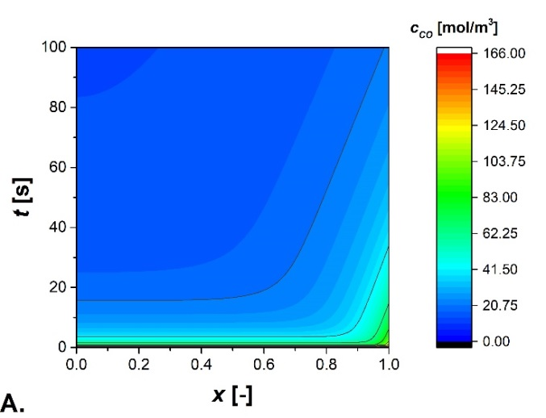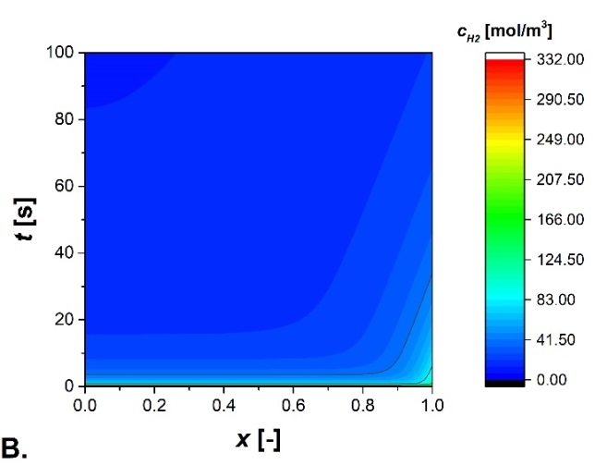
Figure 1. CO (A) and H₂ (B) concentration profiles inside the catalyst particle.
4. Conclusions
Rapid methods are very valuable in the determination of the kinetic and mass transfer effects for heterogeneously catalyzed reactions. The total pressure method is a classical tool in the measurement of the kinetics of gas-phase reactions. It can be successfully applied to the kinetics of gas-phase processes enhanced by solid catalysts. A general theory for the analysis of heterogeneously catalyzed gas-phase kinetics in stirred batch reactors was presented for the case of the kinetic control and combined kinetic-diffusion control. The concept was successfully applied to gas-phase synthesis of methanol from carbon monoxide and hydrogen.

