Sorption enhanced dimethyl ether synthesis for high carbon efficiencies
Jasper van Kampen^{1,2}, Jurriaan Boon^{1,2}, Jaap Vente¹, Martin van Sint Annaland²
1 Sustainable Process Technology, ECN/TNO, Petten, The Netherlands;
2 Chemical Process Intensification, TU/e, Eindhoven, The Netherlands
*Corresponding author: jasper.vankampen@tno.nl
Highlights
- SEDMES: direct synthesis of DME from syngas and CO₂ by in situ H₂O adsorption.
- The dynamic cycle model adequately describes the SEDMES experimental results.
- The working capacity can be tuned by the adsorption and regeneration conditions.
- Cyclic stability confirmed for more than 100 cycles.

1. Introduction
Utilisation of CO₂ is expected to play a crucial role to enable sustainable industrial production of carbon-based products, the large-scale storage and transport of renewable energy, and the production of renewable fuels. An important criterion for the value chain for converting the available CO₂, e.g. from biogenic origin, is a high carbon efficiency [1]. Very high carbon efficiencies have indeed been demonstrated for the conversion of synthesis gas and CO₂ to DME (clean alternative fuel and platform chemical) by sorption enhanced DME synthesis (SEDMES) [2, 3], in which water is removed in situ by the use of a solid adsorbent. The concept is based on Le Chatelier’s principle stating that reactant conversion to products in an equilibrium limited reaction is increased by selectively removing reaction products. Experimental proof-of-principle has shown increased DME yield, improved selectivity towards DME over methanol and reduced CO₂ content in the product [2, 4]. This contribution will present an elaborate model study on the cyclic SEDMES process, which is conducted in parallel to an experimental research line. The combination of theory and experiments in a fundamental way is crucial for a proper understanding of this type of process.
2. Methods
Both a 1D dynamic cycle model was developed and verified using Matlab, and transient experiments in a packed-bed reactor were performed for various stoichiometric feed compositions and inert N₂, Ar. Commercial copper/zinc oxide/alumina catalyst and commercial zeolite A steam adsorbent (mixed in different ratios) were used experimentally. Adsorption was conducted at 250-300 °C, 25-40 bar(a) and with different feed gas compositions. Regeneration was done by switching to dry gas, depressurisation and eventual heating to 400 °C. Analysis was done by a combination of mass spectrometry and GC.
3. Results and discussion
The results of a representative breakthrough experiment of sorption enhanced DME synthesis are shown in Figure 1. Pre-breakthrough of steam, DME and unconverted CO are the primary products. After steam breakthrough the concentration of DME drops, accompanied with the breakthrough of CO₂ and methanol indicating saturation of the adsorbent. As can be seen in Figure 1 the dynamic cycle model, using reaction kinetics and a water adsorption isotherm from literature, adequately describes the experimental results. An elaborate model study, supported by experimental work, shows an operating window for the SEDMES process. For example, Figure 2 shows a process trade-off between carbon selectivity and productivity for various space velocities. The working capacity is a key parameter for optimizing the SEDMES process. Improving this capacity can be done by optimizing the reactive adsorption conditions, such as the space velocity, and by optimizing the inherent regeneration procedure.
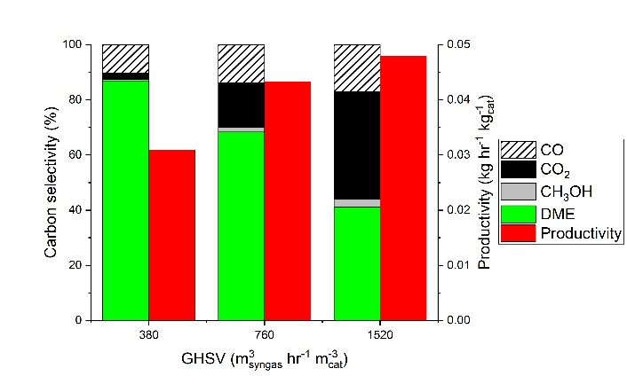
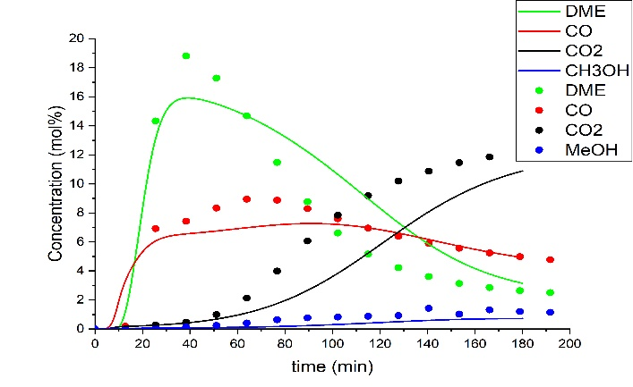
Figure 2. Model carbon selectivity vs. productivity for GHSV of 380, 760 and 1520 hr⁻¹ at 30 bar(a), 275 °C, feed H₂:CO:CO₂ = 8:1:2 (regeneration to 400 °C).
Figure 1. Breakthrough experiment (points) and model prediction (lines) at 40 bar(a), 275 °C, feed H₂:CO:CO₂ = 8:1:2 (regeneration to 400 °C)

In parallel to the dynamic SEDMES cycle model development, different commercial catalysts and steam adsorbents are tested and prove to be promising for further development of the process to industrial relevant conditions. Experimental campaigns, more than 100 cycles without observed degradation, support the model study indicating high carbon efficiency to DME and reduced CO₂ content in the product for a typical SEDMES operating window. The testing focuses on obtaining relevant data as input for validation and tuning of the SEDMES model, which in turn is used for the scale-up of the SEDMES process towards full cycle validation with continuous DME production.
4. Conclusions
The SEDMES process is a promising process intensification, easily achieving 70% single-pass DME carbon yield and minimal CO₂ by-product formation for a three reactor column system. This increased single-pass conversion requires less downstream separation, and smaller recycle streams especially for a CO₂-rich feed. Within EU Horizon 2020 project Fledged, further optimization of the SEDMES process is pursued by experimental and modelling studies.
Acknowledgement
This project has received funding from the European Union’s Horizon 2020 research and innovation programme under grant agreement No 727600.
References
- SAPEA, Novel carbon capture and utilisation technologies: research and climate aspects, Berlin, 2018.
- J. Boon, F.P.F. van Berkel, H.A.J. van Dijk, J.F. Vente, 5th TMFB International Conference, Aachen, 2017.
- I. Iliuta, M.C. Iliuta, F. Larachi, Chem. Eng. Sci. 66 (2011) 2241–2251.
- J. van Kampen, J. Boon, F.P.F. van Berkel, H.A.J. van Dijk, J.F. Vente, M. van Sint Annaland, 25th International Symposium on Chemical Reaction Engineering, Florence, 2018.

