Tomographic visualization of droplet break-up during high-pressure homogenization with orifices in a scaled test section
Benedikt Mutsch¹, Christian J. Kähler²
1 Institut for Fluid Dynamics and Aerodynamics, Bundeswehr University Munich, Werner-Heisenberg-Weg 39, 85577 Neubiberg, Germany; 2 Institut for Fluid Dynamics and Aerodynamics, Bundeswehr University Munich, Werner-Heisenberg-Weg 39, 85577 Neubiberg, Germany

*Corresponding author: benedikt.mutsch@unibw.de
Highlights
- Flow field measurements inside a scaled high-pressure homogenizer.
- Droplet and droplet breakup visualization method.
- Tomographic reconstruction of droplets during breakup
- Determination of droplet breakup regions and mechanisms.

1. Introduction
Emulsions are produced and used in chemical, pharmaceutical and food technology. Since the droplet size and the droplet size distribution have an important influence on the properties of the emulsion, these parameters are of special importance. Drop sizes in the range from 100 nm to 10 μm can be produced by means of high-pressure homogenization.
This process uses high pressure to press the raw emulsion through small channels in the disintegration unit to break the coarse droplets of the raw emulsion into fine droplets of the desired size. However, the physical mechanism responsible for the break up is not known as the accurate visual inspection of the tiny droplets in space and time is not possible due to the small size.
In order to visualize the disintegration process, and to understand the physical phenomena responsible for the droplet break-up, high-speed images of well defined and reproducible droplets emerging from an orifice plate scaled to a scale factor of 50 were taken using the shadow image method. In order to investigate not only the geometric similarity but also a physically similar model, the material parameters density and viscosity of the model material system and the operating pressure are adapted so that the diameter, viscosity and density ratio as well as the Reynolds number and the Weber number are kept constant in comparison to the original process.
For a better understanding of the processes, these images were taken from several angles of view, so that a 3D model of the drop deformation during disintegration could be created for the first time.
The correlation of the drop break-up measurements with 2D2C-PIV measurements shows that the local turbulence intensity has a large influence on the break-up.
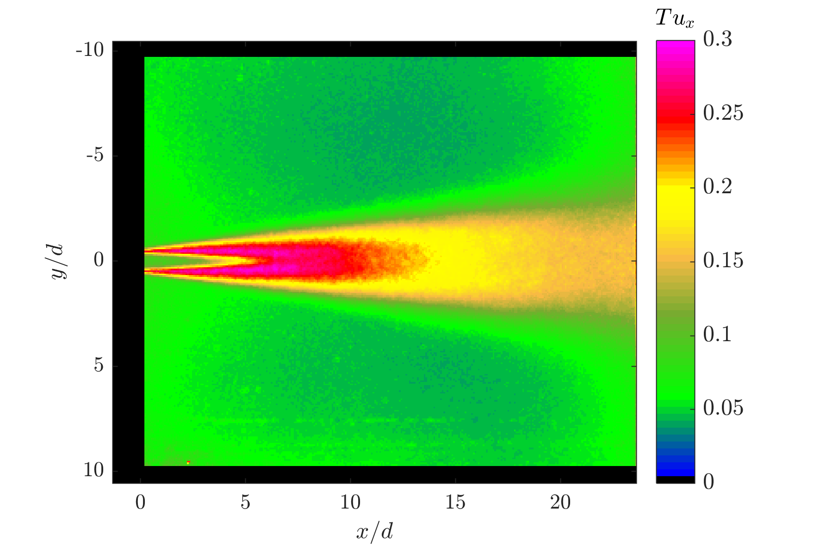
Figure 1. Local mean turbulence intensity behind the orifice
The drop emerges as an elongated filament from the Orifice in the core of the free jet. The images show that the drop is hardly deformed in this area due to the low turbulence. At the transition of the drop from the core area of the free jet to the shear layer, the drop begins to oscillate and meander. As a result of this incipient deformation, the droplet is strongly deformed in the shear layer, resulting in twisting and swirling of the filament. Ultimately, the deformed droplet decays into individual areas that are further deformed until a mist of fine droplets is formed.
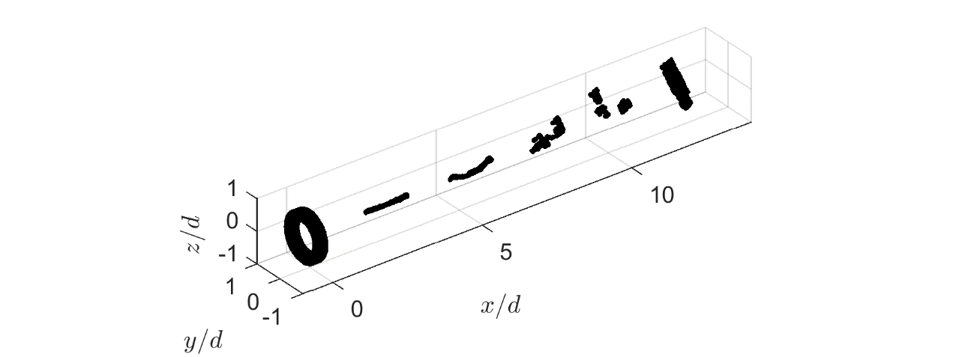
Figure 2. 3D reconstruction of the droplet breakup evolution behind an orifice from a long filament to a spray of small droplets
In order to investigate the droplet break-up mechanisms more closely, further investigations will be carried out. On the one hand, the droplet feed position is varied so that the droplet emerges from the orifice at different radial positions. This allows the expanded droplet to experience the local turbulence of the shear layer earlier and with a different intensity. The result is that the point of break-up shifts towards the orifice.
Furthermore, the Reynolds number is varied in the experiments so that the limits of drop break-up can be investigated with regard to the required turbulence intensity. Depending on the Reynolds number and the resulting different elongation of the droplet, different break-up mechanisms can be observed which have to be investigated in further investigations. The results of the various experimental investigations will be discussed and explained on physical grounds.

