Enhancing the Biochemical Methanation Potential of Sugarcane Bagasse using VoDCa (Vortex based Devices for Cavitation) Pre-treatment
Sanjay Nagarajan and Vivek Vinayak Ranade*
Multiphase flows, reactors and process intensification group, School of Chemistry and Chemical Engineering, David Keir Building, Queen’s University Belfast, Belfast – BT9 5AG, United Kingdom.
* Corresponding author: v.ranade@qub.ac.uk
Highlights
- A patented Vortex based Device for Cavitation was used for bagasse pretreatment
- Effect of additives prior and during cavitation was quantified.
- Biochemical methanation potential (BMP) of untreated & pretreated bagasse were compared.
- 1st order kinetic model (with time delay) was used to describe BMP.

1. Introduction
Anaerobic digestion (AD) for biogas production is an established technology for the production of biofuels combined with waste minimisation. AD was firstly used for wastewater sludge treatment, its application was however extended to biogas production from food waste, organic fraction of municipal solid waste, agri residues, animal slurries and other lignocellulosic biomass (LCB) later. Especially, with the recent climate agreement, global interest in AD to intensify biogas production is on the rise. Although a mature technology, process instability is of concern deterring its expansion.
The predominant hindering factor is the recalcitrance of LCB feedstock. To overcome the recalcitrance and to improve its digestibility, a range of pre-treatments have been reported [1-2]. Amongst the methods available, a physico-chemical method known as cavitation was utilised in this work to pre-treat sugarcane bagasse (SCB) for enhanced biogas production. Acoustic or hydrodynamic cavitation (HC) have been reported in literature for the purpose of pre-treatment of a range of LCB’s. HC is energetically favourable and relatively easier to scale up when compared to ultrasonication and hence preferred [3-5]. Conventional HC treatment were predominantly performed using orifice plates or venturi tubes as HC devices. However, these devices exhibit problems such as erosion and clogging. A recently patented device by Ranade et al; – vortex diode, could however be used as an alternative to conventional devices for this purpose [6]. These Vortex based Devices for Cavitation (VoDCa) have been reported to be superior than the conventional devices for simulated waste water treatment [7], and now its application has been extended for LCB pre-treatment.
In this work, we report the use of VoDCa for the pre-treatment of SCB. SCB was selected as the feedstock due to its availability, for instance, Indian sugar industries generate ~80 million tonnes annually. Additional HC investigations were performed with additives prior or during bagasse cavitation to achieve enhanced pre-treatment. Biochemical methanation potential (BMP) of the samples were then compared and the optimal pre-treatment combination was identified.
2. Methods
HC experiments were conducted in a rig with a configuration shown in Figure 1 with SCB as feedstock. Additional experiments with additives such as alkalis and H₂O₂ prior or during the HC pre-treatment were performed. Solids were characterised using a range of techniques before and after treatment. Liquid phase was analysed using a HPLC. The solids were then subjected to 1 week BMP tests to quantify the enhanced BMP due to pre-treatment. A 1st order kinetic model (with time delay) was developed and used to describe the BMP data.
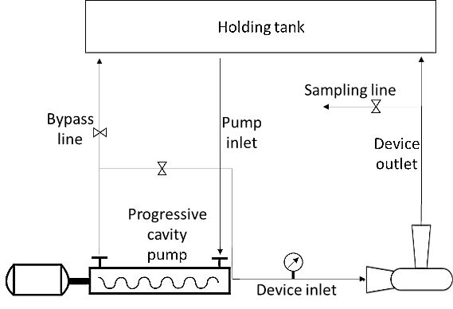
Figure 1. Experimental rig of VoDCa for bagasse pre-treatment
3. Results and discussion
There have been reports in literature that have presented results on LCB delignification using alkali (or H₂O₂)-conventional device HC combined pre-treatment of a variety of LCB for bioethanol or biogas production. Delignification is required, as the lignin, when present and broken down to phenolics, have the capability to inhibit methanogensis. It is expected that the combined pre-treatment in this case using novel VoDCa would be efficient in delignifying bagasse as well as hydrolyse a part of the polysaccharides enhancing its biodigestibility. It was shown that the model parameters obtained from 7 days of BMP data were able to simulate BMP data for longer durations. The model was then used to quantitatively understand the influence of pre-treatment combinations on delay time as well as maximum BMP. The approach and results will be useful to develop optimal pre-treatment for bagasse and other LCB valorization.
4. Conclusions
VoDCa based pre-treatment was found to enhance BMP of bagasse. The approach and results presented here are useful for developing an effective pre-treatment method for bagasse which can be easily scaled-up.
References
- A.T.W.M. Hendriks, G. Zeeman, Bioresour. Technol. 100 (2009) 10-18.
- Y. Zheng, J. Zhao, F. Xu, Y. Li, Prog. Energy. Combust. Sci. 42 (2014) 35-53.
- M.J. Madison, G. Coward-Kelly, C. Liang, M.N. Karim, M. Falls, M.T. Holtzapple, Biomass. Bioenergy. 98 (2017) 135-141.
- R. Terán Hilares, G.F. de Almeida, M.A. Ahmed, F.A.F. Antunes, S.S. da Silva, J. Han, J. Santos, Bioresour. Technol. 235 (2017) 301-308.
- P.N. Patil, P.R. Gogate, L. Csoka, A. Dregelyi-Kiss, M. Horvath, Ultrason. Sonochem. 30 (2016) 79-86.
- V.V Ranade, A.A Kulkarni, V.M Bhandari, US patent US9422952B2, 2016.
- P.G Suryawanshi, V.M. Bhandari, L.G. Sorokhaibam, J.P.Ruparelia, V.V. Ranade. Environ. Prog. Sustain. Energy. 37 (2017) 295-304.

