Alkaline peroxide pretreated sugarcane bagasse as cell immobilization carrier for isopropanol-butanol-ethanol production
Carla Vieira^{1*}, Mateus Codogno¹, Francisco Maugeri-Filho², Rubens Maciel-Filho¹, Adriano P. Mariano¹
1 School of Chemical Engineering - UNICAMP, Av. Albert Einstein, 500 - Campinas - SP - Brazil
2 School of Food Engineering - UNICAMP, R. Monteiro Lobato, 800 - Campinas - SP - Brazil
*Corresponding author: carlafsvieira90@gmail.com
Highlights
- The proposed cell immobilization technique was successful in increasing IBE production.
- A more disorganized bagasse structure allowed the adhesion of a greater number of cells.
- Excessive production of biofilm exopolysaccharides affected the IBE yield.
1. Introduction
Cell immobilization techniques have been widely applied to ABE (acetone-butanol-ethanol) [1] and IBE (isopropanol-butanol-ethanol) [2 - 5] fermentation processes to increase productivity and decrease butanol inhibition to Clostridial species. The use of lignocellulosic materials as immobilization carrier can be an economically advantageous alternative due to their low cost and abundance. However, the adhesion of microorganisms cells can be difficult because of the poor permeability of lignocellulosic tissues [6]. Therefore, we evaluated whether the alkaline peroxide pretreatment can improve the efficiency of sugarcane bagasse as a cell immobilization carrier for IBE fermentation.
2. Methods
Sugarcane bagasse was provided by a mill located in São Paulo state, Brazil. The bagasse was pretreated with alkaline peroxide [0.5% (w/v) NaOH, 2% (w/v) H₂O₂, 10% (w/v) biomass loading] for 24 h at 200 rpm and room temperature in dark place [6]. IBE fermentations using Clostridium beijerinckii DSM 6423 were conducted in 250-mL flasks (triplicate) containing pretreated bagasse (1:20 liquid to solid ratio) and P2 medium [4] with 60 g/L initial glucose. The flasks were incubated in anaerobic chamber at 35 °C. Experimental controls consisted of fermentations without bagasse and with non-treated bagasse.
3. Results and discussion
Upon pretreatment, we observed a more disorganized morphological structure of the sugarcane bagasse (Figure 1), which allowed the adhesion of a greater number of cells (Figure 2). It had a positive impact on IBE concentration, IBE productivity, and sugar conversion (Table 1). Nevertheless, the decrease in the IBE yield can be attributed to an excessive production of biofilm exopolysaccharides, especially in the fermentation with pretreated bagasse.
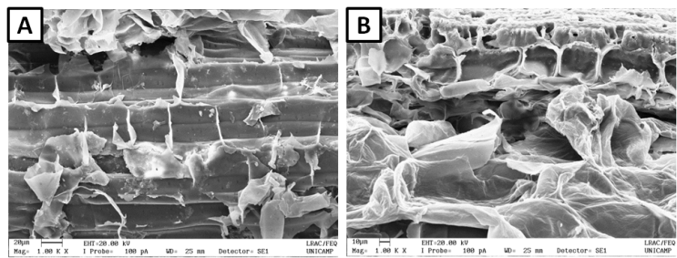
Figure 1 – Morphological structure of the sugarcane bagasse (A) before and (B) after pretreatment with alkaline peroxide.

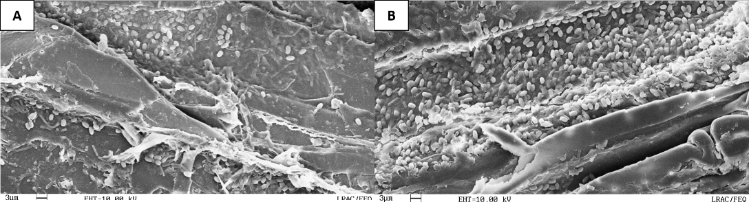
Figure 2 – C. beijerinckii DSM 6423 adhered to the sugarcane bagasse after the fermentation process. (A) Non- and (B) pretreated sugarcane bagasse

Table 1 – Performance of the IBE fermentation
 | Without immobilization | Non-treated bagasse | Pretreated bagasse
Sugar conversion (%) | 32 | 60 | 78
Final IBE concentration (g/L) | 7.8 | 12.8 | 13.9
IBE productivity (g/L.h) | 0.19 | 0.31 | 0.34
IBE yield (g/g) | 0.40 | 0.34 | 0.29
4. Conclusions
Sugarcane bagasse as a cell carrier offered remarkable gains (78%) in IBE production. Further gains (8%) can be obtained if the bagasse is pretreated with alkaline peroxide. However, more sugar was used to produce biofilm exopolysaccharides, thereby affecting the IBE yield more intensively. Thus, future studies should focus on attenuating the production of exopolysaccharides by C. beijerinckii DSM 6423.

References
- M. Kumar, K. Gayen. Appl Energy. 88 (2011) 1999–2012.
- S.A. Survase, E. Sklavounos, G. Jurgens, A. Van Heiningen, T. Granstrom. Appl Microbiol Biotechnol 91 (2011) 1305–1313.
- S. A. Survase, A. Van Heiningen, T. Grantro. J Ind Microbiol Biotech. 40 (2013) 209–15.
- Y. Yang, A. Hoogewind, Y.H. Moon, MOON, D. Day. Bioproc Biosyst Eng. 39 (2013) 421-428.
- S. Zhang, C. Qu, X. Huang, Y. Suo, Z. Liao. J. Ind Microbiol Biotechnol. 43 (2016) 915–25.
- D. Cai, C. Cheng, Y. Wang, S. Hu, C. Cui, P. Qin, T. Tan. Biores Technol. 220 (2016) 68-75.

