Mass transfer intensification in wastewater
aeration system with novel conical mixer
Anastasia Grigoreva^{1,2}, Rufat Abiev²*
1 Asterion Ltd, Saint-Petersburg, Russia;
2 St. Petersburg State Institute of Technology, Moskovskii pr.26, 190013, Saint-Petersburg, Russia;
*Corresponding author: abiev.rufat@gmail.com
Highlights
- New conical mixer has been elaborated and tested.
- New conical mixer has the same mass transfer efficiency as Ruston turbine, but lower power consumption.

1. Introduction
The practice of operating wastewater treatment plants shows that 60-80% of expences depends on the efficiency of the aeration system [1]. This is the most energy-consuming process. Rushton turbine is recognized as the most effective mixer for gas dispersing [2]. We have recently developed aeration system with new type of impeller, which shown in the Fig.1.
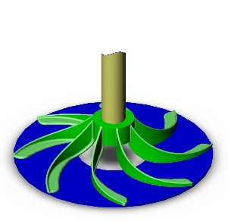
Figure 1. New type conical mixer.
This mixer has more streamlined shape, the blades are rounded, therefore hydraulic losses are minimized.
2. Methods
All tests were hold in plexiglass vessel with volume of 44 litres. In present work we analyzed bubbles’ sizes using photographic method. From 5300 to 7300 bubbles were captured and calculated. Mass transfer was determined by method, described in [3]. Sodium sulfite was added to the tap water for deoxygenation. The oxygen content in the liquid was measured with oxygen sensor (Expert, Туре 009, Russia). Volumetric Mass Transfer Coefficient (K_{L}a) defined as
K_{L}a$=\frac{1}{t2-t1}ln\frac{d1}{d2}$
Where d2 and d1 – oxygen deficiency at the moment of time moments of t2 and t1. Power consumption were measured with stand, which described in [4]. SOTE and SAE were chosen as criteria of efficiency [5].
3. Results and discussion
Oxygen content in the water during experiments shown in the Fig. 2. The main results are presented in the Table 1.
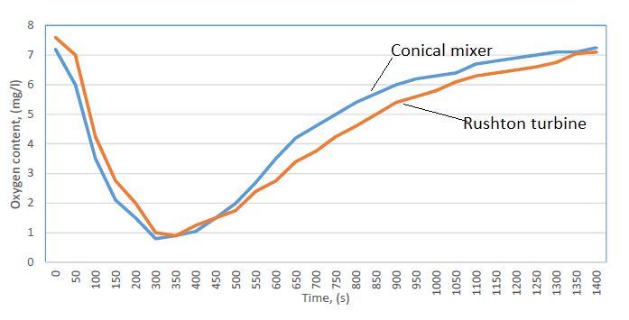
Figure 2. Oxygen content during experiments with conical mixer and Rushton turbine.
Table 1. Mass transfer characteristics of water oxidation
The name of calculated parameter | Rushton turbine | Conical mixer
Volumetric Mass Transfer Coefficient Kla, | 11.06 | 15.62
Oxygen dissolution rate, kg/h | 21.25 | 29.99
Oxygen use percentage SOTE, % | 13.60 | 19.19
The ratio of the amount of oxygen dissolved in a liquid to the amount of electricity used SAE | 0.35 | 0.64
4. Conclusions
Conical mixer shows SAE efficiency 1.82 times more than Rushton turbine. This is because the new type of mixer has a more streamlined shape, contributing to reduced power consumption. The proposed aeration system is a good alternative to the existing pneumatic aeration, especially in shallow tanks (up to 3 meters deep). Installing this kind of mixer will significantly reduce operating costs and avoid problems with clogging of small (approx.. diameter of 0.1 mm) pores in aerators (spargers).
References
- S.Yu.Andreev, A.M.Isayeva, T.V.Malyutina, I.V.Pantyushov, Regional Architecture and Construction, 2 (2008) 63-69 (in Russian).
- E.L. Paul, V.A. Atiemo-Obeng, S.M. Kresta, Handbook of industrial mixing: science and practice. Wiley, 2003
- Ya.A. Karelin, D.D. Zhukov, V.N. Zhurov, B.N. Repin, Treatment of industrial wastewater in aeration tanks., Stroyizdat, Moscow, 1973 (in Russian).
- R.S. Abiev. A.N Grigorieva, Trans. SPSIT (TU), 45 (2018) 94-97.
- Merkblatt DWA-M 229-1. Systeme zur Belueflung und Durchmischung von Belebungsanlagen- Teil 1: Planung, Ausschreibung und Ausfuerung, September 2017.

