**Implementation of catalytic descriptors within kinetic models. How to predict the nC7 aromatisation selectivity obtained with a new catalyst?**

Olivier Said-Aizpuru1, Florent Allain1, Aurélie Dandeu1, Fabrice Diehl1, David Farrusseng2 and Jean-François Joly1

*1 IFP Energies Nouvelles, Rond-point de l'échangeur de Solaize, BP3, 69360 Solaize Cedex, France*

*2 IRCELYON, CNRS, 2 Avenue Albert Einstein, 69100 Villeurbanne, France*

*\*Corresponding author:* [*olivier.said-aizpuru@ifpen.fr*](mailto:olivier.said-aizpuru@ifpen.fr)

**Highlights**

* Integration of catalyst active phase descriptors into kinetic models
* High Throughput catalytic testing for intrinsic kinetics studies
* Bi-functional n-heptane aromatisation catalysis

**1. General context and motivations**

Several refining or petrochemical catalytic processes show a strong dependence of overall performances upon catalytic active phase composition and structure. Their development requires the identification of the relevant dimensioning parameters of the catalyst that are referred to as “descriptors”. Kinetic models provide an indispensable tool for an accurate design of catalytic processes. Extensive descriptions of the active phase behaviour within kinetic models were investigated over the past decades, usually through sophisticated models based on theoretical calculations or more often on advanced characterisations. Yet, the simplicity and a limited amount of parameters of a kinetic model are necessary in order to handle frequent changes in catalytic formulation. There is therefore a deep interest in identifying global catalytic activity descriptors that could be easily measured and controlled by a dedicated catalyst synthesis. We and others have shown that fitting the kinetic parameters of a well-known (*i.e.* model) reaction is an efficient approach to probe and quantify the overall activity of a catalyst. This work addresses the possibility to perform catalytic tests on a model reaction in order to identify relevant and independent descriptors.

**2. Objectives and strategy**

The frame of this study is to set up a methodology in order to implement active phase descriptors within a lumped kinetic model for the n-heptane reforming reaction (see Figure 1). Aromatisation of n-heptane requires a bi-functional catalysis enabling proton and hydrogen transfer. Thus, a typical naphtha reforming catalyst comprises a metallic phase (sub-nanometric Pt or Pt alloys particles) supported on a mild-acidic support (chlorinated γ-Al2O3). A collection of twenty-one active phase formulations specifically prepared in order to exhibit various inter-sites (acid-acid or metal-acid) distances as well as different site ratios is first gathered. Both Pt only and Pt-Sn catalysts are tested and different ranges of Pt (0.3-1%wt) and Cl (0.1-1.4%wt) are considered. Three objectives are then successively targeted: i) Probing the intrinsic surface reactivity over a variety of reforming catalysts ii) Determining the effect of a systematic formulation change over the kinetic parameters for different reforming reaction families iii) Finding statistical correlations between kinetic parameters and physico-chemical properties.

A standard catalytic test protocol was designed to investigate intrinsic n-heptane transformation at the surface of the catalyst. Tests were carried out on a high-throughput Flowrence™ (Avantium) device allowing the use of small sample amounts (see Figure 2). The geometry of the reactors allows for a well-defined hydrodynamics and the unit is used close to isothermal mode.

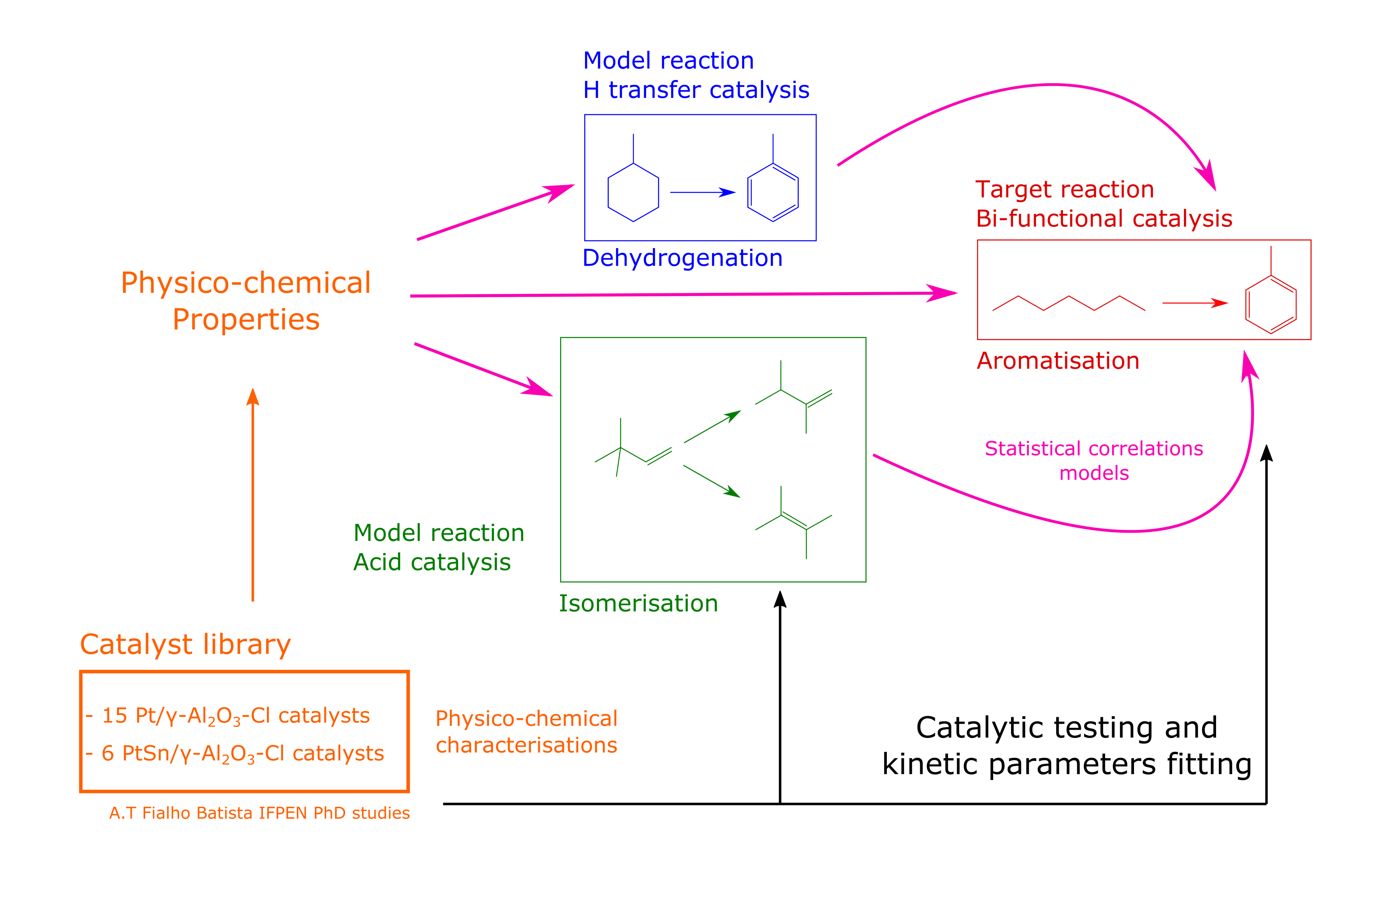

**Figure 1.** General experimental strategy followed for the identification of catalytic activity and selectivity descriptors.

|  |  |
| --- | --- |
|  |  |
| **Figure 2.** Simplified scheme of the reactive section of the High Throughput Experimental device used for catalytic tests. | **Figure 3.** Yield structures obtained at 430°C, 10 barg and H2/HC molar ratio equal to 3. A7 stands for toluene and iC7 for paraffinic isomers. SB3 and TH100 are commercial γ-Al2O3. |

**3. First results and outlooks**

As shown on Figure 3, there is a strong dependence of the reaction scheme selectivity over the amount of chlorine, the amount of platinum and the presence of a second metal (Sn). Competition between sites could be responsible for aromatisation interception by other reactions such as isomerisation or cracking. Then, the challenge in identifying reforming selectivity descriptors lies in understanding which catalytic parameters rule the interactions between sites.

Once the explicit description of the active phase is included in the kinetic model, it will be validated by comparison with results from catalysts with new active phase formulations, demonstrating the possibility of pre-screening catalysts with the model before moving on to traditional experimental screening.