Numerical simulation of a high-shear cone mill mixer for food emulsions production
Antonio Buffo¹, Marco Ferrari¹, Gianluca Boccardo¹, Daniele Marchisio¹
1 Department of Applied Science and Technology, Politecnico di Torino, Torino, Italy
*Corresponding author: antonio.buffo@polito.it
Highlights
- A CFD analysis of a cone-mill mixer for food emulsions production is carried out
- Development of an open simulation platform for a modelling marketplace
- Qualitative analysis of the result sees a match with experimental data

1. Introduction
Mayonnaise belongs to the family of high disperse phase liquid-liquid emulsions and the prediction of the final droplet size distribution is crucial for determining the properties of the final product, such as structure, stability over time, taste and color. The production of mayonnaise is a typical mixing process, in which the ingredients (i.e. egg yolk, vinegar, oil and water) are first brought together and mixed in large stirred vessels at moderate rotational speed. Then the formed emulsion is finally fluxed into a high-shear mixer, where the droplets undergo breakage until the final size distribution is reached; this last step is crucial to fine tune the droplet size distribution, in order to have a final product with the desired features. In this work, we aim to simulate the last step of the production process by means of a Computational Fluid Dynamics approach coupled with a Population Balance Model (CFD-PBM) [1], to properly describe both the non-Newtonian dynamics of the emulsion and the evolution of the droplet size distribution. This methodology is eventually validated with experimental data available in the literature [2,3]. This work focuses on the macroscale of a more complex multiscale simulation, where the interfacial properties and the rheology of the emulsion are also predicted using a numerical approach. This particular workflow will be useful to develop an open simulation platform for generic multiscale and multiphysics simulations, where the computational codes aiming at different parts of the physics are linked and coupled. This will be the main component of a marketplace for modelling of materials and chemical processes.
2. Methods
A schematic representation of the investigated high-shear mixer, i.e. a cone mill mixer, is reported in Fig. 1. As it can be seen, it is constituted of a solid conical frustum rotor inside of a slightly larger stator of the same shape, forming a small gap in which the emulsion flows (moving from the lowest radii section to the largest) and experiences high-shear rates.
From a computational point of view, this geometry was preliminarily reproduced using a two-dimensional grid, exploiting the intrinsic symmetry of this system. The fluid was considered as a shear thinning pseudo single phase, with an apparent viscosity evaluated through a power law model fitted with experiments [2]. However, the feasibility of more sophisticated approaches (such as three-dimensional simulations and two-phase models) will be evaluated in the future. The simulations are carried out with the open source CFD code OpenFOAM (version 6.0).
3. Results and discussion
As expected, the preliminary simulations show a high velocity gradient due to the high rotational speed, in particular the highest velocity corresponds to the tip velocity of the rotor: this can be seen in Fig. 2. Another interesting result is reported in Fig. 3, where the axial velocity profile at the middle section is reported: as it can be seen the emulsion flows in the downward direction but there is a small backflow close to the stationary wall, which is evidence of the presence of recirculation patterns typical of these systems. A qualitative analysis shows good agreement with the experimental data.
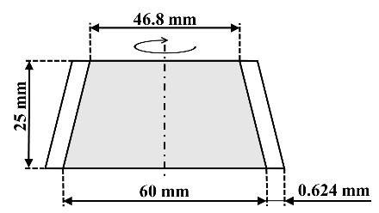  Figure 1. Sketch of the cone mill mixer. | 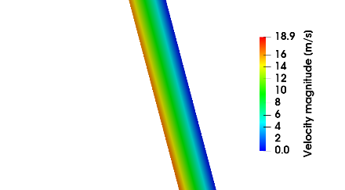  Figure 2. Contour plot of velocity magnitude magnified around the central part of the mixer | 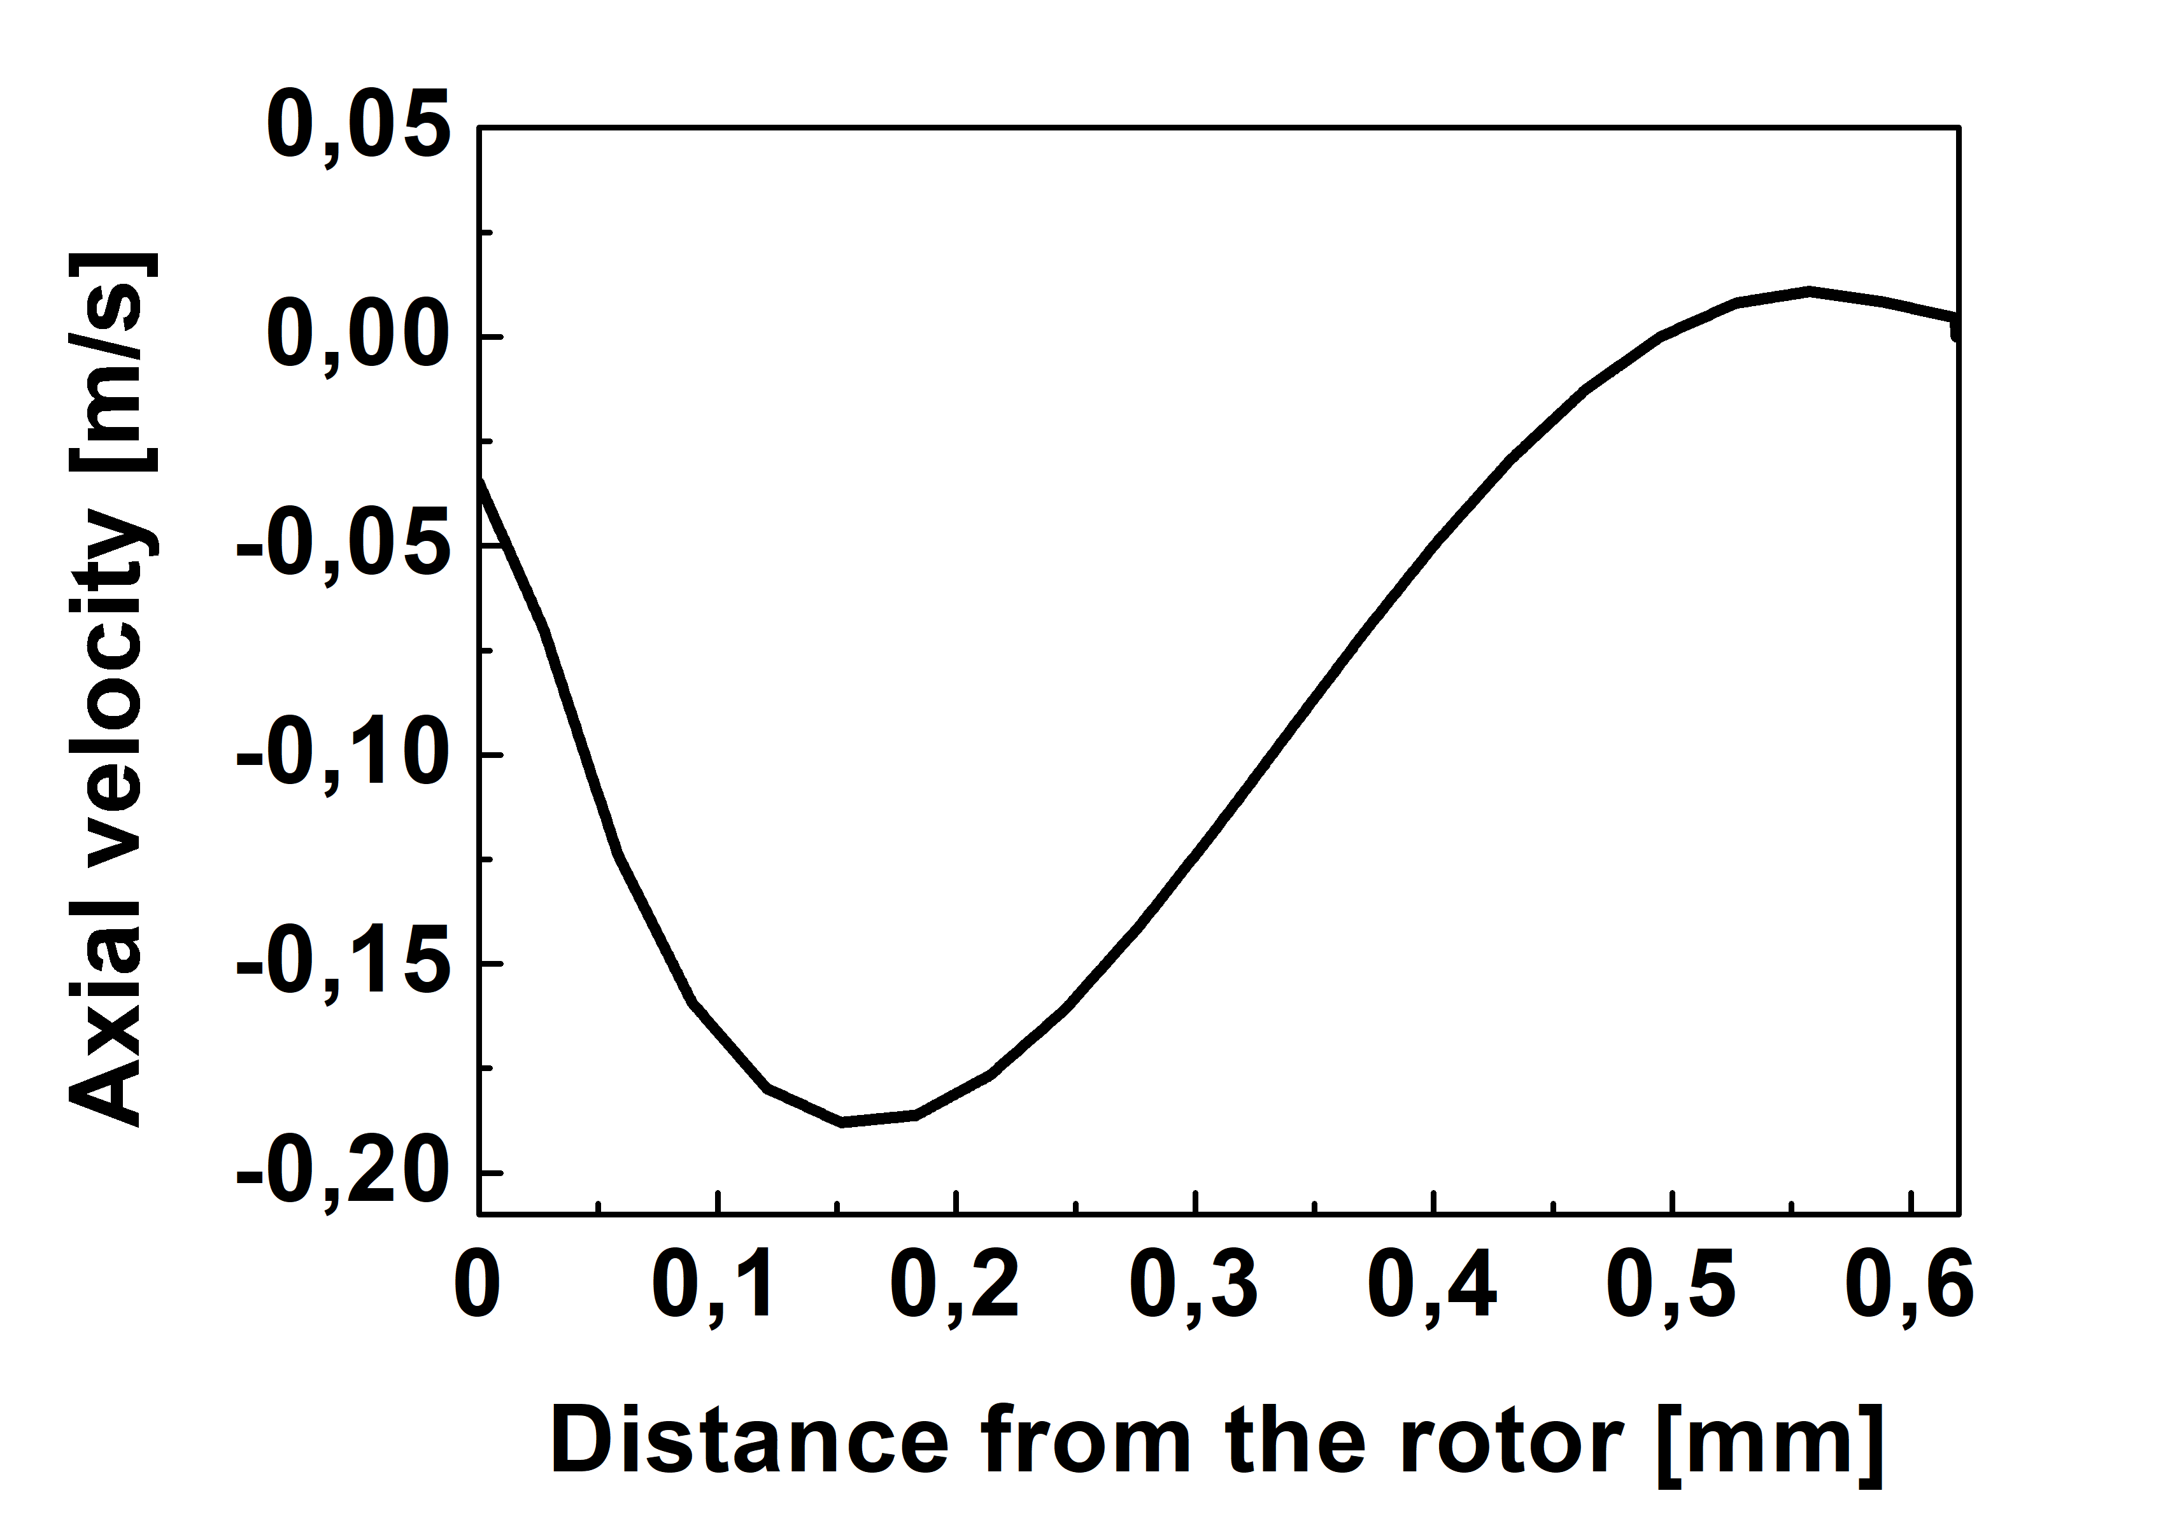  Figure 3. Axial velocity profile at the middle section

4. Conclusions
The first results regarding the fluid dynamics description of the cone mill are promising, as the behavior of the high-shear mixer is properly reproduced. The next step will be the solution of the Population Balance Equation (PBE), in order to account for the droplet breakage induced by the high-shear rates inside the mixer. This will be useful to predict the final droplet size distribution by using a fully-predictive approach.
Acknowledgements
The project leading to this application has received funding from the European Union’s Horizon 2020 Research Innovation Programme under Grant Agreement n. 760907.
References
- D. Li, Z. Gao, A. Buffo, W. Podgorska, D.L. Marchisio, AIChE J. 63 (2017) 2293–2311.
- A. Dubbelboer, J.J.M. Janssen, H. Hoogland, E. Zondervan, J. Meuldijk, Chem. Eng. Sci. 148 (2016) 32–43.
- A. Dubbelboer, Towards optimization of emulsified consumer products: modeling and optimization of sensory and physicochemical aspects, (PhD Thesis) Eindhoven: Technische Universiteit Eindhoven, 2016.

