Evaluation of two-species binding model within anion-exchange membrane chromatography to predict pressure buildup during recovery of a virus

William Kelly^{1*}, Kelsey O’Donnell¹, Zuyi Huang¹
Department of Chemical Engineering
Villanova University, 19085 USA
*William.j.kelly@villanova.edu
Highlights
- Pressure drop across a membrane chromatography unit increases steadily during operation and that this increase is more significant if a higher amount of DNA is present in the feed to the membrane unit.
- A mathematical model was developed that accounts for the competition of DNA and virus for binding sites on the membrane surface, and predicts virus bound per channel length which correlates well with pressure rise.
- The model predicted quite well the experimental breakthrough curves (as well as the amount of virus loaded per membrane channel length) across a range of inlet DNA concentrations from 1 x 10⁻¹⁰ to 5 x 10⁻⁶ g/ml and a range of inlet virus concentration from 1-5 x 10⁻⁴ g/ml.

1. Introduction
Membrane chromatography is an emerging technology for its effective removal of host cell DNA, proteins, and other small macromolecules throughout downstream purification. Multiple vendors supply this single-use technology in several surface chemistry options. The main feature of chromatographic separations based on membranes is the absence of pore diffusion, which is the main transport resistance in conventional column chromatography. Using porous particles. With the membranes, the molecules move via convection through the pores (1).

2. Methods
The presented findings aim to determine the cause of constant pressure rise observed during the loading phase of a viral recovery process using Sartorius Sartobind Q anion exchange membranes. A mathematical model was developed, based on previous work with expanded bed adsorption of proteins (2). The membrane model accounts for the competition of DNA and virus for binding sites on the membrane surface as they flow convectively through a pores/channel. The adsorption isotherm was modelled as Langmuir-like.

3. Results and discussion
The mathematical model predicted the experimental breakthrough curves (as well as the amount of virus loaded per membrane channel length across a range of inlet DNA concentrations from 1 x 10⁻¹⁰ to 5 x 10⁻⁶ g/ml and a range of inlet virus concentration from 1-5 x 10⁻⁴ g/ml.

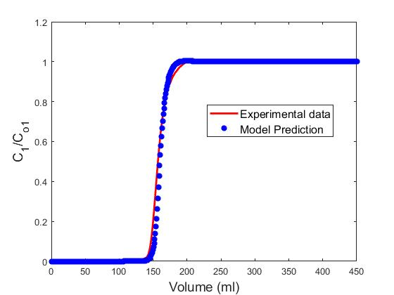
Figure 1. Breakthrough Results – Model versus experimental.
Initial Concentrations: C_{DNA} = 1 x 10⁻⁸ g/ml and C_{virus} = 3.1 x 10⁻⁴ g/ml

4. Conclusions
The model predicted quite well the experimental breakthrough curves. The model can be used to predict the time in a batch when the pressure drop across the column reaches a critical maximum limit, which might prompt operators to reduce the pressure drop by reducing flowrate or replacing the membrane.

References
- Thoemmes, J. and Kula, M. Membrane chromatography - an integrative concept in the downstream processing of proteins. Biotech. Prog. 1995; 11(4): 357-367
- Kelly, W., Ubiera, A., Kamguia, G., Mullen, P., GÖklen, K., Huang, Z., Jones, G. (2013) “Using a two species competitive binding model to predict expanded bed breakthrough of a recombinant protein expressed in a high cell density fermentation”, Biotechnology and BioProcess Engineering. Vol.18, No. 3, pp. 546–559. 2013.

